

**HOLA CAMPUS HOME**

**Requirement & Design Specification**

– Hanoi, Sep 2023 –

# **Record of changes**

| **Date** | **A*  M, D** | **In charge** | **Change Description** |
| --- | --- | --- | --- |
| 11/Sep/2023 | A | LongVH | Thêm Overview, Introduction, Scope, Context diagram |
| 20/Sep/2023 | A | LongVH,HaiKN | Thêm Use Case Diagram |
| 22/Sep/2023 | A,M | LongVH,ThaoTTP | Thêm Use Case Description. Sửa Use Case Diagram. Sửa phân bố nội dung của SRS |
| 26/Sep/2023 | A | LongVH | Thêm Business Rules |
| 1/Oct/2023 | A | LongVH,LoiLQ, TuanVM | Thêm Use Case Diagram,Use Case Specification |
| 1/Oct/2023 | M | TuanVM | Sửa Use Case Specification |
| 1/Oct/2023 | A | ThaoTTP,HaiKN | Thêm Use Case Specification |
| 6/Oct/2023 | M | LongVH | Sửa Use Case Specification |
| 9/Oct/2023 | M | HaiKN | Modify Manager Use Case Diagram |
| 20/Oct/2023 | M | LongVH,LoiLQ | Sửa Use Case Specification |
| 31/10/2023 | A | LongVH | Thêm Screen Flow, Screen Descriptions, Screen Authorization |
| 1/11/2023 | A | LongVH,LoiLQ,ThaoTTP,TuanVM | Thêm Design Specifications |
| 2/11/2023 | A | LongVH, LoiNQ | Appendix |
|  |  |  |  |
|  |  |  |  |
|  |  |  |  |
|  |  |  |  |
|  |  |  |  |
|  |  |  |  |

*A - Added M - Modified D - Deleted

Contents

**Record of changes 2**

**I. Overview 12**

1. User Requirements 12

1.1. Actors 12

1.2. Use Cases 12

a. Diagram 13

Use case diagram for Guest 13

Use case diagram for Student 14

Use case diagram for Admin 15

Use case diagram for Dorm Manager 16

b.Descriptions 17

2. Overall Functionalities 22

2.1. Screens Flow 22

Screens Flow for Guest: 22

Screens Flow for Student: 23

Screens Flow for Dorm Manager: 23

Screens Flow for Admin: 24

2.2. Screens Descriptions 25

2.3. Screens Authorization 28

2.4. Non-UI Functions 32

3. System High Level Design 33

3.1. Database Design 33

3.2. Code Packages 34

**II. Requirement Specification 35**

1.Public Functions 35

1.1 UC-002 View Landing Page 35

a.Functional Description 35

b. Business Rules 36

1.2 UC-003 View Help/FAQ 37

a.Functional Description 37

b. Business Rules 38

1.3 UC-004 View Contact Info 38

a.Functional Description 38

b. Business Rules 39

2.Common Functions 39

2.1 UC-005 Login 39

a.Functional Description 39

b. Business Rules 41

2.2 UC-006 Logout 41

a.Functional Description 41

b. Business Rules 42

2.3 UC-007 View Profile 42

a.Functional Description 42

b. Business Rules 44

2.4 UC-008 Forget Password 44

a.Functional Description 44

b. Business Rules 45

2.5 UC-009 Change Password 46

a.Functional Description 46

b. Business Rules 47

2.6 UC-010 View news 47

a.Functional Description 47

b. Business Rules 48

3.Dorm Manager Functions 49

3.1 UC-151 Create news 49

a. Functional Description 49

b. Business Rules 50

3.2 UC-152 Update news 50

a. Functional Description 50

b. Business Rules 52

3.3 UC-153 Delete news 52

a. Functional Description 52

b. Business Rules 53

3.4 UC-154 View request application 53

a.Functional Description 53

b. Business Rules 54

3.5 UC-155 Reply request application 55

a. Functional Description 55

b. Business Rule 56

3.6 UC-156 View Payment 56

a. Functional Description 56

b. Business Rule 57

3.7 UC-157 View list students information 57

a. Functional Description 57

b. Business Rule 59

3.8 UC-158 View student information details 59

a. Functional Description 59

b. Business Rule 60

3.9 UC-159 View Payment of Student 60

a. Functional Description 60

b. Business Rule 61

3.10 UC-160 View Request of Student 61

a. Functional Description 61

b. Business Rule 63

3.11 UC-161 Search roll number 63

a. Functional Description 63

b. Business Rule 64

3.12 UC-162 Search roll number 64

a. Functional Description 64

b. Business Rule 65

3.13 UC-163 View list room 65

a.Functional Description 65

b. Business Rules 67

3.14 UC-164 View List Beds 67

a.Functional Description 67

b. Business Rules 70

3.15 UC-165 View information of bed 70

a.Functional Description 70

b. Business Rules 72

3.16 UC-166 View Bed Request 72

a.Functional Description 72

b. Business Rules 73

3.17 UC-167 Update Bed Reservation 73

a.Functional Description 73

b. Business Rules 74

4.Students Functions 74

4.1 UC-101 Book bed 75

a.Functional Description 75

b. Business Rules 78

4.2 UC-102 View List Room 78

a.Functional Description 78

b. Business Rules 80

4.3 UC-103 View List Beds 81

a.Functional Description 81

b. Business Rules 83

4.4 UC-104 View Bed Booked History 84

a.Functional Description 84

b. Business Rules 85

4.5 UC-105 View Bed Details 85

a.Functional Description 85

b. Business Rules 87

4.6 UC-106 View Payment 87

a.Functional Description 87

b. Business Rules 89

4.7 UC-107 View Request Application History 89

a.Functional Description 89

b. Business Rule 90

4.8 UC-108 Send Request Application 90

a.Functional Description 90

b. Business Rules 92

5.Admin Functions 92

5.1 UC-501 View List User 92

a.Functional Description 92

b.Business Rules 94

5.2 UC-502 Create User 94

a.Functional Description 94

b.Business Rules 96

5.3 UC-503 Update User 96

a.Functional Description 96

b.Business Rules 98

5.4 UC-504 Delete User 98

a.Functional Description 98

b.Business Rules 100

5.5 UC-505 View User Details 100

a.Functional Description 100

b.Business Rules 101

5.6 UC-506 View List Building 101

a.Functional Description 101

b.Business Rules 102

5.7 UC-507 Create Building 102

a.Functional Description 102

b.Business Rules 104

5.8 UC-508 Update Building 104

a.Functional Description 104

b.Business Rules 106

5.9 UC-509 Delete Building 106

a.Functional Description 106

b.Business Rules 107

5.10 UC-510 View List Room Type 108

a.Functional Description 108

b.Business Rules 109

5.11 UC-511 Create Room Type 109

a.Functional Description 109

b.Business Rules 110

5.12 UC-512 Update Room Type 111

a.Functional Description 111

b.Business Rules 112

5.13 UC-513 Delete Room Type 113

a.Functional Description 113

b.Business Rules 114

5.14 UC-514 View List Room 114

a.Functional Description 114

b.Business Rules 116

5.15 UC-515 Create Room 116

a.Functional Description 116

b.Business Rules 117

5.16 UC-516 Update Room 118

a.Functional Description 118

b.Business Rules 119

5.17 UC-517 Delete Room 119

a.Functional Description 120

b.Business Rules 121

5.18 UC-518 View List Bed 121

a.Functional Description 121

b.Business Rules 122

**III. Design Specifications 122**

1. Public 122

1.1 View Landing Page 122

a.UI Design 123

b.Database Access 124

1.2 View Help/FAQ 125

a.UI Design 125

b.Database Access 125

1.3 View Contact Info 125

a.UI Design 125

b.Database Access 125

2. Common 126

2.1 Login 126

a.UI Design 126

b.Database Access 126

2.2 Logout 127

a.UI Design 127

b.Database Access 127

2.3 View Profile 127

a.UI Design 127

b.Database Access 128

2.4 Forget Password 129

a.UI Design 129

b.Database Access 129

2.5 Change Password 130

a.UI Design 130

b.Database Access 130

3. Dorm Manager 131

3.1 View Request Application 131

a. UI Design 131

b. Database Access 132

3.2 Reply Request Application 132

a. UI Design 132

b. Database Access 133

3.3 View Payment 134

a. UI Design 134

b. Database Access 134

3.4 View List Students Information 134

a. UI Design 135

b. Database Access 135

3.5 View Student Information Detail 136

a. UI Design 136

b. Database Access 136

3.6 View Payment of Student 137

a. UI Design 137

b. Database Access 137

3.7 View Request of Student 137

a. UI Design 137

b. Database Access 138

3.8 View List Room 138

a.UI Design 138

b.Database Access 139

3.9 View List Beds 140

a.UI Design 140

b. Database Access 141

3.10 View Information of Bed 141

a.UI Design 141

b. Database Access 142

3.11 View Bed Request 142

a.UI Design 142

b. Database Access 143

3.12 Update Bed Reservation 143

a.UI Design 143

b. Database Access 145

4. Student 145

4.1 Book bed 145

a.UI Design 145

b.Database Access 146

4.2 View List Room 147

a.UI Design 147

b.Database Access 148

4.3 View List Beds 148

a.UI Design 148

b. Database Access 149

4.4 View Bed Booked History 149

a.UI Design 150

b. Database Access 150

4.5 View Bed Details 151

a.UI Design 151

b. Database Access 152

4.6 View Payment 152

a.UI Design 152

b. Database Access 153

4.7 View Request Application History 153

a.UI Design 153

b. Database Access 154

4.8 Send Request Application 154

a.UI Design 154

b. Database Access 155

5. Admin 155

5.1 View List User 155

a.UI Design 155

b.Database Access 157

5.2 Create User 157

a. UI Design 158

b.Database Access 161

5.3 Update User 161

a.UI Design 161

b.Database Access 164

5.4 Delete User 165

a.UI Design 165

b.Database Access 166

5.5 View User Details 167

a.UI Design 167

b.Database Access 168

5.6 View List Building 168

a.UI Design 169

b.Database Access 169

5.7 Create Building 169

a.UI Design 169

b.Database Access 170

5.8 Update Building 170

a.UI Design 170

b.Database Access 171

5.9 Delete Building 172

a.UI Design 172

b.Database Access 172

5.10 View List Room Type 173

a.UI Design 173

b.Database Access 174

5.11 Create Room Type 174

a.UI Design 174

b.Database Access 175

5.12 Update Room Type 175

a.UI Design 176

b.Database Access 176

5.13 Delete Room Type 177

a.UI Design 177

b.Database Access 177

5.14 View List Room 178

a.UI Design 178

b.Database Access 180

5.15 Create Room 180

a.UI Design 180

b.Database Access 181

5.16 Update Room 182

a.UI Design 182

b.Database Access 183

5.17 Delete Room 184

a.UI Design 184

b.Database Access 184

5.18 View List Bed 185

a.UI Design 185

b.Database Access 185

**IV. Appendix 187**

1. Assumptions & Dependencies 187

Assumptions 187

Dependencies 188

2. Limitations & Exclusions 188

Limitations 188

Exclusions 188

3. Business Rules 188

# 

# **I. Overview**

## **1. User Requirements**

### 1.1. Actors

The table below describes a list of the actors that interact with the system and their respective descriptions.

| **#** | **Actor** | **Description** |
| --- | --- | --- |
| **1** | **Guest** | **An unregistered user of the system** |
| **2** | **Students** | **A person who will be able to stay in the dorm by using a booking service. Students can moderate their residents, transactions history through the system and send request as desire** |
| **3** | **Admin** | **The highest-ranking individual in the management hierarchy of the system. This person is responsible for management of the entire system, including account authorization, homepage management.** |
| **4** | **Dorm Manager** | **A person has responsibility for managing room type, room and bed, also approve or reject students’ bed requests.** |

### **1.2. Use Cases**

The diagrams below provide a visual representation of the interactions between actors (users or external systems) and the system, illustrating the system's functionality and the roles of different users or entities.

#### a. Diagram

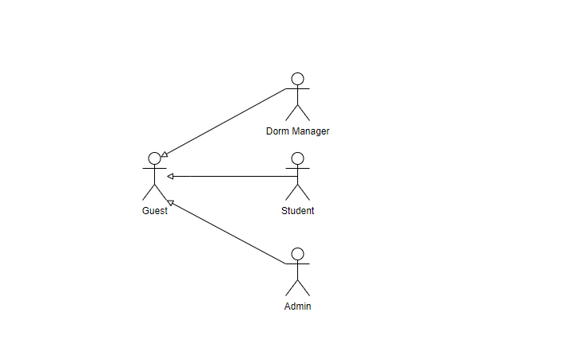

##### Use case diagram for Guest

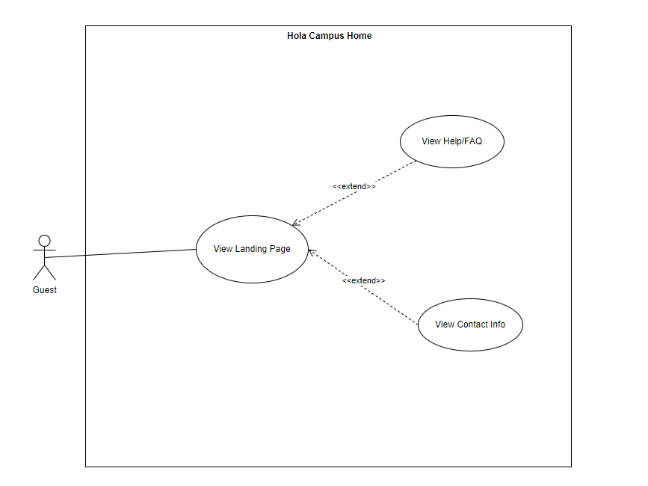

#### 

#### 

#### 

#### 

#### 

#### 

#### 

##### Use case diagram for Student

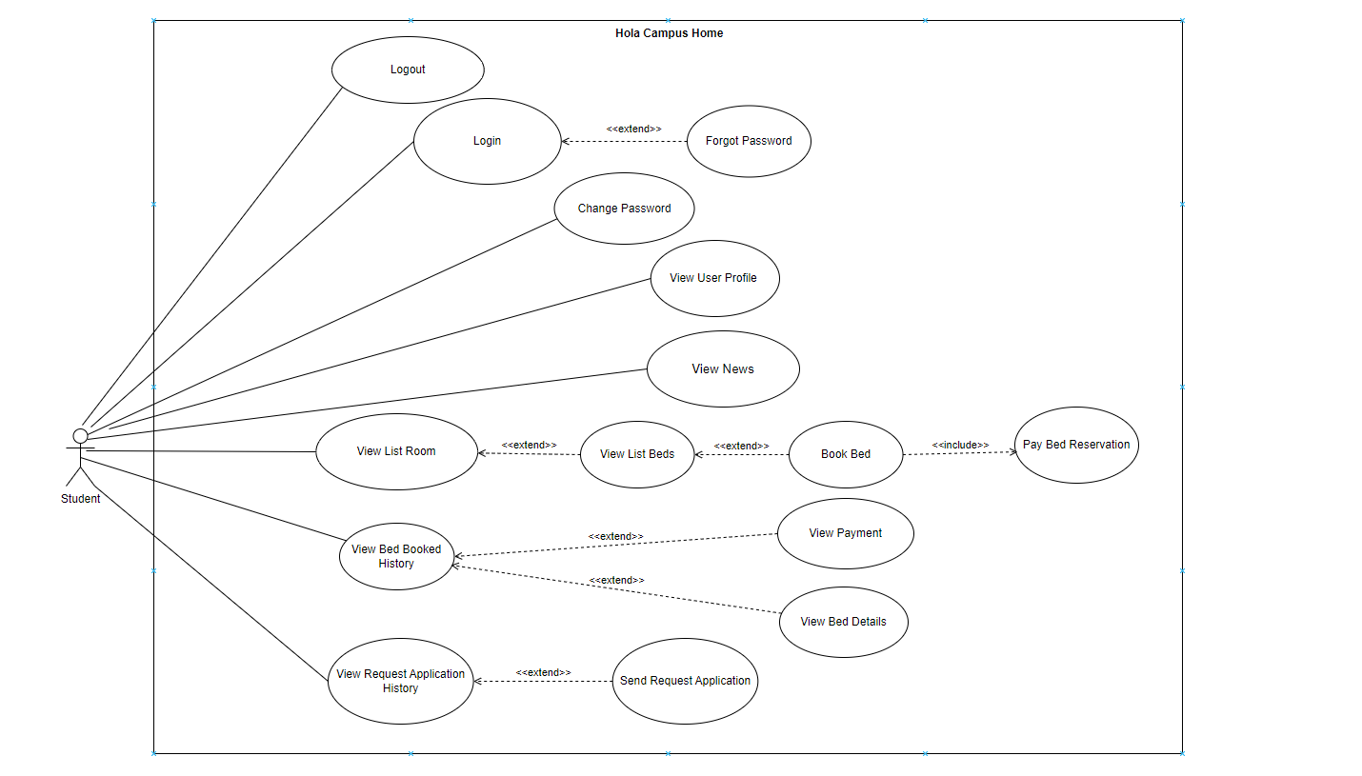

#### 

#### 

#### 

#### 

#### 

#### 

#### 

##### Use case diagram for Admin

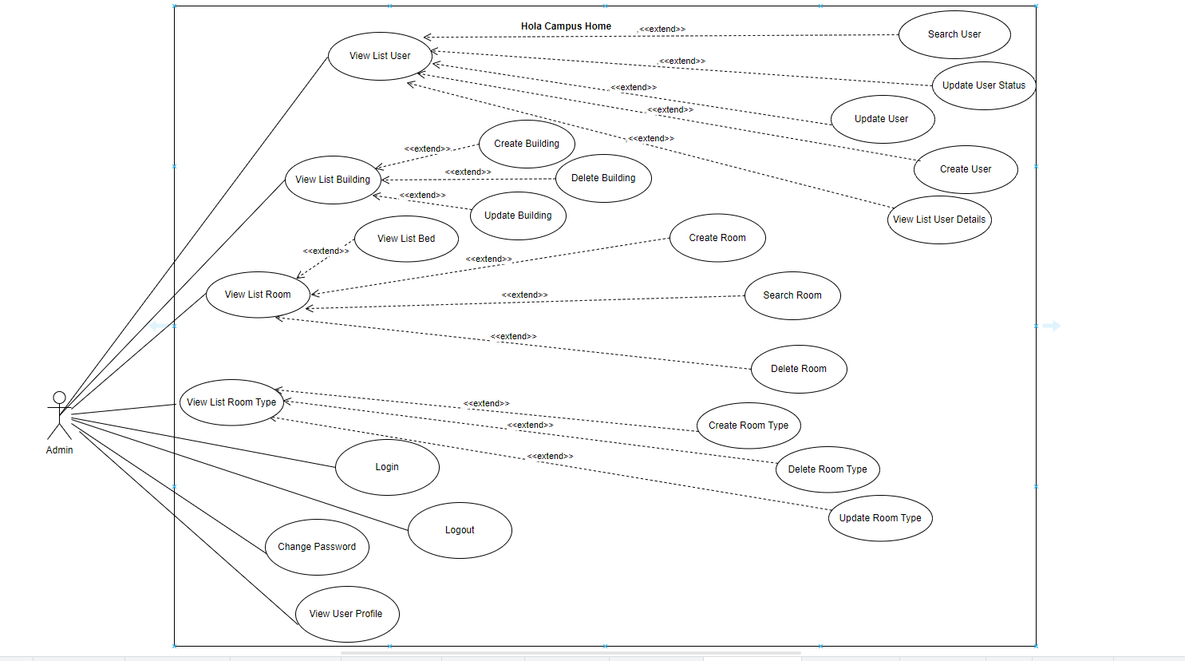

#### 

##### Use case diagram for Dorm Manager

#### 

#### b.Descriptions

| **#** | **Use case** | **Feature** | **Primary Actor** | **Use case description** |
| --- | --- | --- | --- | --- |
| 1 | View Landing Page | Public | Guest | Displays a dashboard with general information for guests. |
| 2 | View Help/FAQ | Public | Guest | Provides access to a Help/FAQ section for common inquiries. |
| 3 | View Contact Info | Public | Guest | Displays contact information for inquiries. |
| 4 | Change Password | Common | Admin, Dorm Manager, Student | Allows the user change their password |
| 5 | Forget Password | Common | Admin, Dorm Manager, Student | Allows user retrieve their password |
| 6 | Login | Common | Admin, Dorm Manager, Student | Allows the user to login in the system by username and password |
| 7 | Logout | Common | Admin, Dorm Manager, Student | Allows user can initiate the sign-out process to securely log out, terminating their current session |
| 8 | View Profile | Common | Dorm Manager, Student | Allows the user to view their profile information and avatar. |
| 9 | View News | Common | Dorm Manager, Student | Allow user can view news in the system |
| 10 | View Request Application | Application Management | Dorm Manager | Allows dorm manager view request application |
| 11 | Update status request application | Application Management | Dorm Manager | Allows dorm manager update request request application |
| 12 | Delete News | News Management | Dorm Manager | Allows dorm manager delete news in the system |
| 13 | Create News | News Management | Dorm Manager | Allows dorm manager create news in the system |
| 14 | View List Bed | Room Management | Dorm Manager | Allows dorm manager view list bed in the system |
| 15 | View List Room | Room Management | Dorm Manager | Allows dorm manager view list room in the system |
| 16 | View information of Bed | Room Management | Dorm Manager | Allows dorm manager view bed information in the room |
| 17 | View Bed Request | Room Management | Dorm Manager | Allows dorm manager view all bed requests |
| 18 | Update Bed Reservation | Room Management | Dorm Manager | Allows dorm manager update bed reservation |
| 19 | View List Student Information | Student Information Management | Dorm Manager | Allows dorm manager can view list student information in the system |
|  | Search Student by Rollnumber | Student Information Management | Dorm Manager | Allows dorm manager can search student by rollnumber |
| 21 | View Payment of Student | Student Information Management | Dorm Manager | Allows dorm manager can view list payment of that individual student in the system |
| 22 | View Request of Student | Student Information Management | Dorm Manager | Allows dorm manager can view list request of that individual student in the system |
| 23 | View Student Information Details | Student Information Management | Dorm Manager | Allows dorm manager can view student information details in the system |
| 24 | View Payment | Payment | Dorm Manager | Allows dorm manager can view list payment in the system |
| 25 | Search payment by rollnumber | Payment | Dorm Manager | Allows dorm manager can search payment by rollnumber |
| 26 | View List Building | Building Management | Admin | Allows admin view list building in the system |
| 27 | Delete Building | Building Management | Admin | Allows admin delete building in the system |
| 28 | Update Building | Building Management | Admin | Allows admin update building in the system |
| 29 | Create Building | Building Management | Admin | Allows admin create building in the system |
| 30 | View List Bed | Room Management | Admin | Allows admin view list bed in the system |
| 31 | Delete Room | Room Management | Admin | Allows admin delete room in the system |
| 32 | View List Room | Room Management | Admin | Allows admin view list room in the system |
| 33 | Create Room | Room Management | Admin | Allows admin create room in the system |
| 34 | Search Room | Room Management | Admin | Allows admin search room in the system |
| 35 | Delete Room Type | Room Type Management | Admin | Allows admin delete room type in the system |
| 36 | View Room Type | Room Type Management | Admin | Allows admin view list room type in the system |
| 37 | Create Room Type | Room Type Management | Admin | Allows admin create room type in the system |
| 38 | Update Room Type | Room Type Management | Admin | Allows admin update room type in the system |
| 39 | Update User | User Management | Admin | Allows admin update user in the system |
| 40 | Create User | User Management | Admin | Allows admin create user in the system |
| 41 | View List User | User Management | Admin | Allows admin view list user in the system |
| 42 | Update User Status | User Management | Admin | Allows admin delete user in the system |
| 43 | View List Beds | Bed Booking | Student | Allows students can view list beds in the system |
| 44 | Book Bed | Bed Booking | Student | Allows students can book bed in the system |
| 45 | View List Room | Bed Booking | Student | Allows students can view list room in the system |
| 46 | View Bed Booked History | Bed Booking | Student | Allows student can view bed booked history in the system |
| 47 | View bed details | Bed Booking | Student | Allows student can view bed details in the system |
| 48 | View Payment | Payment History | Student | Allows students can view list payment history in the system |
| 49 | View Request Application History | Request Application Management | Student | Allow student can view request application history |
| 50 | Send Request Application | Request Application Management | Student | Allows students to choose request type, send request details and track their status. |

## **2. Overall Functionalities**

### **2.1. Screens Flow**

#### **Screens Flow for Guest:**

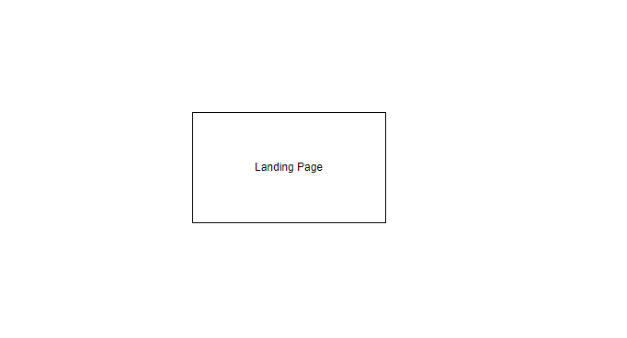

#### **Screens Flow for Student:**

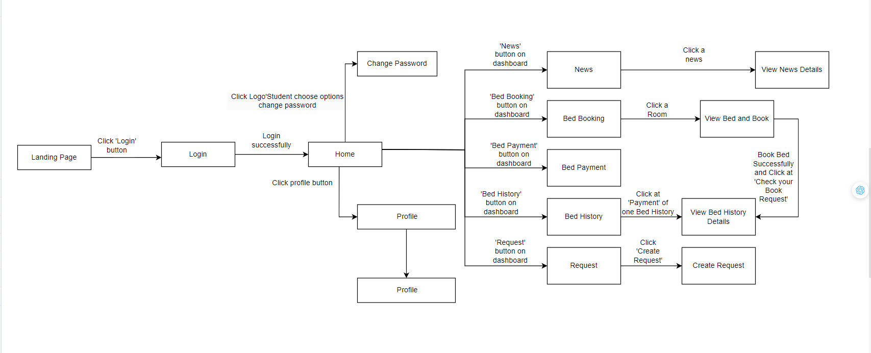

#### **Screens Flow for Dorm Manager:**

#### 

#### 

#### 

#### 

#### 

#### 

#### 

#### **Screens Flow for Admin:**

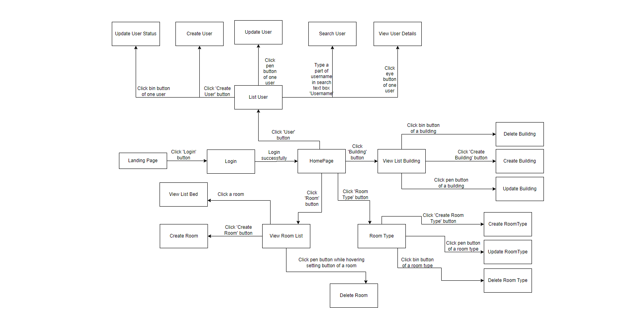

### **2.2. Screens Descriptions**

| **#** | **Feature** | **Screen** | **Description** |
| --- | --- | --- | --- |
| 1 | Login | Login | Allows users to login to their existing accounts using their credentials. |
| 2 | Sign up | Sign up | Enables new users to create an account by providing necessary information and registering. |
| 3 | Forget Password | Forget Password | Allow users to retrieve their passwords. |
| 4 | View Homepage | Homepage | Serves as the main landing page for the Hola Campus Home, providing an overview and navigation to different sections. |
| 5 | View Help/FAQ | Homepage | Provides access to a Help/FAQ section for common inquiries. |
| 6 | View Contact Info | Homepage | Displays contact information for inquiries. |
| 7 | View Application Introduction | Homepage | Display introduction about the application |
| 8 | View Home | Student’s home | Users can view lists of News and Personal Information and navigate to other pages |
| 9 | View news | Student’s news | Allow users can view lists of news in the system |
| 10 | Search news | Student's news | Allow users can search news by title |
| 11 | View list room | Student’s Bed Booking | Allow users can view all room in the system |
| 12 | View list bed | Student’s Bed Booking | Allow users can view all bed in the system |
| 13 | View bed details | Student’s Bed Booking | Allow users can view all bed details in the system |
| 14 | Booking bed | Student’s Bed Booking | Allow users can book available rooms in the system |
| 15 | View Payment Bill | Student’s Bed Payment | The system will display a list of bills that have been paid by the user. |
| 16 | View Booked History | Student’s Booked History | Allow users can view the history of beds they have booked |
| 17 | View Payment | Student’s Booked History | Allow users can view information of payment |
| 18 | View Bed Details | Student’s Booked History | Allow users can view bed details |
| 19 | View Request | Student’s Request | Allows users can view all request |
| 20 | Create Request | Student’s Request | Allows users can create request |
| 21 | View news | Dorm Manager’s News | Allow users can view lists of news in the system |
| 22 | View list room | Dorm Manager’Room | Allow users can view all room in the system and users can view list room by filter |
| 23 | View list bed | Dorm Manager’Room | Allow users can view all bed in the system |
| 24 | View list student | Dorm Manager’Student | Allow users can view all student in the system and users can view list student by filter |
| 25 | Search by rollnumber | Dorm Manager’Student | Allow users can search all student in the system by rollnumber |
| 26 | View Bed Request | Dorm Manager’Bed Request | Allow users can view all bed request in the system |
| 27 | Search by rollnumber | Dorm Manager’Bed Request | Allow users can search all student in the system by rollnumber |
| 28 | View payment | Dorm Manager’Payment | Allow users can view list payment in the system |
| 29 | Search by rollnumber | Dorm Manager’Payment | Allow users can search all students in the system by rollnumber. |
| 30 | View list user | Admin’User | Allow users can view list account in the system and users can view account by filter |
| 31 | Create user | Admin’User | Allows users create a new account in the system |
| 32 | Update user | Admin’User | Allows users update account in the system |
| 33 | Update status user | Admin’User | Allows users delete account in the system |
| 34 | View list building | Admin’Building | Allows users can view list building in the system |
| 35 | Create building | Admin’Building | Allows users can create a new building in the system. |
| 36 | Update building | Admin’Building | Allows users can update building in the system. |
| 37 | Delete building | Admin’Building | Allows users can delete building in the system.. |
| 38 | View list room type | Admin’s Room Type | Allows users can view list room type in the system |
| 39 | Create room type | Admin’s Room Type | Allows users can create room type in the system |
| 40 | Update room type | Admin’s Room Type | Allows users can update room type in the system |
| 41 | Delete room type | Admin’s Room Type | Allows users can delete room type in the system |
| 42 | View list room | Admin’Room | Allows users can view list room in the system |
| 43 | Create room | Admin’Room | Allows users can create room in the system |
| 44 | Delete room | Admin’Room | Allows users can delete room in the system |
| 45 | View list bed | Admin’Room | Allows users can view list bed in the system |
|  |  |  |  |

### **2.3. Screens Authorization**

| **Screen** | **Guest** | **Student** | **Dorm Manager** | **Admin** |
| --- | --- | --- | --- | --- |
| Student Login |  | X |  |  |
| Login |  | X |  |  |
| Dorm Manager Login |  |  | X |  |
| Login |  |  | X |  |
| Admin Login |  |  |  | X |
| Login |  |  |  | X |
| Guest Sign up | X |  |  |  |
| Sign up | X |  |  |  |
| Student Sign up |  | X |  |  |
| Sign up |  | X |  |  |
| Dorm Manager Sign up |  |  | X |  |
| Sign up |  |  | X |  |
| Admin Sign up |  |  |  | X |
| Sign up |  |  |  | X |
| Forget Password |  | X | X | X |
| Change Password |  | X | X | X |
| Home Page | X | X | X | X |
| View home page | X | X | X | X |
| View Help/FAQ | X | X | X | X |
| View Contact Info | X | X | X | X |
| View Application Introduction | X | X | X | X |
| Student’s home |  | X |  |  |
| View Home |  | X |  |  |
| Student's news |  | X |  |  |
| View news |  | X |  |  |
| Search news |  | X |  |  |
| Student’s Bed Booking |  | X |  |  |
| View list room |  | X |  |  |
| View list bed |  | X |  |  |
| Booking bed |  | X |  |  |
| View Bed Details |  | X |  |  |
| Student’s Bed Payment |  | X |  |  |
| View Payment Bill |  | X |  |  |
| Student’s Booked History |  | X |  |  |
| View Booked History |  | X |  |  |
| View Payment |  | X |  |  |
| Student’Request |  | X |  |  |
| View Request |  | X |  |  |
| Create Request |  | X |  |  |
| Dorm Manager’s News |  |  | X |  |
| View news |  |  | X |  |
| Dorm Manager’Room |  |  | X |  |
| View list room |  |  | X |  |
| View list bed |  |  | X |  |
| Dorm Manager’Student |  |  | X |  |
| View list student |  |  | X |  |
| Search by rollnumber |  |  | X |  |
| Dorm Manager’Bed Request |  |  | X |  |
| View Bed Request |  |  | X |  |
| Search by rollnumber |  |  | X |  |
| Dorm Manager’Payment |  |  | X |  |
| View payment |  |  | X |  |
| Search by rollnumber |  |  | X |  |
| Admin’User |  |  |  | X |
| View list user |  |  |  | X |
| Create user |  |  |  | X |
| Update user |  |  |  | X |
| Update status user |  |  |  | X |
| Admin’Building |  |  |  | X |
| View list building |  |  |  | X |
| Create building |  |  |  | X |
| Delete building |  |  |  | X |
| Update building |  |  |  | X |
| Admin’s Room Type |  |  |  | X |
| View list room type |  |  |  | X |
| Create room type |  |  |  | X |
| Update room type |  |  |  | X |
| Delete room type |  |  |  | X |
| Admin’Room |  |  |  | X |
| View list room |  |  |  | X |
| Delete room |  |  |  | X |
| Create room |  |  |  | X |
| View list bed |  |  |  | X |

### **2.4. Non-UI Functions**

| **#** | **Feature** | **System Function** | **Description** |
| --- | --- | --- | --- |
| 1 | User Authorization | Authentication & Authorization | Handles the process of verifying the identity of users and granting appropriate access privileges to different areas or functionalities within the system. |
| 2 | Mail Verification | Mail Sending | Facilitates the sending of emails or electronic messages from the system to intended recipients, often used for notifications, confirmations, or alerts. |

## **3. System High Level Design**

### **3.1. Database Design**

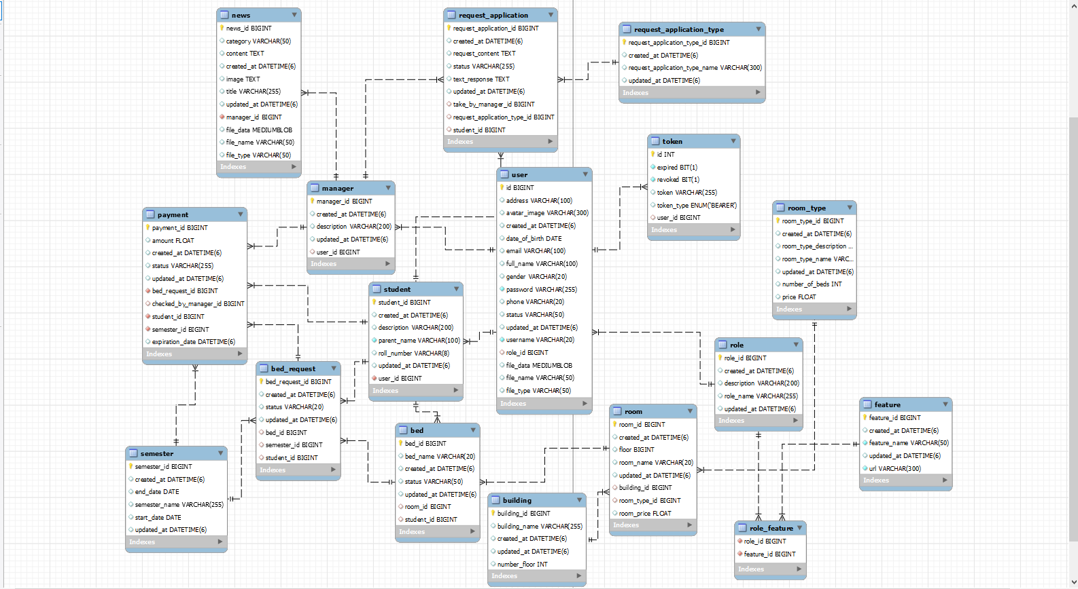

### **3.2. Code Packages**

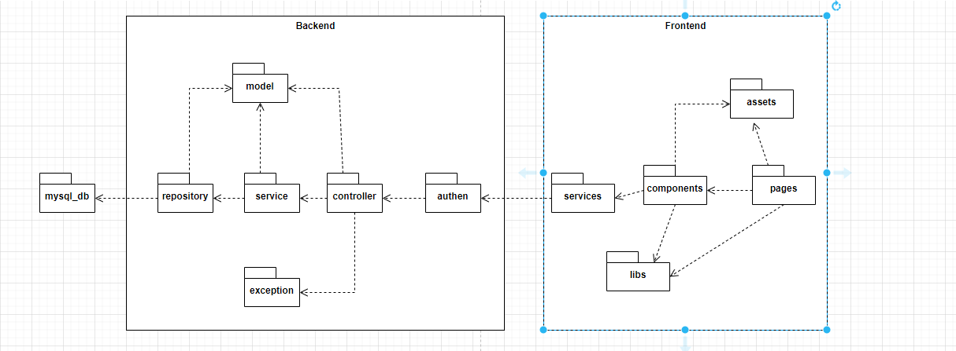

***Package descriptions***

| **No** | **Package** | **Description** |
| --- | --- | --- |
| 01 | mysql-db | MySQL Database, containing data for the whole application |
| 02 | repository | Interact with and get data from database |
| 03 | service | Get the data from repository and handle logic process |
| 04 | controller | Get the result from service and push data through http methods |
| 05 | model | Declare and define kinds of data |
| 06 | exception | Custom exception for controller to know exactly what problem happening, helping developing and maintaining |
| 07 | authen | Security filter check if the Request from Frontend is permittable |
| 08 | services | Get api data from backend by sending url and token |
| 09 | components | Comprise reusable UI elements in the application, which can be utilized across different pages |
| 10 | pages | Represent the individual views or screens within the application. |
| 11 | libs | Store advance styled for components and pages |
| 12 | assets | Store picture and image for components and pages |

# **II. Requirement Specification**

## **1.Public Functions**

### 

#### 

### 1.1 UC-002 View Landing Page

#### a.Functional Description

#### 

| **UC ID and Name:** | UC-002 View Landing Page | | |
| --- | --- | --- | --- |
| **Created By:** | LongVH | **Date Created:** | 1/Oct/2023 |
| **Primary Actor:** | Guest | **Secondary Actors:** | None |
| **Trigger:** | The user wants to access the system's homepage to view information related to the dormitory | | |
| **Description:** | When a guest user wants to view the system's homepage, they simply need to access the correct link of the system, and they can see everything that is available on the system | | |
| **Preconditions:** | Access true link | | |
| **Postconditions:** | User can see homepage in the system | | |
| **Normal Flow:** | 1. User access the true link  2. The system display the homepage | | |
| **Alternative Flows:** | N/A | | |
| **Exceptions:** | 1. User access incorrect link | | |
| **Priority:** | High | | |
| **Frequency of Use:** | Everyday | | |
| **Business Rules:** | N/A | | |
| **Other Information:** | N/A | | |
| **Assumptions:** | N/A | | |

#### b. Business Rules

N/A

### 1.2 UC-003 View Help/FAQ

#### a.Functional Description

#### 

| **UC ID and Name:** | UC-003 View Help/FAQ | | |
| --- | --- | --- | --- |
| **Created By:** | LongVH | **Date Created:** | 1/Oct/2023 |
| **Primary Actor:** | Guest | **Secondary Actors:** | None |
| **Trigger:** | When the user wants to access the homepage and view the Help/FAQ section to learn about common issues while staying in the dormitory. | | |
| **Description:** | When accessing the correct system link, the homepage will be displayed, and then the user can select the 'Help/FAQ' option to view all the information related to ‘Help/FAQ’ | | |
| **Preconditions:** | Access successful the system | | |
| **Postconditions:** | User can see Help/FAQ in the system | | |
| **Normal Flow:** | 1. User access the true link  2. The system display the homepage  2. User choose option Help/FAQ  3. System list all standard choice for Help/FAQ | | |
| **Alternative Flows:** | N/A | | |
| **Exceptions:** | 1. User access incorrect link  2. User loses database connection | | |
| **Priority:** | High | | |
| **Frequency of Use:** | Everyday | | |
| **Business Rules:** | N/A | | |
| **Other Information:** | This section will be updated regularly based on the issues and questions frequently asked by system users | | |
| **Assumptions:** | N/A | | |

#### 

#### b. Business Rules

N/A

### 1.3 UC-004 View Contact Info

#### a.Functional Description

#### 

| **UC ID and Name:** | UC-004 View Contact Info | | |
| --- | --- | --- | --- |
| **Created By:** | LongVH | **Date Created:** | 1/Oct/2023 |
| **Primary Actor:** | Guest | **Secondary Actors:** | None |
| **Trigger:** | When the user wants to access the homepage and view the Contact Info section to learn about common issues while staying in the dormitory. | | |
| **Description:** | When accessing the correct system link, the homepage will be displayed, and then the user can select the 'Contact Info' option to view all the information related to ‘Contact Info’ | | |
| **Preconditions:** | Access successful the system | | |
| **Postconditions:** | User can see contact info in the system | | |
| **Normal Flow:** | 1. User access the true link  2. The system display the homepage  3. The user scrolls down to the bottom of the page  4. System list all standard choice for Contact Info | | |
| **Alternative Flows:** | N/A | | |
| **Exceptions:** | 1. User access incorrect link  2. System loses database connection and system can’t load data | | |
| **Priority:** | High | | |
| **Frequency of Use:** | When in need of contact information | | |
| **Business Rules:** | N/A | | |
| **Other Information:** | N/A | | |
| **Assumptions:** | N/A | | |

#### b. Business Rules

N/A

## **2.Common Functions**

### 2.1 UC-005 Login

#### a.Functional Description

#### 

| **UC ID and Name:** | UC-005 Login | | |
| --- | --- | --- | --- |
| **Created By:** | LongVH | **Date Created:** | 1/Oct/2023 |
| **Primary Actor:** | All User | **Secondary Actors:** | None |
| **Trigger:** | Users want to log in to the system to experience other functions, so they need to click on the orange Login button in the corner of the screen | | |
| **Description:** | Users can log into the system to experience various functions by clicking the orange Login button on the top right of the screen | | |
| **Preconditions:** | 1. Access successful the system 2. Users have a account | | |
| **Postconditions:** | User can login successful in the system | | |
| **Normal Flow:** | 1. User click the orange button “Login”  2. The system display the login screen  3. User fill in username and password and click button “Login”(EX1)  4. The system redirect home screen | | |
| **Alternative Flows:** | N/A | | |
| **Exceptions:** | 1. User access incorrect link  2. User loses database connection  EX1.User input invalid username and password  1.User enter incorrect format and data username or password  2.The system display warning message | | |
| **Priority:** | High | | |
| **Frequency of Use:** | FR1 | | |
| **Business Rules:** | N/A | | |
| **Other Information:** | N/A | | |
| **Assumptions:** | N/A | | |

#### b. Business Rules

#### 

| **ID** | **Business Rule** | **Business Rule Description** |
| --- | --- | --- |
| FR1 | FPTU Account | All students registering or logging in must be FPT University students |

#### 

### 2.2 UC-006 Logout

#### a.Functional Description

#### 

| **UC ID and Name:** | UC-006 Logout | | |
| --- | --- | --- | --- |
| **Created By:** | LongVH | **Date Created:** | 1/Oct/2023 |
| **Primary Actor:** | Student, Admin, Dorm Manager | **Secondary Actors:** | None |
| **Trigger:** | Users want to log out of the system to return to the initial homepage | | |
| **Description:** | Users can log out of the system to return to the homepage | | |
| **Preconditions:** | User login successful in the system | | |
| **Postconditions:** | User logout successful | | |
| **Normal Flow:** | 1. User click the orange button “LOGOUT”  2.The system returns to the initial homepage screen | | |
| **Alternative Flows:** | N/A | | |
| **Exceptions:** | 1. User access incorrect link  2. User loses database connection | | |
| **Priority:** | High | | |
| **Frequency of Use:** | FR1 | | |
| **Business Rules:** | N/A | | |
| **Other Information:** | N/A | | |
| **Assumptions:** | N/A | | |

#### b. Business Rules

#### 

| **ID** | **Business Rule** | **Business Rule Description** |
| --- | --- | --- |
| FR1 | FPTU Account | All students registering or logging in must be FPT University students |

### 2.3 UC-007 View Profile

#### a.Functional Description

#### 

| **UC ID and Name:** | UC-007 View Profile | | |
| --- | --- | --- | --- |
| **Created By:** | LongVH | **Date Created:** | 1/Oct/2023 |
| **Primary Actor:** | Student, Admin, Dorm Manager | **Secondary Actors:** | None |
| **Trigger:** | Users want to view their own profile | | |
| **Description:** | User can view their own profile | | |
| **Preconditions:** | User login successful in the system | | |
| **Postconditions:** | User view their profile | | |
| **Normal Flow:** | 1. User click the avatar  2.The system provides options  3.User choose “Profile”  4.The system display user’s profile(Include FullName, DOB, Gender, Bed, Email) | | |
| **Alternative Flows:** | N/A | | |
| **Exceptions:** | 1. User access incorrect link  2. User loses database connection | | |
| **Priority:** | High | | |
| **Frequency of Use:** | FR1 | | |
| **Business Rules:** | N/A | | |
| **Other Information:** | N/A | | |
| **Assumptions:** | N/A | | |

#### b. Business Rules

#### 

| ID | Business Rule | Business Rule Description |
| --- | --- | --- |
| FR1 | FPTU Account | All students registering or logging in must be FPT University students |

### 2.4 UC-008 Forget Password

#### a.Functional Description

#### 

| **UC ID and Name:** | UC-008 Forget Password | | |
| --- | --- | --- | --- |
| **Created By:** | LoiNQ | **Date Created:** | 1/Oct/2023 |
| **Primary Actor:** | Student, Admin, Dorm Manager | **Secondary Actors:** | None |
| **Trigger:** | The user has forgotten their password and wants to recover it | | |
| **Description:** | Users can be issued a new password to regain access to the system | | |
| **Preconditions:** | Access true link  Click button “Login” | | |
| **Postconditions:** | User forget password in the system | | |
| **Normal Flow:** | 1. User click the hyperlink(“Forget Password”)  2.The system display forget password screen  3.User enter the username and email and click “Send new a password”(EX1)  4.The system send new password to user’s email | | |
| **Alternative Flows:** | N/A | | |
| **Exceptions:** | 1. User access incorrect link  2. User loses database connection  EX1.User input invalid username and email  1.User enter incorrect format and data username or email  2.The system display warning message | | |
| **Priority:** | High | | |
| **Frequency of Use:** | FR1 | | |
| **Business Rules:** | N/A | | |
| **Other Information:** | N/A | | |
| **Assumptions:** | N/A | | |

#### b. Business Rules

#### 

| **ID** | **Business Rule** | **Business Rule Description** |
| --- | --- | --- |
| FR1 | FPTU Account | All students registering or logging in must be FPT University students |

### 2.5 UC-009 Change Password

#### a.Functional Description

#### 

| **UC ID and Name:** | UC-009 Change Password | | |
| --- | --- | --- | --- |
| **Created By:** | LoiNQ | **Date Created:** | 1/Oct/2023 |
| **Primary Actor:** | Student, Admin, Dorm Manager | **Secondary Actors:** | None |
| **Trigger:** | Users want to change password | | |
| **Description:** | User can change password | | |
| **Preconditions:** | User login successfully | | |
| **Postconditions:** | User change password successfully | | |
| **Normal Flow:** | 1. User click the avatar  2.The system provides options  3.User choose “Change Password”  4.The system display change password screen(AF1)  5. User enter “Old password”, “New Password”, “Confirm New Password” and click button “Change Password”(EX1)  6. The system display notification successfully | | |
| **Alternative Flows:** | AF1;User don’t enter the fields   1. User click “Back to dashboard” 2. The system returns the dashboard screen | | |
| **Exceptions:** | 1. User access incorrect link  2. User loses database connection  EX1.User input invalid old password, new password, confirm new password  1.User enter incorrect format and data old password, new password, confirm new password  2.The system display warning message | | |
| **Priority:** | High | | |
| **Frequency of Use:** | FR1 | | |
| **Business Rules:** | FR1 | | |
| **Other Information:** | N/A | | |
| **Assumptions:** | N/A | | |

#### b. Business Rules

#### 

| **ID** | **Business Rule** | **Business Rule Description** |
| --- | --- | --- |
| FR1 | FPTU Account | All students registering or logging in must be FPT University students |

### 2.6 UC-010 View news

#### a.Functional Description

| **UC ID and Name:** | UC-010 View news | | |
| --- | --- | --- | --- |
| **Created By:** | LongVH | **Date Created:** | 24/Oct/2023 |
| **Primary Actor:** | Dorm Manager, Admin | **Secondary Actors:** | None |
| **Trigger:** | User wants to see list of news through the system | | |
| **Description:** | User, in the role of a manager, wants to see a list of news. When using this function, the user can see a list of news and take further actions about news | | |
| **Preconditions:** | User have a account | | |
| **Postconditions:** | User can see list of news | | |
| **Normal Flow:** | 1. User login successfully  2. The system displays the 8 latest news on the dashboard screen(AF1) | | |
| **Alternative Flows:** | AF1:User click sidebar navigation link “News”  The system display the 8 latest news | | |
| **Exceptions:** | 1. The user loses database connection | | |
| **Priority:** | Low | | |
| **Frequency of Use:** | Every week | | |
| **Business Rules:** | N/A | | |
| **Other Information:** | N/A | | |
| **Assumptions:** | N/A | | |

#### b. Business Rules

N/A

## **3.Dorm Manager Functions**

### 3.1 UC-151 Create news

#### a. Functional Description

| **UC ID and Name:** | UC-151 Create news | | |
| --- | --- | --- | --- |
| **Created By:** | TuanVM | Date Created: | 24/Oct/2023 |
| **Primary Actor:** | Dorm Manager | Secondary Actors: | None |
| **Trigger:** | User wants to create news through the system | | |
| **Description:** | User, in the role of a manager, wants to create news. When using this function, User can notify the news to all other managers, guards and students. | | |
| **Preconditions:** | Manager has already been in ‘View news’ screen | | |
| **Postconditions:** | · User can create news  · System saves the news to the database | | |
| **Normal Flow:** | 1. User clicks the ‘+’ button.  2. The system will display the ‘Create news’ screen  3. User fills in the title and description, and uploads the .pdf file as desired. (See E3.1, E3.2)  4. The system displays Alert ‘Do you want to create this news?’  5. User clicks ‘Yes’ button (See E5.1)  6. System saves the change to the database and displays Notification ‘Create news successfully!’ | | |
| **Alternative Flows:** | N/A | | |
| **Exceptions:** | 1. The user loses internet connection  E3.1 User fills invalid file  3. User uploads invalid file  4. The system displays Notification ‘Invalid file’, and then return to step 2 in Normal Flow  E3.2 User doesn’t fill the title of the News  3. User doesn't fill the title of the News  4. The system displays Notification ‘Title can’t be blank’, and then return to step 2 in Normal Flow  E5.1 User clicks ‘No’ button, system returns step 2 in Normal Flow | | |
| **Priority:** | Low | | |
| **Frequency of Use:** | Twice or three times per week | | |
| **Business Rules:** | N/A | | |
| **Other Information:** | N/A | | |
| **Assumptions:** | N/A | | |

#### b. Business Rules

#### 

### 3.2 UC-153 Delete news

#### a. Functional Description

| **UC ID and Name:** | UC-153 Delete news | | |
| --- | --- | --- | --- |
| **Created By:** | TuanVM | Date Created: | 24/Oct/2023 |
| **Primary Actor:** | Dorm Manager | Secondary Actors: | None |
| **Trigger:** | User wants to delete news through the system | | |
| **Description:** | User, in the role of a manager, wants to create news. When using this function, User can delete the news, making it no longer exist. | | |
| **Preconditions:** | · Manager has already been in ‘List news’ screen | | |
| **Postconditions:** | · System delete the news from the database | | |
| **Normal Flow:** | 1. User click ‘-’ button of the desired news  2. The system displays Alert ‘Do you want to delete this news?’  3. User clicks ‘Yes’ button (See E3.1)  4. System saves the change to the database and displays Notification ‘Delete news successfully!’ | | |
| **Alternative Flows:** | N/A | | |
| **Exceptions:** | 1. The user loses internet connection  E3.1 User clicks ‘No’ button, system returns before steps 1 in Normal Flow | | |
| **Priority:** | Low | | |
| **Frequency of Use:** | Rarely | | |
| **Business Rules:** | N/A | | |
| **Other Information:** | N/A | | |
| **Assumptions:** | N/A | | |

#### b. Business Rules

### 3.3 UC-154 View request application

#### a.Functional Description

| **UC ID and Name:** | UC-154 View request application | | |
| --- | --- | --- | --- |
| **Created By:** | HaiKN | Date Created: | 24/Oct/2023 |
| **Primary Actor:** | Dorm Manager | Secondary Actors: | None |
| **Trigger:** | User wants to see list of request application through the system | | |
| **Description:** | User, in the role of a manager, wants to see a list of request applications. When using this function, the user can see a list of request application and take further actions about request application | | |
| **Preconditions:** | Manager logins successfully in the system | | |
| **Postconditions:** | User can see list of request application | | |
| **Normal Flow:** | 1. User click ‘Request’ at sidebar navigation 2. The system will display a list of the 8 request applications sorted by oldest in page 1 (default is 8 request applications per page). A request application has 8 fields: Id, Created By, Request Type, Created Date, Application Content, Response Content, Status, Action. 3. User clicks greater-than sign (>) (AF1) 4. System displays next newer 8 request application 5. User clicks less-than sign (<) (AF2) 6. System displays next older 8 request application | | |
| **Alternative Flows:** | AF1. User click number not “>”   1. User clicks the number of page below to see newer request application 2. System return to step 2 in Normal Flow   AF2.User click number not “<”   1. User clicks the number of page below to see older request application 2. System return to step 2 in Normal Flow | | |
| **Exceptions:** | 1. The user loses internet connection  2. User cannot connect to server | | |
| **Priority:** | High | | |
| **Frequency of Use:** | Every day | | |
| **Business Rules:** | N/A | | |
| **Other Information:** | User can filter Request Application by Type and Status | | |
| **Assumptions:** | N/A | | |

#### b. Business Rules

| ID | Business Rule | Business Rule Description |
| --- | --- | --- |
| FR4 | Response Time | The application processing department will respond to students' applications/emails within 48 hours |
| FR5 | Limit spam applications | To limit SPAM, the time to respond to SPAM applications/emails will be extended according to the principle: When students send N applications/emails (N>1) for the same request, the response time will be within Nx48 hours. |

#### 

### 3.4 UC-155 Reply request application

#### a. Functional Description

| **UC ID and Name:** | UC-155 Reply request application | | |
| --- | --- | --- | --- |
| **Created By:** | TuanVM | Date Created: | 24/Oct/2023 |
| **Primary Actor:** | Dorm Manager | Secondary Actors: | None |
| **Trigger:** | User wants to reply request application through the system | | |
| **Description:** | User, in the role of a manager, wants to reply to the request application. When using this function, user can notify the request application to all other managers and students | | |
| **Preconditions:** | Manager has already been in ‘View request application’ screen | | |
| **Postconditions:** | User reply request application successfully | | |
| **Normal Flow:** | 1. User click button reply at Action column in a row of a request application. (AF1) 2. Fill in text response and choose an updated status for application then click button ‘Send’ (E1) 3. System notifies reply application successfully | | |
| **Alternative Flows:** | AF1. Status of selected application was DENIED or RESOLVED, system will notify that can not reply that at the right bottom of the screen | | |
| **Exceptions:** | 1. The user loses internet connection  E1. User do not type anything in text response or not choose any updated status then click button ‘Send’, system display error that need to fulfill all before sending replication | | |
| **Priority:** | High | | |
| **Frequency of Use:** | Every day | | |
| **Business Rules:** | N/A | | |
| **Other Information:** | N/A | | |
| **Assumptions:** | N/A | | |

#### b. Business Rule

### 3.5 UC-156 View Payment

#### a. Functional Description

| **UC ID and Name:** | UC-156 View payment | | |
| --- | --- | --- | --- |
| **Created By:** | TuanVM | Date Created: | 24/Oct/2023 |
| **Primary Actor:** | Dorm Manager | Secondary Actors: | None |
| **Trigger:** | User wants to see all payment through the system | | |
| **Description:** | User, in the role of a manager, wants to see a list of payments. When using this function, the user can see a list of payments and take further actions about payments | | |
| **Preconditions:** | Manager logins successfully in the system | | |
| **Postconditions:** | User can see list of payments | | |
| **Normal Flow:** | 1. User click ‘Request’ at sidebar navigation 2. The system will display a list of the 8 payments on page 1 (default is 8 payments per page). A payment has 7 fields: Id, Created By, Checked by, Amount, Created Date, Update Date, Status 3. User clicks greater-than sign (>) (AF1) 4. System displays next newer 8 payments 5. User clicks less-than sign (<) (AF2) 6. System displays next older 8 payments | | |
| **Alternative Flows:** | AF1. User clicks the number of page below to see newer payments, system return to step 2 in Normal Flow  AF2. User clicks the number of page below to see older payments, system return to step 2 in Normal Flow | | |
| **Exceptions:** | 1. The user loses internet connection  2. User cannot connect to server | | |
| **Priority:** | High | | |
| **Frequency of Use:** | Every day | | |
| **Business Rules:** | N/A | | |
| **Other Information:** | User can search payment by student roll number | | |
| **Assumptions:** | N/A | | |

#### b. Business Rule

### 3.6 UC-157 View list students information

#### a. Functional Description

| **UC ID and Name:** | UC-157 View list student information | | |
| --- | --- | --- | --- |
| **Created By:** | HaiKN | Date Created: | 24/Oct/2023 |
| **Primary Actor:** | Dorm Manager | Secondary Actors: | None |
| **Trigger:** | User wants to see all students through the system | | |
| **Description:** | User, in the role of a manager, wants to see a list of students. When using this function, the user can see a list of students and take further actions about students | | |
| **Preconditions:** | Manager logins successfully in the system | | |
| **Postconditions:** | User can see list of students | | |
| **Normal Flow:** | 1. User click ‘Student’ at sidebar navigation 2. The system will display a list of the 8 students on page 1 (default is 8 students per page). A student has 9 fields: Id, Student Roll Number, Name, Room, Bed, Dormitory, Room Type, Email, View details 3. User clicks greater-than sign (>) (AF1) 4. System displays next 8 students 5. User clicks less-than sign (<) (AF2) 6. System displays next 8 students | | |
| **Alternative Flows:** | AF1. User clicks the number of page below to see next 8 students, system return to step 2 in Normal Flow  AF2. User clicks the number of page below to see next 8 students, system return to step 2 in Normal Flow | | |
| **Exceptions:** | 1. The user loses internet connection  2. User cannot connect to server | | |
| **Priority:** | High | | |
| **Frequency of Use:** | Every day | | |
| **Business Rules:** | N/A | | |
| **Other Information:** | User can search payment by student roll number  User can filter student by building, floor, room | | |
| **Assumptions:** | N/A | | |

#### b. Business Rule

### 3.7 UC-158 View student information details

#### a. Functional Description

| **UC ID and Name:** | UC-158 View student information details | | |
| --- | --- | --- | --- |
| **Created By:** | ThaoTTP | Date Created: | 24/Oct/2023 |
| **Primary Actor:** | Dorm Manager | Secondary Actors: | None |
| **Trigger:** | User wants to view students information details | | |
| **Description:** | User, in the role of a manager, wants to view all information in one student. When using this function, user can see details of a student and take further actions about student | | |
| **Preconditions:** | Manager has already been in ‘View list student information’ screen | | |
| **Postconditions:** | User can view information details of a student | | |
| **Normal Flow:** | 1. User clicks button icon ‘eye’ on View details column of the student 2. System display a student information card | | |
| **Alternative Flows:** | N/A | | |
| **Exceptions:** | 1. The user loses internet connection  2. User cannot connect to server | | |
| **Priority:** | Low | | |
| **Frequency of Use:** | Every week | | |
| **Business Rules:** | N/A | | |
| **Other Information:** | N/A | | |
| **Assumptions:** | N/A | | |

#### b. Business Rule

### 3.8 UC-159 View Payment of Student

#### a. Functional Description

| **UC ID and Name:** | UC-159 View Payments of Students | | |
| --- | --- | --- | --- |
| **Created By:** | HaiKN | Date Created: | 24/Oct/2023 |
| **Primary Actor:** | Dorm Manager | Secondary Actors: | None |
| **Trigger:** | User wants to view students payment details | | |
| **Description:** | User, in the role of a manager, wants to view all payments of one student. When using this function, user can see details of a student and take further actions about student payment | | |
| **Preconditions:** | Manager has already been in ‘View list student information details’ screen | | |
| **Postconditions:** | User can view payment of a student | | |
| **Normal Flow:** | 1. User clicks button ‘View payment’ on the right of the student information details card 2. System display list payment of student | | |
| **Alternative Flows:** | N/A | | |
| **Exceptions:** | 1. The user loses internet connection  2. User cannot connect to server | | |
| **Priority:** | Low | | |
| **Frequency of Use:** | Every week | | |
| **Business Rules:** | N/A | | |
| **Other Information:** | N/A | | |
| **Assumptions:** | N/A | | |

#### b. Business Rule

### 3.9 UC-160 View Request of Student

#### a. Functional Description

| **UC ID and Name:** | UC-160 View request of Student | | |
| --- | --- | --- | --- |
| **Created By:** | HaiKN | Date Created: | 24/Oct/2023 |
| **Primary Actor:** | Dorm Manager | Secondary Actors: | None |
| **Trigger:** | User wants to view students request details | | |
| **Description:** | User, in the role of a manager, wants to view all request of one student. When using this function, user can see request details of a student and take further actions about student request | | |
| **Preconditions:** | Manager has already been in ‘View list student information details’ screen | | |
| **Postconditions:** | User can view request of a student | | |
| **Normal Flow:** | 1. User clicks button ‘View request’ on the right of the student information details card 2. System display list payment of request | | |
| **Alternative Flows:** | N/A | | |
| **Exceptions:** | 1. The user loses internet connection  2. User cannot connect to server | | |
| **Priority:** | Low | | |
| **Frequency of Use:** | Every week | | |
| **Business Rules:** | N/A | | |
| **Other Information:** | N/A | | |
| **Assumptions:** | N/A | | |

#### b. Business Rule

### 3.10 UC-161 Search payment by roll number

#### a. Functional Description

| **UC ID and Name:** | UC-161 Search payment by roll number | | |
| --- | --- | --- | --- |
| **Created By:** | TuanVM | Date Created: | 24/Oct/2023 |
| **Primary Actor:** | Dorm Manager | Secondary Actors: | None |
| **Trigger:** | User wants to search student by roll number | | |
| **Description:** | User, in the role of a manager, wants to search payment by roll number | | |
| **Preconditions:** | Manager has already been in ‘Payment’ screen | | |
| **Postconditions:** | User can search payment by roll number | | |
| **Normal Flow:** | 1. User type roll number want to search on search box 2. System display list payment after searching | | |
| **Alternative Flows:** | N/A | | |
| **Exceptions:** | 1. The user loses internet connection  2. User cannot connect to server | | |
| **Priority:** | Low | | |
| **Frequency of Use:** | Every week | | |
| **Business Rules:** | N/A | | |
| **Other Information:** | N/A | | |
| **Assumptions:** | N/A | | |

#### b. Business Rule

### 3.11 UC-162 Search student by roll number

#### a. Functional Description

| **UC ID and Name:** | UC-162 Search student by roll number | | |
| --- | --- | --- | --- |
| **Created By:** | TuanVM | Date Created: | 24/Oct/2023 |
| **Primary Actor:** | Dorm Manager | Secondary Actors: | None |
| **Trigger:** | User wants to search student by roll number | | |
| **Description:** | User, in the role of a manager, wants to search student by roll number, then can take further actions about student request | | |
| **Preconditions:** | Manager has already been in ‘View list student’ screen | | |
| **Postconditions:** | User can search student by roll number | | |
| **Normal Flow:** | 1. User type roll number want to search on search box 2. System display student after searching | | |
| **Alternative Flows:** | N/A | | |
| **Exceptions:** | 1. The user loses internet connection  2. User cannot connect to server | | |
| **Priority:** | Low | | |
| **Frequency of Use:** | Every week | | |
| **Business Rules:** | N/A | | |
| **Other Information:** | N/A | | |
| **Assumptions:** | N/A | | |

#### b. Business Rule

### 3.12 UC-163 View list room

#### a.Functional Description

| **UC ID and Name:** | UC-163 View List Room | | |
| --- | --- | --- | --- |
| **Created By:** | ThaoTTP | **Date Created:** | 1/Oct/2023 |
| **Primary Actor:** | Dorm Manager | **Secondary Actors:** | None |
| **Trigger:** | The user wants to view list rooms in the system | | |
| **Description:** | The user can view list rooms in the system | | |
| **Preconditions:** | Login successfully in the system | | |
| **Postconditions:** | User can view all room in the system | | |
| **Normal Flow:** | 1. User clicks sidebar navigation link “Room” 2. The system will display the next semester and three filters for room type, building, floor 3. User clicks 3 filter “Select a room type”, “Select a building”, “Select a floor” (AF1, AF2, AF3) 4. The system displays options for room type, building, floor 5. User choose one options for room type, building, floor 6. The pagination is displayed, with 6 rooms per page 7. User clicks greater-than sign (>) (AF4) 8. System displays the next 6 rooms 9. User clicks less-than sign (<) (AF5) 10. System displays the previous 6 rooms | | |
| **Alternative Flows:** | AF1: User clicks one filter “Select a room type”   1. The system display options for room type 2. User choose one options 3. The pagination is displayed, with 6 rooms per page   AF2: User clicks one filter “Select a building”   1. The system display options for building 2. User choose one options 3. The pagination is displayed, with 6 rooms per page   AF3: User clicks one filter “Select a floor”   1. The system display options for floor 2. User choose one options 3. The pagination is displayed, with 6 rooms per page   AF4: User click number not “>”   1. User choose number greater 2. The system return step 8 normal flow   AF5: User click number not “<”   1. User choose number smaller 2. The system return step 10 normal flow | | |
| **Exceptions:** | 1. User lost internet connection while browsing.  2. User login not successful  3. User disconnect the server | | |
| **Priority:** | High | | |
| **Frequency of Use:** | N/A | | |
| **Business Rules:** | FR1 | | |
| **Other Information:** | N/A | | |
| **Assumptions:** | N/A | | |

#### b. Business Rules

| **ID** | **Business Rule** | **Business Rule Description** |
| --- | --- | --- |
| **FR1** | FPTU Account | All students registering or logging in must be FPT University students |

#### 

### 3.13 UC-164 View List Beds

#### a.Functional Description

#### 

| **UC ID and Name:** | UC-164 View List Beds | | |
| --- | --- | --- | --- |
| **Created By:** | HaiKN | **Date Created:** | 1/Oct/2023 |
| **Primary Actor:** | Dorm Manager | **Secondary Actors:** | None |
| **Trigger:** | The user wants to view list beds in the system | | |
| **Description:** | The user can view list beds in the system | | |
| **Preconditions:** | Login successfully in the system | | |
| **Postconditions:** | User can view all beds in the system | | |
| **Normal Flow:** | 1. User clicks sidebar navigation link “Bed Booking” 2. The system will display the next semester and three filters for room type, building, floor 3. User clicks 3 filter “Select a room type”, “Select a building”, “Select a floor” (AF1, AF2, AF3) 4. The system displays options for room type, building, floor 5. User choose one options for room type, building, floor 6. The pagination is displayed, with 6 rooms per page 7. User clicks greater-than sign (>) (AF4) 8. System displays the next 6 rooms 9. User clicks less-than sign (<) (AF5) 10. System displays the previous 6 rooms 11. User clicks on the room they want 12. The system displays list beds in the room | | |
| **Alternative Flows:** | AF1: User clicks one filter “Select a room type”   1. The system display options for room type 2. User choose one options 3. The pagination is displayed, with 6 rooms per page 4. User clicks greater-than sign (>) (AF4) 5. System displays the next 6 rooms 6. User clicks less-than sign (<) (AF5) 7. System displays the previous 6 rooms 8. User clicks on the room they want 9. The system displays list beds in the room     AF2: User clicks one filter “Select a building”   1. The system display options for building 2. User choose one options 3. The pagination is displayed, with 6 rooms per page 4. User clicks greater-than sign (>) (AF4) 5. System displays the next 6 rooms 6. User clicks less-than sign (<) (AF5) 7. System displays the previous 6 rooms 8. User clicks on the room they want 9. The system displays list beds in the room     AF3: User clicks one filter “Select a floor”   1. The system display options for floor 2. User choose one options 3. The pagination is displayed, with 6 rooms per page 4. User clicks greater-than sign (>) (AF4) 5. System displays the next 6 rooms 6. User clicks less-than sign (<) (AF5) 7. System displays the previous 6 rooms 8. User clicks on the room they want 9. The system displays list beds in the room     AF4: User click number not “>”   1. User choose number greater 2. The system return step 8 normal flow   AF5: User click number not “<”   1. User choose number smaller 2. The system return step 10 normal flow | | |
| **Exceptions:** | 1. User lost internet connection while browsing.  2. User login not successful  3. User disconnect the server | | |
| **Priority:** | High | | |
| **Frequency of Use:** | N/A | | |
| **Business Rules:** | FR1 | | |
| **Other Information:** | N/A | | |
| **Assumptions:** | N/A | | |

#### b. Business Rules

#### 

#### 

| **ID** | **Business Rule** | **Business Rule Description** |
| --- | --- | --- |
| **FR1** | FPTU Account | All students registering or logging in must be FPT University students |

### 

### 3.14 UC-165 View information of bed

#### a.Functional Description

#### 

| **UC ID and Name:** | UC-164 View information of bed | | |
| --- | --- | --- | --- |
| **Created By:** | TuanVM | **Date Created:** | 1/Oct/2023 |
| **Primary Actor:** | Dorm Manager | **Secondary Actors:** | None |
| **Trigger:** | The user wants to view list beds in the system | | |
| **Description:** | The user can view bed information in the system | | |
| **Preconditions:** | User is in ‘View list beds’ screen | | |
| **Postconditions:** | User can view bed information in the system | | |
| **Normal Flow:** | 1. User click to “Bed” icon 2. System display a dropdown below selected bed to show details of bed (includes Status, Student in) | | |
| **Alternative Flows:** |  | | |
| **Exceptions:** | 1. User lost internet connection while browsing.  2. User login not successful  3. User disconnect the server | | |
| **Priority:** | High | | |
| **Frequency of Use:** | N/A | | |
| **Business Rules:** | N/A | | |
| **Other Information:** | N/A | | |
| **Assumptions:** | N/A | | |

#### b. Business Rules

### 3.15 UC-166 View Bed Request

#### a.Functional Description

| **UC ID and Name:** | UC-166 View Bed Request | | |
| --- | --- | --- | --- |
| **Created By:** | TuanVM | **Date Created:** | 1/Oct/2023 |
| **Primary Actor:** | Dorm Manager | **Secondary Actors:** | None |
| **Trigger:** | The user wants to see list bed requests in the system | | |
| **Description:** | The user can update bed reservation | | |
| **Preconditions:** | Login successful into the system | | |
| **Postconditions:** | Update reservation successful | | |
| **Normal Flow:** | User clicks ‘Bed Request’ at the sidebar navigation  System displays 8 bed requests in the first page (default is 8 bed requests in a page). A bed request has 11 fields: Id, Student Rollnumber, Bed, Semester, Dorm, Room, Room Type, Created Date, Updated Date, Status, Payment  User clicks greater-than sign (>) (AF1)  System displays next newer 8 bed requests  User clicks less-than sign (<) (AF2)  System displays next older 8 bed requests | | |
| **Alternative Flows:** | AF1. User click number not “>”   1. User clicks the number of page below to see next 8 bed requests 2. System return to step 2 in Normal Flow   AF2.User click number not “<”   1. User clicks the number of page below to see next 8 bed requests 2. System return to step 2 in Normal Flow | | |
| **Exceptions:** | 1. User lost internet connection while browsing.  2. User login not successful  3. User disconnect the server | | |
| **Priority:** | High | | |
| **Frequency of Use:** | N/A | | |
| **Business Rules:** | N/A | | |
| **Other Information:** | N/A | | |
| **Assumptions:** | N/A | | |

#### b. Business Rules

### 3.16 UC-167 Update Bed Reservation

#### a.Functional Description

| **UC ID and Name:** | UC-167 Update Bed Reservation | | |
| --- | --- | --- | --- |
| **Created By:** | TuanVM | **Date Created:** | 1/Oct/2023 |
| **Primary Actor:** | Dorm Manager | **Secondary Actors:** | None |
| **Trigger:** | The user wants to update bed reservation | | |
| **Description:** | The user can update bed reservation | | |
| **Preconditions:** | User in ‘View Bed Request’ screen | | |
| **Postconditions:** | Update reservation successful | | |
| **Normal Flow:** | 1. User clicks ‘Payment’ button at column Payment of a bed request 2. System display information payment of bed request 3. User click Button ‘Tick’ next to payment status 4. System update approved bed request, change status of payment to paid, student is assigned to the bed, then page reloads. | | |
| **Alternative Flows:** |  | | |
| **Exceptions:** | 1. User lost internet connection while browsing.  2. User login not successful  3. User disconnect the server | | |
| **Priority:** | High | | |
| **Frequency of Use:** | N/A | | |
| **Business Rules:** | N/A | | |
| **Other Information:** | N/A | | |
| **Assumptions:** | N/A | | |

#### b. Business Rules

## **4.Students Functions**

## 

### 4.1 UC-101 Book bed

#### a.Functional Description

### 

#### 

| **UC ID and Name:** | UC-101 Book Bed | | |
| --- | --- | --- | --- |
| **Created By:** | HaiKN | **Date Created:** | 1/Oct/2023 |
| **Primary Actor:** | Student | **Secondary Actors:** | None |
| **Trigger:** | User wants to book a bed in the dormitory through the system | | |
| **Description:** | User, in the role of a student, wants to stay in the dormitory and will use the system to be able to register for a room during that academic semester next semester. When using this function, the user can book a room and utilize the university's dormitory facilities | | |
| **Preconditions:** | Login successfully in the system | | |
| **Postconditions:** | User can booking bed in the dormitory next semester | | |
| **Normal Flow:** | 1. User clicks sidebar navigation link “Bed Booking” 2. The system will display the next semester and three filters for room type, building, floor and the pagination is displayed, with 6 rooms per page 3. User clicks 3 filter “Select a room type”, “Select a building”, “Select a floor” (AF1, AF2, AF3) 4. The system displays options for room type, building, floor 5. User choose one options for room type, building, floor 6. User clicks greater-than sign (>) (AF4) 7. System displays the next 6 rooms 8. User clicks less-than sign (<) (AF5) 9. System displays the previous 6 rooms 10. User clicks on the room they want 11. The system displays list beds in the room 12. User clicks on the bed they want (EX1) 13. The system displays status and button “Book” 14. User clicks the button “Book” 15. The system display the message confirm 16. User click “OK” (EX2) 17. The system displays message “Booked Success” and hyperlink “Check your booking request” | | |
| **Alternative Flows:** | AF1: User clicks one filter “Select a room type”   1. The system display options for room type 2. User choose one options 3. User click on the room they want 4. The system display list bed in the room 5. User click on the bed they want 6. The system display status and button “Book” 7. User click the button “Book” 8. The system display the message confirm 9. User click “OK” 10. The system display message “Booked Success” and hyperlink “Check your booking request”   AF2:User click one filter “Select a building”   1. The system display options for building 2. User choose one option 3. User click on the room they want 4. The system display list bed in the room 5. User click on the bed they want 6. The system display status and button “Book” 7. User click the button “Book” 8. The system display the message confirm 9. User click “OK” 10. The system display message “Booked Success” and hyperlink “Check your booking request”   AF3:User click one filter “Select a floor”   1. The system display options for floor 2. User choose one options 3. User click on the room they want 4. The system display list bed in the room 5. User click on the bed they want 6. The system display status and button “Book” 7. User click the button “Book” 8. The system display the message confirm 9. User click “OK” 10. The system display message “Booked Success” and hyperlink “Check your booking request”   AF4: User click number not “>”   1. User choose number greater 2. The system return step 8 normal flow   AF5: User click number not “<”   1. User choose number smaller 2. The system return step 10 normal flow | | |
| **Exceptions:** | EX1:The user selects a bed that has already been reserved by someone else   1. Users choose a bed, and if someone else has already booked it that 2. System display bed's logo will be displayed in red, and the bed cannot be reserved again   EX2:The user selects a bed that has already been reserved by someone else  1.User has already reserved a bed and attempts to reserve another one  2.The system display message “Booked Failed” and hyperlink “Check your booking request” | | |
| **Priority:** | High | | |
| **Frequency of Use:** | Once a semester | | |
| **Business Rules:** | FR1, FR2, FR3 | | |
| **Other Information:** | All students making room reservations are required to make advance payment. | | |
| **Assumptions:** | N/A | | |

#### 

#### b. Business Rules

#### 

| **ID** | **Business Rule** | **Business Rule Description** |
| --- | --- | --- |
| **FR1** | FPTU Account | All students registering or logging in must be FPT University students |
| **FR2** | Payment Timeout Policy | In case of booking a room without payment, the reservation request will be automatically canceled after 15 minutes |
| **FR3** | Individual Student Room Allocation Rule | Student is only allowed to reserve a single room and is not permitted to reserve multiple rooms at once |

#### 

#### 

### 4.2 UC-102 View List Room

#### a.Functional Description

#### 

| **UC ID and Name:** | UC-102 View List Room | | |
| --- | --- | --- | --- |
| **Created By:** | LongVH | **Date Created:** | 1/Oct/2023 |
| **Primary Actor:** | Student | **Secondary Actors:** | None |
| **Trigger:** | The user wants to view list rooms in the system | | |
| **Description:** | The user can view list rooms in the system | | |
| **Preconditions:** | Login successfully in the system | | |
| **Postconditions:** | User can view all room in the system | | |
| **Normal Flow:** | 1. User clicks sidebar navigation link “Bed Booking” 2. The system will display the next semester and three filters for room type, building, floor and the pagination is displayed, with 6 rooms per page 3. User clicks 3 filter “Select a room type”, “Select a building”, “Select a floor” (AF1, AF2, AF3) 4. The system displays options for room type, building, floor 5. User choose one options for room type, building, floor 6. User clicks greater-than sign (>) (AF4) 7. System displays the next 6 rooms 8. User clicks less-than sign (<) (AF5) 9. System displays the previous 6 rooms | | |
| **Alternative Flows:** | AF1: User clicks one filter “Select a room type”   1. The system display options for room type 2. User choose one options 3. Return step 6 normal flow   AF2: User clicks one filter “Select a building”   1. The system display options for building 2. User choose one options 3. Return step 6 normal flow   AF3: User clicks one filter “Select a floor”   1. The system display options for floor 2. User choose one options 3. Return step 6 normal flow   AF4: User click number not “>”   1. User choose number greater 2. The system return step 7 normal flow   AF5: User click number not “<”   1. User choose number smaller 2. The system return step 9 normal flow | | |
| **Exceptions:** | 1. User loses internet connection while browsing.  2. User login not successful  3. User disconnect the server | | |
| **Priority:** | High | | |
| **Frequency of Use:** | N/A | | |
| **Business Rules:** | FR1 | | |
| **Other Information:** | N/A | | |
| **Assumptions:** | N/A | | |

#### b. Business Rules

#### 

#### 

| **ID** | **Business Rule** | **Business Rule Description** |
| --- | --- | --- |
| **FR1** | FPTU Account | All students registering or logging in must be FPT University students |

#### 

#### 

### 4.3 UC-103 View List Beds

#### a.Functional Description

#### 

| **UC ID and Name:** | UC-103 View List Beds | | |
| --- | --- | --- | --- |
| **Created By:** | HaiKN | **Date Created:** | 1/Oct/2023 |
| **Primary Actor:** | Student | **Secondary Actors:** | None |
| **Trigger:** | The user wants to view list beds in the system | | |
| **Description:** | The user can view list beds in the system | | |
| **Preconditions:** | Login successfully in the system | | |
| **Postconditions:** | User can view all beds in the system | | |
| **Normal Flow:** | 1. User clicks sidebar navigation link “Bed Booking” 2. The system will display the next semester and three filters for room type, building, floor and the pagination is displayed, with 6 rooms per page 3. User clicks 3 filter “Select a room type”, “Select a building”, “Select a floor” (AF1, AF2, AF3) 4. The system displays options for room type, building, floor 5. User choose one options for room type, building, floor 6. User clicks greater-than sign (>) (AF4) 7. System displays the next 6 rooms 8. User clicks less-than sign (<) (AF5) 9. System displays the previous 6 rooms 10. User clicks on the room they want 11. The system displays list beds in the room | | |
| **Alternative Flows:** | AF1: User clicks one filter “Select a room type”   1. The system display options for room type 2. User choose one options 3. User clicks greater-than sign (>) (AF4) 4. System displays the next 6 rooms 5. User clicks less-than sign (<) (AF5) 6. System displays the previous 6 rooms 7. User clicks on the room they want 8. The system displays list beds in the room     AF2: User clicks one filter “Select a building”   1. The system display options for building 2. User choose one options 3. User clicks greater-than sign (>) (AF4) 4. System displays the next 6 rooms 5. User clicks less-than sign (<) (AF5) 6. System displays the previous 6 rooms 7. User clicks on the room they want 8. The system displays list beds in the room     AF3: User clicks one filter “Select a floor”   1. The system display options for floor 2. User choose one options 3. User clicks greater-than sign (>) (AF4) 4. System displays the next 6 rooms 5. User clicks less-than sign (<) (AF5) 6. System displays the previous 6 rooms 7. User clicks on the room they want 8. The system displays list beds in the room     AF4: User click number not “>”   1. User choose number greater 2. The system return step 7 normal flow   AF5: User click number not “<”   1. User choose number smaller 2. The system return step 9 normal flow | | |
| **Exceptions:** | 1. User loses internet connection while browsing.  2. User login not successful  3. User disconnect the server | | |
| **Priority:** | High | | |
| **Frequency of Use:** | N/A | | |
| **Business Rules:** | FR1 | | |
| **Other Information:** | N/A | | |
| **Assumptions:** | N/A | | |

#### b. Business Rules

#### 

#### 

| **ID** | **Business Rule** | **Business Rule Description** |
| --- | --- | --- |
| **FR1** | FPTU Account | All students registering or logging in must be FPT University students |

### 

### 4.4 UC-104 View Bed Booked History

#### a.Functional Description

#### 

| **UC ID and Name:** | UC-104 View Bed Booked History | | |
| --- | --- | --- | --- |
| **Created By:** | ThaoTTP | **Date Created:** | 1/Oct/2023 |
| **Primary Actor:** | Student | **Secondary Actors:** | None |
| **Trigger:** | User wants to view bed booked history in the dormitory through the system | | |
| **Description:** | Users can view their bed booking history in the system to see all the beds they have previously booked | | |
| **Preconditions:** | Login successfully in the system  Users have booked rooms in the dormitory before. | | |
| **Postconditions:** | User can view bed booked history | | |
| **Normal Flow:** | 1. User clicks sidebar navigation link “Booked History” 2. The pagination is displayed, with 8 bed request per page(include ID, Bed, Created Date, Returned Date, Status, Payment) 3. User clicks greater-than sign (>) (AF1) 4. System displays the next 8 bed request 5. User clicks less-than sign (<) (AF2) 6. System displays the previous 8 bed request | | |
| **Alternative Flows:** | AF4: User click number not “>”   1. User choose number greater 2. The system return step 4 normal flow   AF5: User click number not “<”   1. User choose number smaller 2. The system return step 6 normal flow | | |
| **Exceptions:** | N/A | | |
| **Priority:** | High | | |
| **Frequency of Use:** | N/A | | |
| **Business Rules:** | FR1 | | |
| **Other Information:** | N/A | | |
| **Assumptions:** | N/A | | |

#### b. Business Rules

#### 

#### 

| **ID** | **Business Rule** | **Business Rule Description** |
| --- | --- | --- |
| **FR1** | FPTU Account | All students registering or logging in must be FPT University students |

### 

### 4.5 UC-105 View Bed Details

#### a.Functional Description

#### 

| **UC ID and Name:** | UC-105 View Bed Details | | |
| --- | --- | --- | --- |
| **Created By:** | TuanVM | **Date Created:** | 1/Oct/2023 |
| **Primary Actor:** | Student | **Secondary Actors:** | None |
| **Trigger:** | The user wants to view details of the bed they have previously booked in the system | | |
| **Description:** | Users can review all the details of the beds they have previously booked in the system | | |
| **Preconditions:** | Login successfully in the system  Users have booked rooms in the dormitory before. | | |
| **Postconditions:** | User can view bed details | | |
| **Normal Flow:** | 1. User clicks sidebar navigation link “Booked History” 2. The pagination is displayed, with 8 bed request per page(include ID, Bed, Created Date, Returned Date, Status, Payment) 3. User clicks greater-than sign (>) (AF1) 4. System displays the next 8 bed request 5. User clicks less-than sign (<) (AF2) 6. System displays the previous 8 bed request 7. User click icon “eye” in column Bed 8. The system display Bed Details(include Name, Dorm, Room, Room Type) | | |
| **Alternative Flows:** | AF4: User click number not “>”   1. User choose number greater 2. The system return step 4 normal flow   AF5: User click number not “<”   1. User choose number smaller 2. The system return step 6 normal flow | | |
| **Exceptions:** | N/A | | |
| **Priority:** | High | | |
| **Frequency of Use:** | N/A | | |
| **Business Rules:** | FR1 | | |
| **Other Information:** | N/A | | |
| **Assumptions:** | N/A | | |

#### b. Business Rules

#### 

#### 

| **ID** | **Business Rule** | **Business Rule Description** |
| --- | --- | --- |
| **FR1** | FPTU Account | All students registering or logging in must be FPT University students |

### 

### 4.6 UC-106 View Payment

#### a.Functional Description

#### 

| **UC ID and Name:** | UC-106 View Payment | | |
| --- | --- | --- | --- |
| **Created By:** | LongVH | **Date Created:** | 1/Oct/2023 |
| **Primary Actor:** | Student | **Secondary Actors:** | None |
| **Trigger:** | The user wants to view payment they have previously booked in the system | | |
| **Description:** | Users can review all the payment they have previously booked in the system | | |
| **Preconditions:** | Login successfully in the system  Users have booked rooms in the dormitory before. | | |
| **Postconditions:** | User can view payment | | |
| **Normal Flow:** | 1. User clicks sidebar navigation link “Booked History” 2. The pagination is displayed, with 8 bed request per page(include ID, Bed, Created Date, Returned Date, Status, Payment) 3. User clicks greater-than sign (>) (AF1) 4. System displays the next 8 bed request 5. User clicks less-than sign (<) (AF2) 6. System displays the previous 8 bed request 7. User click button “Payment” 8. The system display Payment(include ID, Amount, Status, Expiration Date) | | |
| **Alternative Flows:** | AF1: User click number not “>”   1. User choose number greater 2. The system return step 4 normal flow   AF2: User click number not “<”   1. User choose number smaller 2. The system return step 6 normal flow | | |
| **Exceptions:** | N/A | | |
| **Priority:** | High | | |
| **Frequency of Use:** | N/A | | |
| **Business Rules:** | FR1,FR2 | | |
| **Other Information:** | N/A | | |
| **Assumptions:** | N/A | | |

#### b. Business Rules

#### 

| **ID** | **Business Rule** | **Business Rule Description** |
| --- | --- | --- |
| **FR1** | FPTU Account | All students registering or logging in must be FPT University students |
| **FR2** | Payment Timeout Policy | In case of booking a room without payment, the reservation request will be automatically canceled after 15 minutes |

### 4.7 UC-107 View Request Application History

#### a.Functional Description

| **UC ID and Name:** | UC-107 View Request Application History | | |
| --- | --- | --- | --- |
| **Created By:** | LongVH | Date Created: | 1/Oct/2023 |
| **Primary Actor:** | Student | Secondary Actors: | None |
| **Trigger:** | The user wants to view all the requests they have submitted in the past | | |
| **Description:** | Users can view all the requests they have ever submitted that exist in the system | | |
| **Preconditions:** | Login successfully in the system  Users have sent requests in the dormitory before. | | |
| **Postconditions:** | User can view request application history | | |
| **Normal Flow:** | 1. User clicks sidebar navigation link “Request” 2. The pagination is displayed, with 8 request per page(ID, Request Type, Created Date,Content, Response from Manager, Status) 3. User clicks greater-than sign (>) (AF1) 4. System displays the next 8 request 5. User clicks less-than sign (<) (AF2) 6. System displays the previous 8 request | | |
| **Alternative Flows:** | AF1: User click number not “>”   1. User choose number greater 2. The system return step 4 normal flow   AF2: User click number not “<”   1. User choose number smaller 2. The system return step 6 normal flow | | |
| **Exceptions:** | N/A | | |
| **Priority:** | High | | |
| **Frequency of Use:** | N/A | | |
| **Business Rules:** | N/A | | |
| **Other Information:** | N/A | | |
| **Assumptions:** | N/A | | |

#### b. Business Rule

N/A

### 4.8 UC-108 Send Request Application

#### a.Functional Description

| **UC ID and Name:** | UC-108 Send Request Application | | |
| --- | --- | --- | --- |
| **Created By:** | LongVH | Date Created: | 1/Oct/2023 |
| **Primary Actor:** | Student | Secondary Actors: | None |
| **Trigger:** | The user wants to create a request and submit it to the system | | |
| **Description:** | Users can submit the requests they create to the system | | |
| **Preconditions:** | Login successfully in the system | | |
| **Postconditions:** | User can send request application | | |
| **Normal Flow:** | 1. User clicks sidebar navigation link “Request” 2. The pagination is displayed, with 8 request per page(ID, Request Type, Created Date,Content, Response from Manager, Status) and button “CREATE REQUEST” 3. User click the button “CREATE REQUEST” 4. The system display the pop-up (Include Request Type, My Request) 5. User choose Request type and enter My request and click “SEND”(AF1) 6. The system display alert “Send Request Success” | | |
| **Alternative Flows:** | AF1: User don’t click Send but click Cancel   1. User choose Request type and enter My request and click “CANCEL” 2. The system return step 4 | | |
| **Exceptions:** | N/A | | |
| **Priority:** | High | | |
| **Frequency of Use:** | N/A | | |
| **Business Rules:** | FR1 | | |
| **Other Information:** | N/A | | |
| **Assumptions:** | N/A | | |

#### b. Business Rules

#### 

#### 

| **ID** | **Business Rule** | **Business Rule Description** |
| --- | --- | --- |
| **FR1** | FPTU Account | All students registering or logging in must be FPT University students |

### 

#### 

## **5.Admin Functions**

### 5.1 UC-501 View List User

#### a.Functional Description

| **UC ID and Name:** | UC-501 View List User | | |
| --- | --- | --- | --- |
| **Created By:** | LongVH | Date Created: | 1/Oct/2023 |
| **Primary Actor:** | Admin | Secondary Actors: | None |
| **Trigger:** | Admin wants to see all users and desire to have further actions to users, they will use the 'View list user' function | | |
| **Description:** | User, in the role of admin, wants to view the list of users. When using this function, admin can view list of users for better users management | | |
| **Preconditions:** | Login successfully in the system  User is already in the dashboard | | |
| **Postconditions:** | User can view all the users in the system | | |
| **Normal Flow:** | 1. User click on nav link ‘User’ on the admin sidebar 2. The system will display a list of the 8 users (default is 8 users per page). An user has 7 fields: Id, Username, Email, Status, Created Date, Updated Date.(AF1,AF2) 3. User clicks greater-than sign (>) (AF3) 4. System displays next 8 users 5. User clicks less-than sign (<) (AF3) 6. System displays next 8 users | | |
| **Alternative Flows:** | AF1. User want to view list of student users   1. User click on the nav link ‘Student’ on the small right sidebar 2. The system will display a list of at most the 8 students (default is 8 students per page). A student has 5 fields: Id, FullName, RollNumber, Created Date, Updated Date. 3. Follow up from step 3 as Normal Flow   AF2. User want to view list of manager users   1. User click on the nav link ‘Manager’ on the small right sidebar 2. The system will display a list of at most 8 managers (default is 8 managers per page). A manager has 5 fields: Id, FullName, Description, Created Date, Updated Date. 3. Follow up from step 3 as normal flow   AF3. User clicks the number of page below to see other users, system return to step 2 in Normal Flow | | |
| **Exceptions:** | 1. User access incorrect link  2. User loses database connection | | |
| **Priority:** | High | | |
| **Frequency of Use:** | Daily | | |
| **Business Rules:** | N/A | | |
| **Other Information:** | N/A | | |
| **Assumptions:** | N/A | | |

#### b.Business Rules

N/A

### 5.2 UC-502 Create User

#### a.Functional Description

| **UC ID and Name:** | UC-502 Create User | | |
| --- | --- | --- | --- |
| **Created By:** | LoiNQ | Date Created: | 1/Oct/2023 |
| **Primary Actor:** | Admin | Secondary Actors: | None |
| **Trigger:** | When admin wants to see all users and desire to have further actions to users, they will click the link ‘User’ on sidebar | | |
| **Description:** | User, in the role of admin, want to create new user. When using this function, admin create new user to expanding the system’s user base | | |
| **Preconditions:** | Login successfully in the system  User is already in the ‘View list user’ screen | | |
| **Postconditions:** | System save new user with suitable role  User can view new list of users | | |
| **Normal Flow:** | 1. User click on the ‘Create’ button 2. System display a pop up screen with form to create new user with field as: Username, FullName, Address, Phone, Gender, Date of Birth, Avatar, Email, Role(AF1) 3. User fills in the information of the user with role as Student and click the ‘Next’ button(EX1) 4. System redirect to the Student User screen 5. System displays another pop up form including previously entered info and two new fields for Student user: Roll Number and Parent Name. 6. User fill in or update with the information of user with role Student and click ‘Create’ button(EX1) 7. System save the new user 8. System notify ‘Create User successfully’ 9. Return to UC-514_View list users | | |
| **Alternative Flows:** | AF1. User fill in the information user with role as Manager and click the ‘Next’ button(AF2)   1. System redirect to the Manager User screen 2. System display another pop up form with the information user has just input added with 1 more field of user with role Manager: Description 3. User fill in or update with the information of user with role Manager and click ‘Create’ button(EX1) 4. System return to step 7 of normal flow | | |
| **Exceptions:** | 1. User access incorrect link  2. User loses database connection  EX1. User input invalid information for user   1. System denied next/create action 2. System display error message of the input field with invalid value | | |
| **Priority:** | High | | |
| **Frequency of Use:** | Weekly | | |
| **Business Rules:** | FR1,FR2 | | |
| **Other Information:** | N/A | | |
| **Assumptions:** | N/A | | |

#### b.Business Rules

#### 

| **ID** | **Business Rule** | **Business Rule Description** |
| --- | --- | --- |
| **FR1** | Unique Username | Each user must have an unique username |
| **FR2** | Unique Roll Number | Each user must have an unique roll number |

### 5.3 UC-503 Update User

#### a.Functional Description

| **UC ID and Name:** | UC-503 Update User | | |
| --- | --- | --- | --- |
| **Created By:** | LoiNQ | Date Created: | 1/Oct/2023 |
| **Primary Actor:** | Admin | Secondary Actors: | None |
| **Trigger:** | When admin wants to see all users and desire to have ability to delete users, they will click the icon button ‘garbage bin’ | | |
| **Description:** | User, in the role of admin, want to update user details information. When using this function, user update others user details for more precise and up-to-date user profiles | | |
| **Preconditions:** | Login successfully in the system  User is already in the ‘View list user’ screen | | |
| **Postconditions:** | System delete all user information  User can view new list of users | | |
| **Normal Flow:** | 1. User click on the ‘garbage bin’ icon button(AF1,AF2) 2. System display a pop up screen with form (the form has been pre filled with the chosen user’s information) to edit user with field as : FullName, Address, Phone, Gender, Date of Birth, Avatar, Email 3. User fills in the new information of the user and click ‘Save’ (AF3) 4. System save the new user 5. System notify ‘Update User successfully’ 6. Return to UC-514_View list users | | |
| **Alternative Flows:** | AF1. User want to update student user   1. User click ‘Student’ link on the small right sidebar 2. System redirect to the Student User screen 3. User click on the ‘pen’ icon button 4. System display a pop up screen with form (the form has been pre filled with the chosen user’s information) to edit user with field as : FullName, Address, Phone, Gender, Date of Birth, Avatar, Email, RollNumber, ParentName 5. Return to step 3 of Normal Flow   AF2. User want to update manager user   1. User click ‘Manager’ link on the small right sidebar 2. System redirect to the Student User screen 3. User click on the ‘pen’ icon button 4. System display a pop up screen with form (the form has been pre filled with the chosen user’s information) to edit user with field as : FullName, Address, Phone, Gender, Date of Birth, Avatar, Email, Description 5. Return to step 3 of Normal Flow | | |
| **Exceptions:** | 1. User access incorrect link  2. User loses database connection  EX1. User input invalid information for user   1. System denied save action 2. System display error message of the input field with invalid value | | |
| **Priority:** | High | | |
| **Frequency of Use:** | Daily to Weekly | | |
| **Business Rules:** | FR1 | | |
| **Other Information:** | N/A | | |
| **Assumptions:** | N/A | | |

#### b.Business Rules

#### 

| **ID** | **Business Rule** | **Business Rule Description** |
| --- | --- | --- |
| **FR1** | Unique Roll Number | Each student must have an unique roll number |

### 5.4 UC-504 Update User Status

#### a.Functional Description

| **UC ID and Name:** | UC-504 Update User Status | | |
| --- | --- | --- | --- |
| **Created By:** | LoiNQ | Date Created: | 1/Oct/2023 |
| **Primary Actor:** | Admin | Secondary Actors: | None |
| **Trigger:** | When admin wants to see all users and desire to update status an user | | |
| **Description:** | User, in the role of admin, want to update status other users. When using this function, user can update status other users from the system | | |
| **Preconditions:** | Login successfully in the system  User is already in the ‘View list user’ screen | | |
| **Postconditions:** | System update user’s status in the system  User with inactive status cannot login in the system  User with active status can login in the system | | |
| **Normal Flow:** | 1. User clicks toggle button in the Status column that is in on state(AF1) 2. System displays pop-up ‘Do you want to deactivate user ID {userId}?’ with ‘Yes’ and ‘No’ buttons (AF2) 3. User clicks the ‘Yes’ button 4. System update that user’s status to in inactive 5. Return to UC-514_View list user | | |
| **Alternative Flows:** | AF1. User want to activate user account   1. User click toggle button in the Status column that is in off state 2. System displays pop-up ‘Do you want to activate user ID {userId}?’ with ‘Yes’ and ‘No’ buttons 3. User clicks the ‘Yes’ button 4. System update that user’s status to in active 5. Return to UC-514_View list user   AF2. User don’t want to delete that user   1. User click ‘No’ button 2. System return to UC-514_View list user | | |
| **Exceptions:** | 1. User access incorrect link  2. User loses database connection | | |
| **Priority:** | High | | |
| **Frequency of Use:** | Weekly | | |
| **Business Rules:** | N/A | | |
| **Other Information:** | N/A | | |
| **Assumptions:** | N/A | | |

#### b.Business Rules

N/A

### 5.5 UC-505 View User Details

#### a.Functional Description

| **UC ID and Name:** | UC-505 View User Details | | |
| --- | --- | --- | --- |
| **Created By:** | LoiNQ | Date Created: | 1/Oct/2023 |
| **Primary Actor:** | Admin | Secondary Actors: | None |
| **Trigger:** | When admin wants to see all users and desire to view details information of users, they will click the ‘eye’ icon button | | |
| **Description:** | User, in the role of admin, want to view user details information. When using this function, user can view all user details | | |
| **Preconditions:** | Login successfully in the system  User is already in the ‘View list user’ screen | | |
| **Postconditions:** | User can view the users details | | |
| **Normal Flow:** | 1. User click on the ‘eye’ icon button(AF1,AF2) 2. System redirect to a page of student details with these information : ID(depend on that user role),FullName, Address, Phone, Gender, Date of Birth, Avatar 3. User click on the ‘Forward Arrow’ icon 4. System display other information of student as Account with field: UserId, UserName,Email,Status 5. User click on the ‘Backward Arrow’ icon 6. System return to step 2 | | |
| **Alternative Flows:** | AF1. User want to view student user details   1. User click ‘Student’ link on the small right sidebar 2. System redirect to the Student User screen 3. User click on the ‘eye’ icon button 4. Return to step 2 of Normal Flow   AF2. User want to view manager user details   1. User click ‘Manager’ link on the small right sidebar 2. System redirect to the Manager User screen 3. User click on the ‘garbage bin’ icon button 4. Return to step 2 of Normal Flow | | |
| **Exceptions:** | 1. User access incorrect link  2. User loses database connection | | |
| **Priority:** | High | | |
| **Frequency of Use:** | Daily | | |
| **Business Rules:** | N/A | | |
| **Other Information:** | N/A | | |
| **Assumptions:** | N/A | | |

#### b.Business Rules

N/A

### 5.6 UC-506 View List Building

#### a.Functional Description

| **UC ID and Name:** | UC-506  View List Building | | |
| --- | --- | --- | --- |
| **Created By:** | LoiNQ | Date Created: | 20/Oct/2023 |
| **Primary Actor:** | Admin | Secondary Actors: | None |
| **Trigger:** | User want to see list building in the system | | |
| **Description:** | User, in the role of admin, wants to view list buildings. When using this function, admin can gain a comprehensive overview of all buildings | | |
| **Preconditions:** | User login successfully | | |
| **Postconditions:** | User can view list building in the system | | |
| **Normal Flow:** | 1.User click on nav link ‘Building’ on the admin sidebar  2.The system displays list of building (The system will display include :ID, Name, Number of Floor, Created Date, Updated Date, Actions) | | |
| **Alternative Flows:** | N/A | | |
| **Exceptions:** | 1. User access incorrect link  2. User loses database connection | | |
| **Priority:** | High | | |
| **Frequency of Use:** | Daily | | |
| **Business Rules:** | N/A | | |
| **Other Information:** | Display all buildings in the system, currently present and in use | | |
| **Assumptions:** | N/A | | |

#### b.Business Rules

N/A

### 5.7 UC-507 Create Building

#### a.Functional Description

| **UC ID and Name:** | UC-507  Create Building | | |
| --- | --- | --- | --- |
| **Created By:** | TuanVM | Date Created: | 20/Oct/2023 |
| **Primary Actor:** | Admin | Secondary Actors: | None |
| **Trigger:** | Admin want to creates one building so that it can be synchronized with reality | | |
| **Description:** | User, in the role of admin, want to create new buildings. When using this function, admin can expand the system’s infrastructure | | |
| **Preconditions:** | Admin is already in the ‘List buildings’ screen | | |
| **Postconditions:** | System saves the new building  User can view new building on the building table | | |
| **Normal Flow:** | 1. User click on the ‘Create’ button  2. System display a pop up screen with form to edit chosen building(AF1)  3. User fills in the information of the building and click the ‘Save’ button(EX1)  4. System saves the new building  5. System notifies ‘Create new building successfully’  6. Return to UC-501_View list building | | |
| **Alternative Flows:** | AF1. User don’t want to create building   1. User clicks the ‘X’ button of the pop up form 2. System close pop up form and return to ‘View list building’ screen | | |
| **Exceptions:** | 1. User access incorrect link  2. User loses database connection  EX1. User input invalid information   1. System denied create action 2. System display error message of the input field with invalid value | | |
| **Priority:** | High | | |
| **Frequency of Use:** | Monthly to Quarterly | | |
| **Business Rules:** | FR1 | | |
| **Other Information:** | N/A | | |
| **Assumptions:** | N/A | | |

#### b.Business Rules

#### 

| **ID** | **Business Rule** | **Business Rule Description** |
| --- | --- | --- |
| **FR1** | Unique Building Names | Each building must have an unique name within the system |

### 

### 5.8 UC-508 Update Building

#### a.Functional Description

| **UC ID and Name:** | UC-508  Update Building | | |
| --- | --- | --- | --- |
| **Created By:** | LongVH | Date Created: | 01/Oct/2023 |
| **Primary Actor:** | Admin | Secondary Actors: | None |
| **Trigger:** | User want to update building information so that it can be synchronized with reality | | |
| **Description:** | User, in the role of admin, wants to update buildings information. When using this function, admin can ensure that the system reflects up-to-date and accurate data | | |
| **Preconditions:** | User is already in the ‘View list building’ screen | | |
| **Postconditions:** | System saves the new information of that building  System changes the traits of the all rooms that are belonged to that building based on the updated information  User can view updated building table | | |
| **Normal Flow:** | 1. User click on the ‘pen’ Icon of a user  2. System display a pop up screen with form to edit chosen building(AF1)  3. User changes the information of the building and click the ‘Save’ button(EX1)  4. System saves the updated information  5. System notifies ‘Update building successfully’  6. Return to UC-501_View list building | | |
| **Alternative Flows:** | AF1. User clicks the don’t want to update that user   1. User clicks the ‘X’ button of the pop up form 2. System return to the ‘View list user’ screen | | |
| **Exceptions:** | 1. User access incorrect link  2. User loses database connection  EX1. User input invalid building information   1. System denied save action 2. System display error message of the input field with invalid value | | |
| **Priority:** | Low | | |
| **Frequency of Use:** | Weekly to Monthly | | |
| **Business Rules:** | FR1,FR2 | | |
| **Other Information:** | N/A | | |
| **Assumptions:** | N/A | | |

#### b.Business Rules

#### 

| **ID** | **Business Rule** | **Business Rule Description** |
| --- | --- | --- |
| **FR1** | Unique Building Names | Each building must have an unique name within the system |
| **FR2** | Update Number Floor Constraint | Updated Number of floor cannot be lower than current one |

### 

### 5.9 UC-509 Delete Building

#### a.Functional Description

| **UC ID and Name:** | UC-509  Delete Building | | |
| --- | --- | --- | --- |
| **Created By:** | LongVH | Date Created: | 01/Oct/2023 |
| **Primary Actor:** | Admin | Secondary Actors: | None |
| **Trigger:** | Admin wants to delete one building so that it can be synchronized with reality | | |
| **Description:** | User, in the role of admin, wants to delete buildings. When using this function, admin can remove outdated building in the system | | |
| **Preconditions:** | Admin is already in the ‘View list buildings’ screen | | |
| **Postconditions:** | System deletes the chosen building  System deletes all rooms belonged to this building | | |
| **Normal Flow:** | 1. User clicks the ‘garbage bin’ button of a building  2. System displays pop-up ‘Do you want to delete building ID {roomTypeId}?’ with ‘Yes’ and ‘No’ buttons (AF1)  3. User clicks the ‘Yes’ button  4. System deletes that building and all rooms belonged to it and notifies ‘Delete building successfully’ and return to UC-510_View list building | | |
| **Alternative Flows:** | AF1. User don’t want to delete this building   1. User clicks the ‘No’ button 2. System return to screen ‘View list building’ | | |
| **Exceptions:** | 1. User access incorrect link  2. User loses database connection | | |
| **Priority:** | High | | |
| **Frequency of Use:** | Monthly to Quarterly | | |
| **Business Rules:** | N/A | | |
| **Other Information:** | N/A | | |
| **Assumptions:** | N/A | | |

#### b.Business Rules

N/A

### 

### 5.10 UC-510 View List Room Type

#### a.Functional Description

| **UC ID and Name:** | UC-510  View List Room Type | | |
| --- | --- | --- | --- |
| **Created By:** | ThaoTTP | Date Created: | 01/Oct/2023 |
| **Primary Actor:** | Admin | Secondary Actors: | None |
| **Trigger:** | User wants to view room types list so they click on the navigation link ‘Room Type’ on the admin sidebar | | |
| **Description:** | User, in the role of admin, wants to view list room types. When using this function, admin can gain a comprehensive overview of all room types | | |
| **Preconditions:** | Login successfully in the system | | |
| **Postconditions:** | User can view all room type list | | |
| **Normal Flow:** | 1. User click on navigation link ‘Room Type’ on the admin sidebar 2. System display a table of room type list | | |
| **Alternative Flows:** | N/A | | |
| **Exceptions:** | 1. User access incorrect link  2. User loses database connection | | |
| **Priority:** | High | | |
| **Frequency of Use:** | Daily | | |
| **Business Rules:** | N/A | | |
| **Other Information:** | N/A | | |
| **Assumptions:** | N/A | | |

#### b.Business Rules

N/A

### 5.11 UC-511 Create Room Type

#### a.Functional Description

| **UC ID and Name:** | UC-511  Create Room Type | | |
| --- | --- | --- | --- |
| **Created By:** | ThaoTTP | Date Created: | 01/Oct/2023 |
| **Primary Actor:** | Admin | Secondary Actors: | None |
| **Trigger:** | Admin want to creates one room type so that it can be synchronized with reality | | |
| **Description:** | User, in the role of admin, want to create new buildings. When using this function, admin can expand the system’s infrastructure | | |
| **Preconditions:** | Admin is already in the ‘List room types’ screen | | |
| **Postconditions:** | System saves the new room type  User can view new room type on the room type table | | |
| **Normal Flow:** | 1. User click on the ‘Create’ button  2. System display a pop up screen with form to edit chosen room type(AF1)  3. User fills in the information of the room type and click the ‘Save’ button(EX1)  4. System saves the new room type  5. System notifies ‘Create new room type successfully’  6. Return to UC-501_List room type | | |
| **Alternative Flows:** | AF1. User don’t want to create room type   1. User clicks the ‘X’ button of the pop up form 2. System close pop up form and return to ‘List room type’ screen | | |
| **Exceptions:** | 1. User access incorrect link  2. User loses database connection  EX1. User input invalid information   1. System denied create action 2. System display error message of the input field with invalid value | | |
| **Priority:** | High | | |
| **Frequency of Use:** | Monthly to Quarterly | | |
| **Business Rules:** | FR1 | | |
| **Other Information:** | N/A | | |
| **Assumptions:** | N/A | | |

#### 

#### b.Business Rules

#### 

| **ID** | **Business Rule** | **Business Rule Description** |
| --- | --- | --- |
| **FR1** | Unique Room Type Names | Each room type must have an unique name within the system |
| **FR2** | Number of Beds Constraint | Cannot change number of beds |

### 

### 5.12 UC-512 Update Room Type

#### a.Functional Description

### 

| **UC ID and Name:** | UC-512  Update Room Type | | |
| --- | --- | --- | --- |
| **Created By:** | ThaoTTP | Date Created: | 01/Oct/2023 |
| **Primary Actor:** | Admin | Secondary Actors: | None |
| **Trigger:** | Admin want to updates the information of one room type for it to be synchronized with reality, so admin click on the ‘pen’ icon button | | |
| **Description:** | User, in the role of admin, wants to update room types information. When using this function, admin can ensure that the system reflects up-to-date and accurate data | | |
| **Preconditions:** | User is already in the ‘List room types’ screen | | |
| **Postconditions:** | System saves the new information of that room type  System changes the traits of the all rooms that are belonged to that room type based on the updated information  User can view updated room type table | | |
| **Normal Flow:** | 1. User click on the ‘pen’ Icon of a room type  2. System display a pop up screen with form to edit chosen room type(AF1)  3. User changes the information of the room type and click the ‘Save’ button(EX1)  4. System saves the updated information  5. System notifies ‘Update room type successfully’  6. Return to UC-501_List room type | | |
| **Alternative Flows:** | AF1. User clicks the don’t want to update room   1. User clicks the ‘X’ button of the pop up form 2. System return to the ‘List room type’ screen | | |
| **Exceptions:** | 1. User access incorrect link  2. User loses database connection  EX1. User input invalid Room type information   1. System denied save action 2. System display error message of the input field with invalid value | | |
| **Priority:** | Low | | |
| **Frequency of Use:** | Monthly to Quarterly | | |
| **Business Rules:** | FR1 | | |
| **Other Information:** | N/A | | |
| **Assumptions:** | N/A | | |

#### b.Business Rules

#### 

| **ID** | **Business Rule** | **Business Rule Description** |
| --- | --- | --- |
| **FR1** | Unique Room Type Names | Each room type must have an unique name within the system |
| **FR2** | Number of beds constraint | Number of beds cannot be modified |

### 

### 

### 5.13 UC-513 Delete Room Type

#### a.Functional Description

| **UC ID and Name:** | UC-513  Delete Room Type | | |
| --- | --- | --- | --- |
| **Created By:** | ThaoTTP | Date Created: | 01/Oct/2023 |
| **Primary Actor:** | Admin | Secondary Actors: | None |
| **Trigger:** | Admin wants to delete one room type so that it can be synchronized with reality | | |
| **Description:** | User, in the role of admin, wants to delete room types. When using this function, admin can remove outdated room types in the system | | |
| **Preconditions:** | Admin is already in the ‘List room types’ screen | | |
| **Postconditions:** | System deletes the chosen room type  System deletes all rooms belonged to this room type | | |
| **Normal Flow:** | 1. User clicks the ‘garbage bin’ button of a room type  2. System displays pop-up ‘Do you want to delete room type ID {roomTypeId}?’ with ‘Yes’ and ‘No’ buttons (AF1)  3. User clicks the ‘Yes’ button  4. System deletes that room type and all rooms belonged to it and notifies ‘Delete room type successfully’ and return to UC-501_List room type | | |
| **Alternative Flows:** | AF1. User don’t want to delete this room type   1. User clicks the ‘No’ button 2. System return to screen ‘List room type’ | | |
| **Exceptions:** | 1. User access incorrect link  2. User loses database connection | | |
| **Priority:** | High | | |
| **Frequency of Use:** | Monthly to Quarterly | | |
| **Business Rules:** | N/A | | |
| **Other Information:** | N/A | | |
| **Assumptions:** | N/A | | |

#### b.Business Rules

N/A

### 5.14 UC-514 View List Room

#### a.Functional Description

| **UC ID and Name:** | UC-514  View List Room | | |
| --- | --- | --- | --- |
| **Created By:** | HaiKN | Date Created: | 01/Oct/2023 |
| **Primary Actor:** | Admin | Secondary Actors: | None |
| **Trigger:** | Admin wants to view rooms list so that it can be synchronized with reality | | |
| **Description:** | User, in the role of admin, wants to view list rooms. When using this function, admin can gain a comprehensive overview of all rooms | | |
| **Preconditions:** | Login successfully in the system | | |
| **Postconditions:** | User can view all list room | | |
| **Normal Flow:** | 1. User click on nav link ‘Room’ on the admin sidebar 2. The system will display a list of the 8 rooms (default is 8 rooms per page). A room has 8 fields: Id, Name, RoomTypeName, Number of Bed, Price. 3. User clicks greater-than sign (>) (AF1) 4. System displays next 8 rooms 5. User clicks less-than sign (<) (AF1) 6. System displays next 8 rooms | | |
| **Alternative Flows:** | AF1. User clicks the number of page below to see other rooms, system return to step 2 in Normal Flow | | |
| **Exceptions:** | 1. User access incorrect link  2. User loses database connection | | |
| **Priority:** | High | | |
| **Frequency of Use:** | Daily | | |
| **Business Rules:** | N/A | | |
| **Other Information:** | N/A | | |
| **Assumptions:** | N/A | | |

#### b.Business Rules

N/A

### 5.15 UC-515 Create Room

#### a.Functional Description

| **UC ID and Name:** | UC-515  Create Room | | |
| --- | --- | --- | --- |
| **Created By:** | HaiKN | Date Created: | 01/Oct/2023 |
| **Primary Actor:** | Admin | Secondary Actors: | None |
| **Trigger:** | Admin wants to create one room so that it can be synchronized with reality | | |
| **Description:** | User, in the role of admin, want to create new rooms. When using this function, admin can expand the system’s infrastructure | | |
| **Preconditions:** | Admin is already in the ‘List room’ screen | | |
| **Postconditions:** | System saves the new room and new beds that were created automatically according to that room information | | |
| **Normal Flow:** | 1. User click on the ‘ADD’ button  2. System display a pop up screen with form to create room(AF1)  2. User fills in the information of the room and click the ‘Create’ button(EX1)  3. System displays pop-up ‘Do you want to create the room?’ with ‘Yes’ and ‘No’ buttons  4. User clicks the ‘Yes’ button  5. System saves the new room and notifies ‘Create room successfully’ and return to UC-505_View list room | | |
| **Alternative Flows:** | AF1. User don’t want to create new room   1. User clicks the ‘X’ button of the pop up form 2. System close the pop up form and return to the ‘View list room’ screen | | |
| **Exceptions:** | 1. User access incorrect link  2. User loses database connection  EX1. User input invalid room information   1. System denied create action 2. System display error message of the input field with invalid value | | |
| **Priority:** | High | | |
| **Frequency of Use:** | Monthly to Quarterly | | |
| **Business Rules:** | N/A | | |
| **Other Information:** | N/A | | |
| **Assumptions:** | N/A | | |

#### b.Business Rules

#### 

| **ID** | **Business Rule** | **Business Rule Description** |
| --- | --- | --- |
| **FR1** | Unique Room Names | Each room must have an unique name within the system |

### 

### 

### 5.16 UC-516 Delete Room

#### a.Functional Description

| **UC ID and Name:** | UC-516  Delete Room | | |
| --- | --- | --- | --- |
| **Created By:** | LongVH | Date Created: | 01/Oct/2023 |
| **Primary Actor:** | Admin | Secondary Actors: | None |
| **Trigger:** | Admin wants to delete one room so that it can be synchronized with reality | | |
| **Description:** | User, in the role of admin, wants to delete rooms. When using this function, admin can remove outdated rooms in the system | | |
| **Preconditions:** | Admin is already in the ‘List room’ screen | | |
| **Postconditions:** | System deletes the chosen room  System deletes all beds belonged to this room | | |
| **Normal Flow:** | 1. User hover to the ‘setting’ icon and clicks the ‘garbage bin’ button of one room  2. System displays pop-up ‘Do you want to delete this room?’ with ‘Yes’ and ‘No’ buttons(AF!)  3. User clicks the ‘Yes’ button  4. System deletes that room and notifies ‘Delete room successfully’  5. Return to UC-206_List room | | |
| **Alternative Flows:** | AF1. User don’t want to delete this room  1. User clicks the ‘No’ button  2. System return to ‘View list room’ screen | | |
| **Exceptions:** | 1. User access incorrect link  2. User loses database connection | | |
| **Priority:** | High | | |
| **Frequency of Use:** | Monthly to Quarterly | | |
| **Business Rules:** | N/A | | |
| **Other Information:** | N/A | | |
| **Assumptions:** | N/A | | |

#### b.Business Rules

N/A

### 5.17 UC-517 View List Bed

#### a.Functional Description

| **UC ID and Name:** | UC-517  View List Bed | | |
| --- | --- | --- | --- |
| **Created By:** | LoiNQ | Date Created: | 01/Oct/2023 |
| **Primary Actor:** | Admin | Secondary Actors: | None |
| **Trigger:** | Admin wants to view beds list | | |
| **Description:** | User, in the role of admin, wants to view list beds. When using this function, admin can gain a comprehensive overview of all beds | | |
| **Preconditions:** | Admin is already in the ‘View list room’ screen | | |
| **Postconditions:** | User can view list of beds in the chosen room | | |
| **Normal Flow:** | 1. User click on a room card in the list of room  2. System display a pop up screen that show the list of bed in the chosen room | | |
| **Alternative Flows:** | N/A | | |
| **Exceptions:** | 1. User access incorrect link  2. User loses database connection | | |
| **Priority:** | Low | | |
| **Frequency of Use:** | Daily | | |
| **Business Rules:** | N/A | | |
| **Other Information:** | N/A | | |
| **Assumptions:** | N/A | | |

#### b.Business Rules

N/A

# **III. Design Specifications**

## 1. Public

### **1.1 View Landing Page**

This feature allows users to view homepage on the system

* Related UC:View Landing Pagee

#### a.UI Design

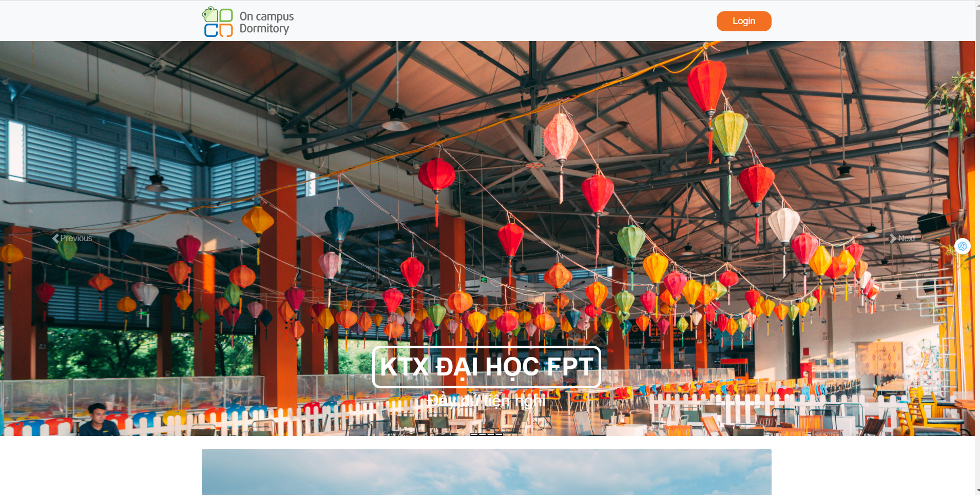

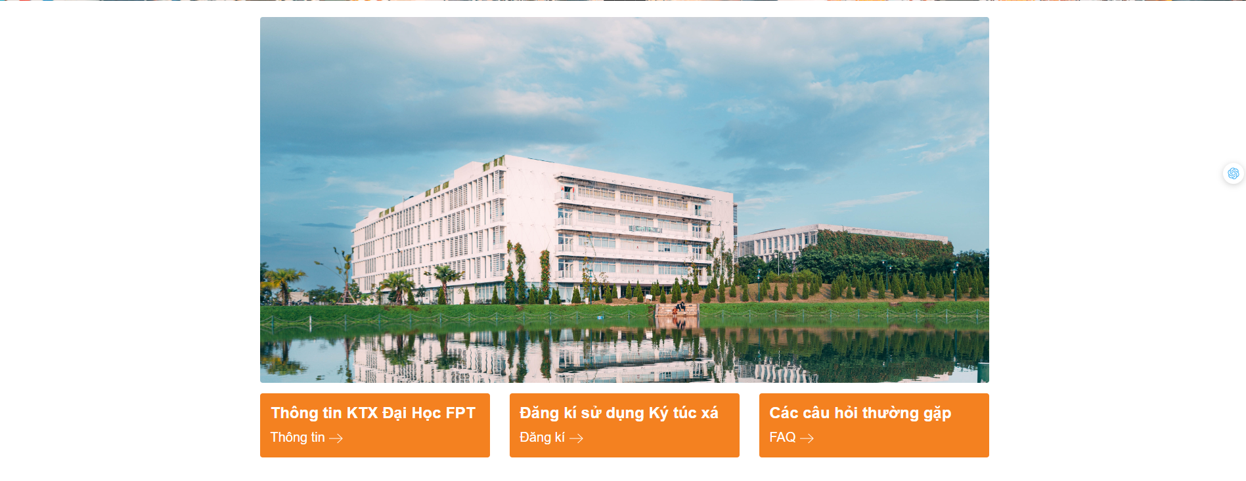

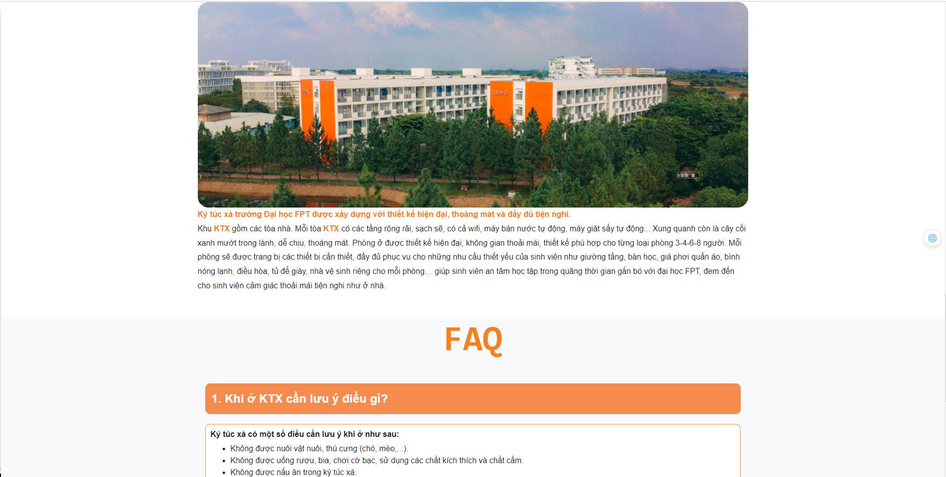

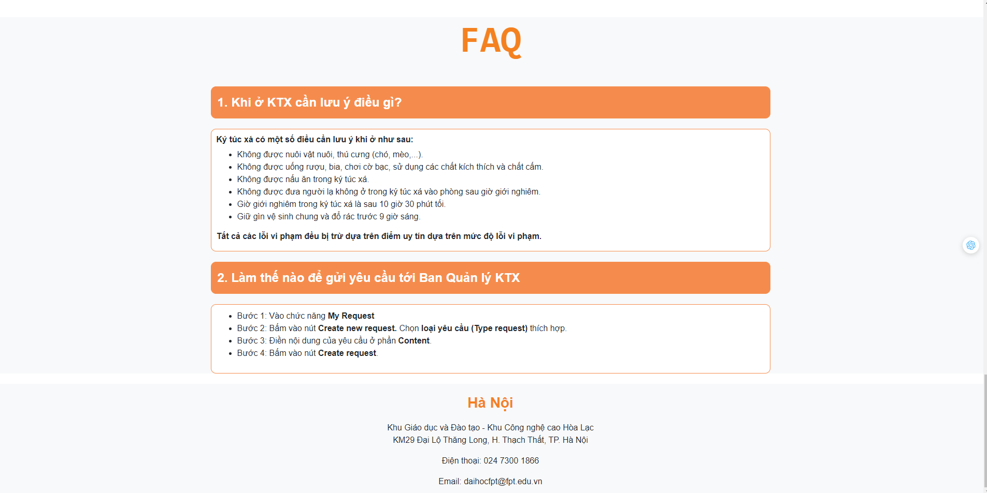

| **Field Name** | **Field Type** | **Description** |
| --- | --- | --- |
| Login | Button | Enables transitioning to the login screen |
| Thông tin(->) | Link | Navigate to the “Thông tin” |
| Đăng kí(->) | Link | Navigate to the “Login” screen |
| FAQ(->) | Link | Navigate to the “FAQ” |

#### b.Database Access

N/A

### **1.2 View Help/FAQ**

This feature allows users to view Help/FAQ on the system

#### a.UI Design

* Related UC:View Help/FAQ

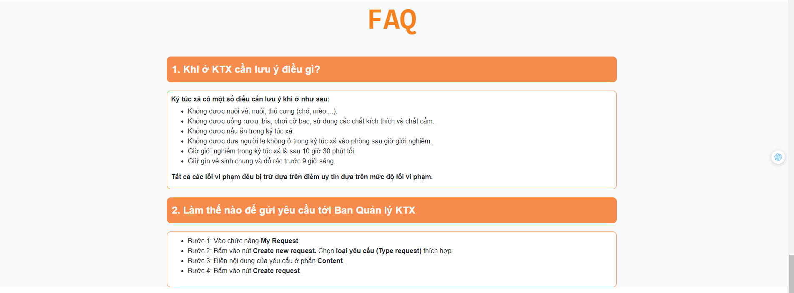

#### b.Database Access

N/A

### **1.3 View Contact Info**

This feature allows users to view Contact Info on the system

#### a.UI Design

* Related UC:View Contact Info

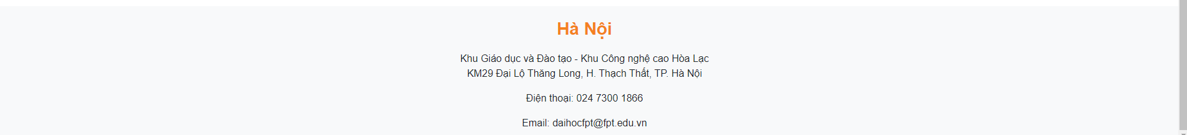

#### b.Database Access

N/A

## 2. Common

### 2.1 Login

The feature allow users to log in to the system

#### a.UI Design

* Related UC:Login

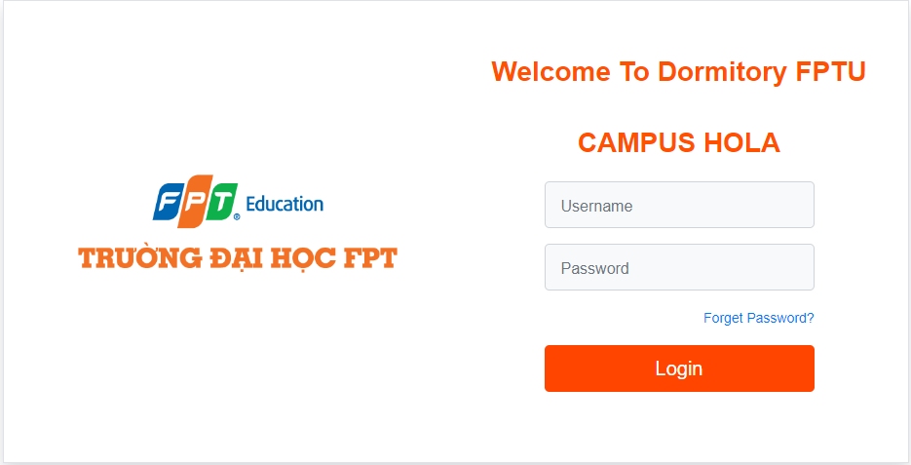

| **Field Name** | **Field Type** | **Description** |
| --- | --- | --- |
| Login | Button | Enables transitioning to the login screen |
| Username | text | User enter the username |
| Password | text | User enter the password |
| Forget Password | Hyperlink | User click to redirect “Forget Password” screen |

#### b.Database Access

**1/ Select user if exist**

SELECT * FROM user u

WHERE u.username = ?;

**2/ Select token generate when login successfully and system generate for this user**

SELECT t.token FROM user u

INNER JOIN token t on t.user_id = u.user_id

WHERE u.user_id = ?;

### 2.2 Logout

The feature allow users to log out to the system

#### a.UI Design

* Related UC:Logout

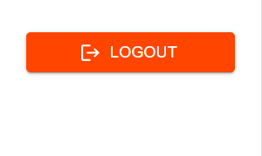

| **Field Name** | **Field Type** | **Description** |
| --- | --- | --- |
| Logout | Button | User click to redirect to homepage |

#### 

#### b.Database Access

DELETE FROM token t

WHERE t.user_id = ?;

### 2.3 View Profile

The feature allow users to view profile the system

#### a.UI Design

* Related UC:View Profile

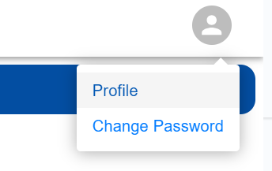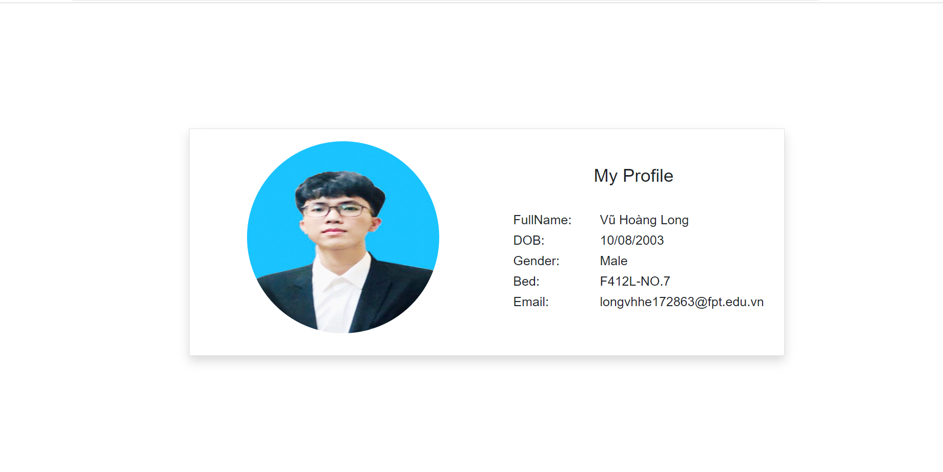

| **Field Name** | **Field Type** | **Description** |
| --- | --- | --- |
| Avatar | Image | User click to avatar display two options |
| Profile | Hyperlink | User click to redirect to profile screen |
| Change Password | Hyperlink | User click to redirect to change password screen |

#### b.Database Access

**1/ If he is a student**

SELECT u.*, s.*, b.bed_name FROM user u

INNER JOIN student s ON s.user_id = u.user_id

INNER JOIN bed b ON b.student_id = s.student_id

WHERE u.user_id = ?;

**2/ If he is a manager**

SELECT * FROM user u

INNER JOIN manager m ON m.user_id = u.user_id

WHERE u.user_id = ?;

### 

### 2.4 Forget Password

The feature allow users to recover password

#### a.UI Design

* Related UC:Forget Password

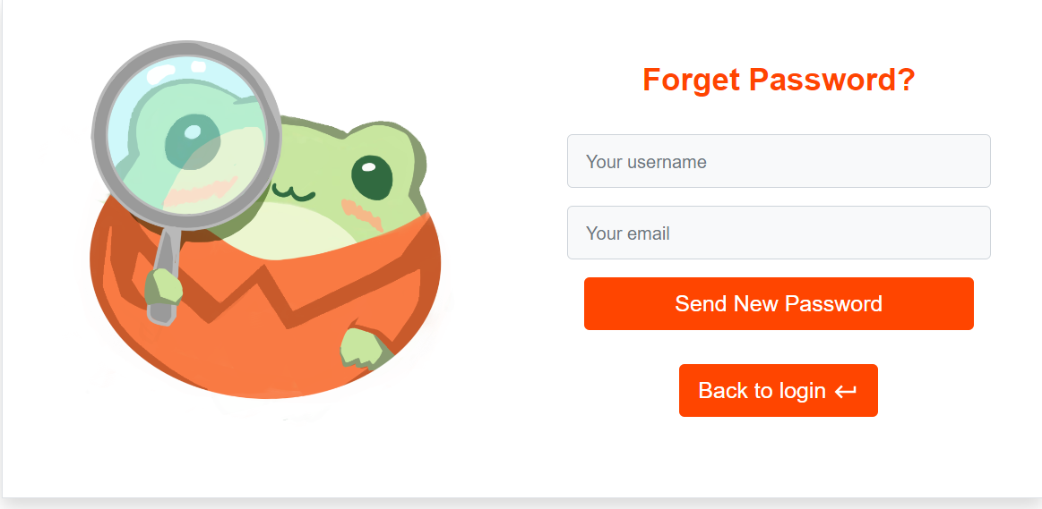

| **Field Name** | **Field Type** | **Description** |
| --- | --- | --- |
| Your username | text | User enter username |
| Your email | text | User enter email |
| Send New Password | Button | User click button and send new password to the email |
| Back to login | Button | User click to redirect to homepage |

#### b.Database Access

**1/ Check if existing an account with username and email**

SELECT * FROM user u

WHERE u.username = ? and u.email = ?;

**2/ Set the new auto-generated by system**

UPDATE user u

SET u.password = ?;

### 2.5 Change Password

The feature allow users to change password

#### a.UI Design

* Related UC:Change Password

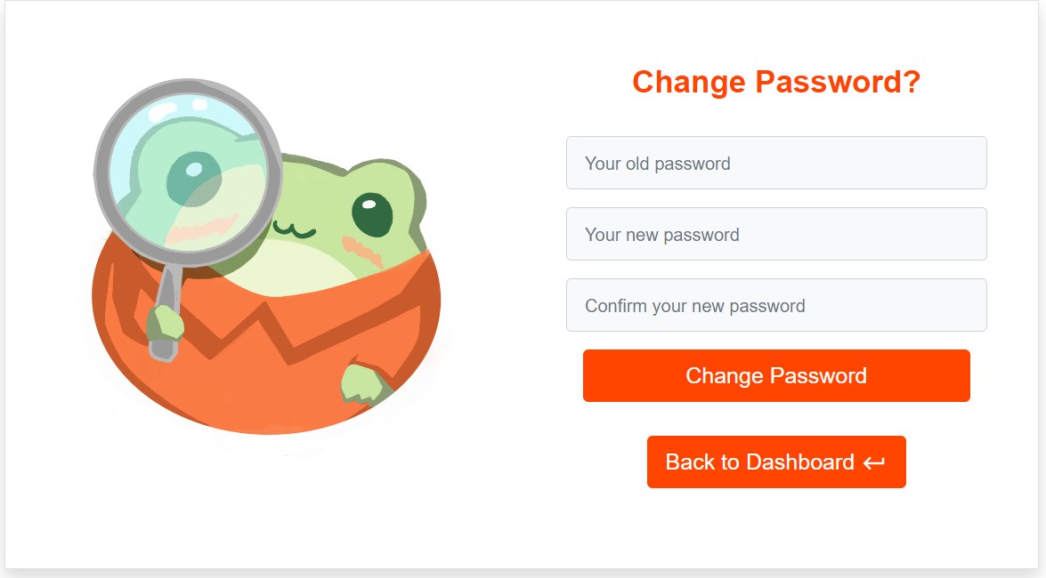

| **Field Name** | **Field Type** | **Description** |
| --- | --- | --- |
| Your old password | text | User enter old password |
| Your new password | text | User enter new password |
| Confirm your new password | text | User enter confirm your new password |
| Change Password | Button | User click to change password successful |
| Back to Dashboard | Button | User click to redirect to dashboard |

#### b.Database Access

**1/ Check if the old password is the same or not**

SELECT * FROM user u

WHERE u.password = ?

AND u.user_id = ?;

**2/ Set the new password**

UPDATE user

SET u.password = ?

WHERE u.user_id = ?;

## 3. Dorm Manager

### 3.1 View Request Application

The feature allow users to view request application orders by latest

#### a. UI Design

Related UC: View Request Application

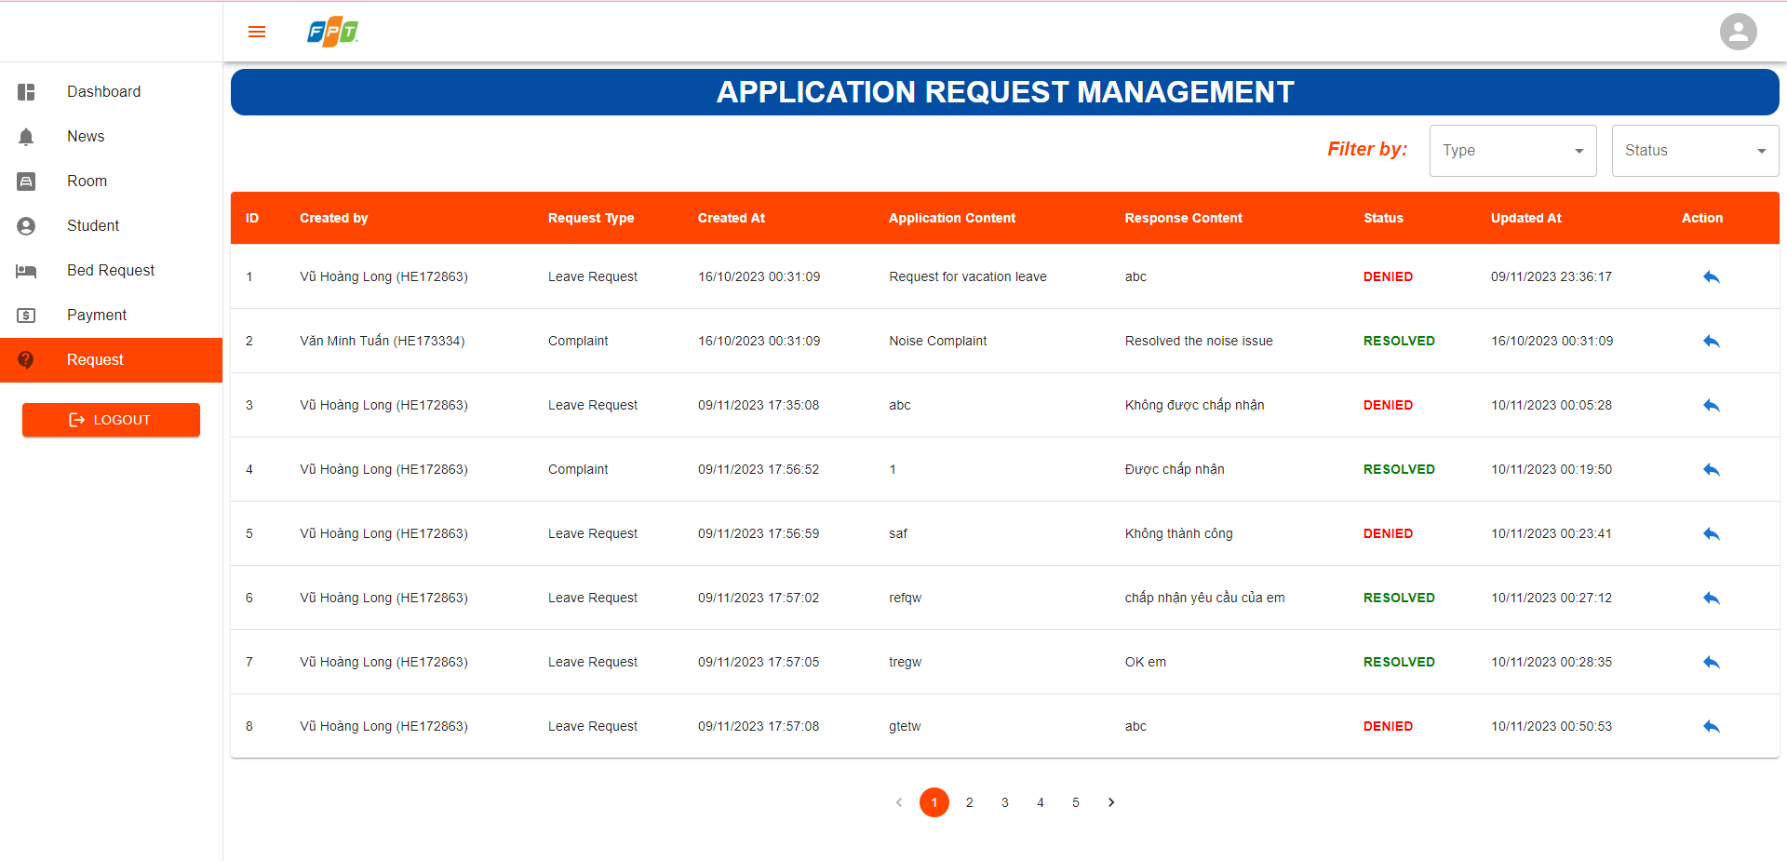

| **Field Name** | **Field Type** | **Description** |
| --- | --- | --- |
| Home | Hyperlink | User click to redirect to home |
| News | Hyperlink | User click to redirect to news |
| Bed Booking | Hyperlink | User click to redirect to bed booking |
| Bed Payment | Hyperlink | User click to redirect to bed payment |
| Booked History | Hyperlink | User click to redirect to booked history |
| Request | Hyperlink | User click to redirect to request |
| Room | Image | User can view information room and display list bed |
| Select Type | Select | User can choose option request type |
| Select Status | Select | User can choose option status of request |
| Icon Reply | Button | User can reply a request |
| Number(1,2..) | Button | User click to redirect to next or previous pages |
| < | Button | User click to redirect previous pages |
| > | Button | User click to redirect next pages |

#### 

#### b. Database Access

SELECT * FROM request_application

WHERE (:studentId IS NULL OR student_id = :studentId)

AND (:requestTypeId IS NULL OR request_application_type_id = :requestTypeId)

AND (:status IS NULL OR :status = '' or status = :status)

### 3.2 Reply Request Application

The feature allow users to view news orders by latest

#### a. UI Design

Related UC: Reply Request Application

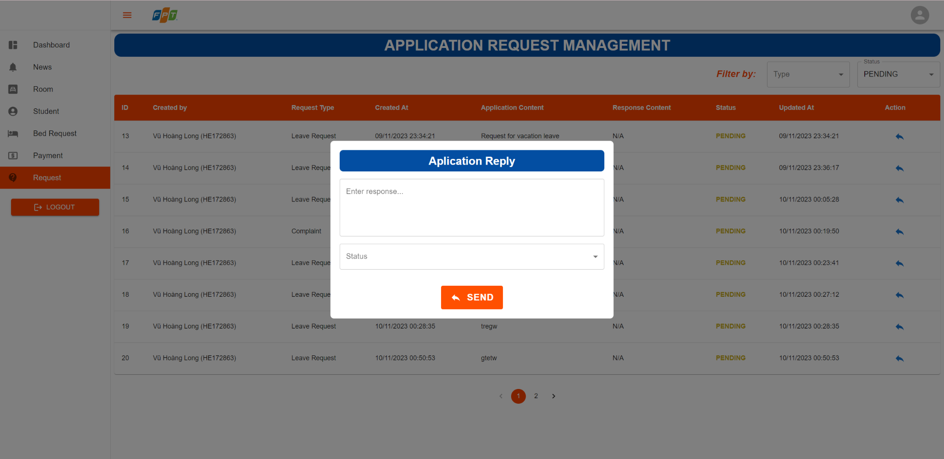

| **Field Name** | **Field Type** | **Description** |
| --- | --- | --- |
| Home | Hyperlink | User click to redirect to home |
| News | Hyperlink | User click to redirect to news |
| Bed Booking | Hyperlink | User click to redirect to bed booking |
| Bed Payment | Hyperlink | User click to redirect to bed payment |
| Booked History | Hyperlink | User click to redirect to booked history |
| Request | Hyperlink | User click to redirect to request |
| Room | Image | User can view information room and display list bed |
| Select Type | Select | User can choose option request type |
| Select Status | Select | User can choose option status of request |
| Icon Reply | Button | User can reply a request |
| Number(1,2..) | Button | User click to redirect to next or previous pages |
| < | Button | User click to redirect previous pages |
| > | Button | User click to redirect next pages |
| Enter response… | Input text | User click to enter input text text response |
| Send button | Button | User click to send application reply |

#### 

#### b. Database Access

UPDATE request_application ra

SET text_response = ?,

status = ?

WHERE ra.request_application_id = ?

### 3.3 View Payment

The feature allow users to view all payments

#### a. UI Design

Related UC: View Payment

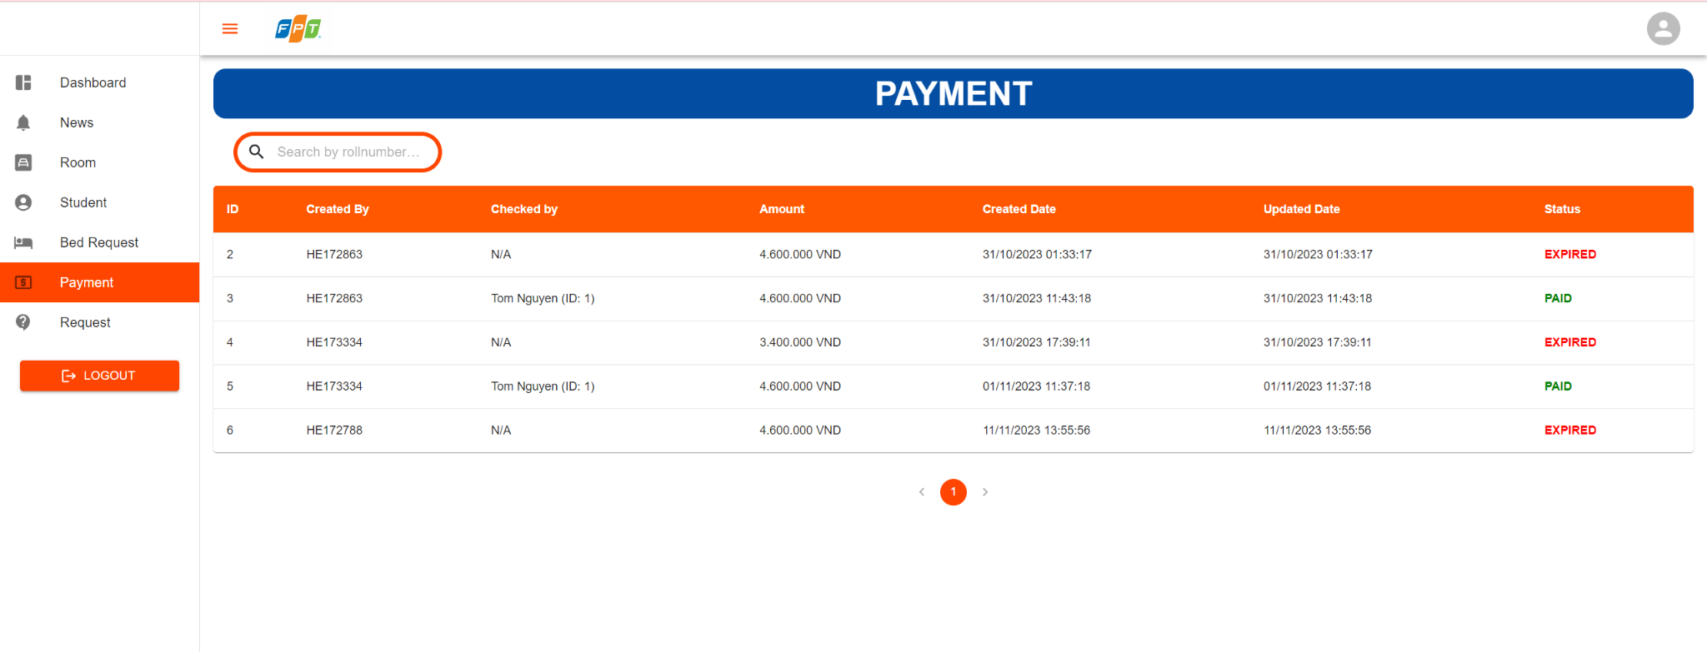

| **Field Name** | **Field Type** | **Description** |
| --- | --- | --- |
| Home | Hyperlink | User click to redirect to home |
| News | Hyperlink | User click to redirect to news |
| Bed Booking | Hyperlink | User click to redirect to bed booking |
| Bed Payment | Hyperlink | User click to redirect to bed payment |
| Booked History | Hyperlink | User click to redirect to booked history |
| Request | Hyperlink | User click to redirect to request |
| Room | Image | User can view information room and display list bed |
| Number(1,2..) | Button | User click to redirect to next or previous pages |
| < | Button | User click to redirect previous pages |
| > | Button | User click to redirect next pages |
| Search by rollnumber | Input field | User enter rollnumber to search |

#### 

#### b. Database Access

SELECT * from payment

### 3.4 View List Students Information

The feature allow users to view all students in the system

#### a. UI Design

Related UC: View List Students Information

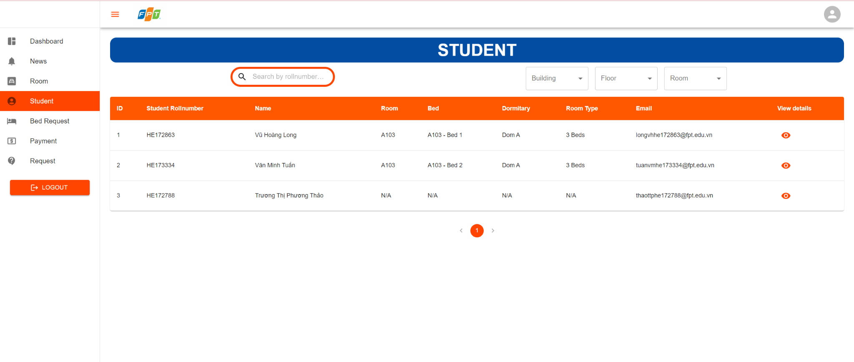

| **Field Name** | **Field Type** | **Description** |
| --- | --- | --- |
| Home | Hyperlink | User click to redirect to home |
| News | Hyperlink | User click to redirect to news |
| Bed Booking | Hyperlink | User click to redirect to bed booking |
| Bed Payment | Hyperlink | User click to redirect to bed payment |
| Booked History | Hyperlink | User click to redirect to booked history |
| Request | Hyperlink | User click to redirect to request |
| Room | Image | User can view information room and display list bed |
| Number(1,2..) | Button | User click to redirect to next or previous pages |
| < | Button | User click to redirect previous pages |
| > | Button | User click to redirect next pages |
| Search by rollnumber | Input field | User enter rollnumber to search by rollnumber |
| Select a building | Select | User can choose option building |
| Select a floor | Select | User can choose option floor |
| Select a room | Select | User can choose option room |
| Icon eye | Button | User can click to view student details |

#### 

#### b. Database Access

SELECT * FROM student s

INNER JOIN user u ON s.user_id = u.user_id

INNER JOIN bed b ON s.bed_id = b.bed_id

INNER JOIN room r ON b.room_id = r.room_id

INNER JOIN room_type rt ON r.room_type_id = rt.room_type_id

INNER JOIN building bu ON r.building_id = bu.building_id

### 3.5 View Student Information Detail

The feature allow users to view student information detail in the system

#### a. UI Design

Related UC: View Student Information Detail

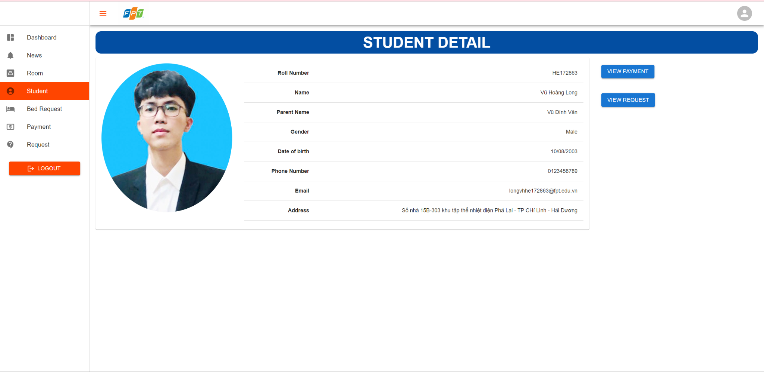

| **Field Name** | **Field Type** | **Description** |
| --- | --- | --- |
| Home | Hyperlink | User click to redirect to home |
| News | Hyperlink | User click to redirect to news |
| Bed Booking | Hyperlink | User click to redirect to bed booking |
| Bed Payment | Hyperlink | User click to redirect to bed payment |
| Booked History | Hyperlink | User click to redirect to booked history |
| Request | Hyperlink | User click to redirect to request |
| Room | Image | User can view information room and display list bed |
| Number(1,2..) | Button | User click to redirect to next or previous pages |
| < | Button | User click to redirect previous pages |
| > | Button | User click to redirect next pages |
| View Payment | Button | User click to view payment of student |
| View Request | Button | User click to view request of student |

#### 

#### b. Database Access

SELECT * FROM student s

INNER JOIN user u ON s.user_id = u.user_id

WHERE s.student_id = ?

### 3.6 View Payment of Student

The feature allow users to view student pay in the system

#### a. UI Design

Related UC: View Payment of Student

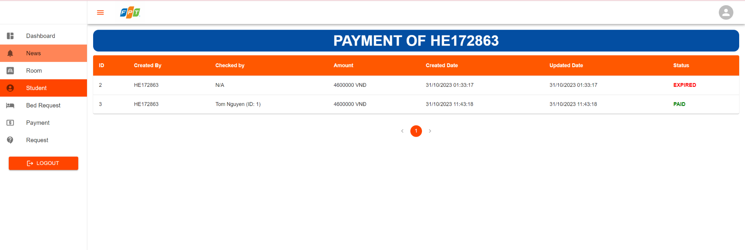

| **Field Name** | **Field Type** | **Description** |
| --- | --- | --- |
| Home | Hyperlink | User click to redirect to home |
| News | Hyperlink | User click to redirect to news |
| Bed Booking | Hyperlink | User click to redirect to bed booking |
| Bed Payment | Hyperlink | User click to redirect to bed payment |
| Booked History | Hyperlink | User click to redirect to booked history |
| Request | Hyperlink | User click to redirect to request |
| Room | Image | User can view information room and display list bed |
| Number(1,2..) | Button | User click to redirect to next or previous pages |
| < | Button | User click to redirect previous pages |
| > | Button | User click to redirect next pages |

#### 

#### b. Database Access

SELECT * FROM payment p

INNER JOIN student s ON p.student_id = s.student_id

### 3.7 View Request of Student

The feature allow users to view student request in the system

#### a. UI Design

Related UC: View Request of Student

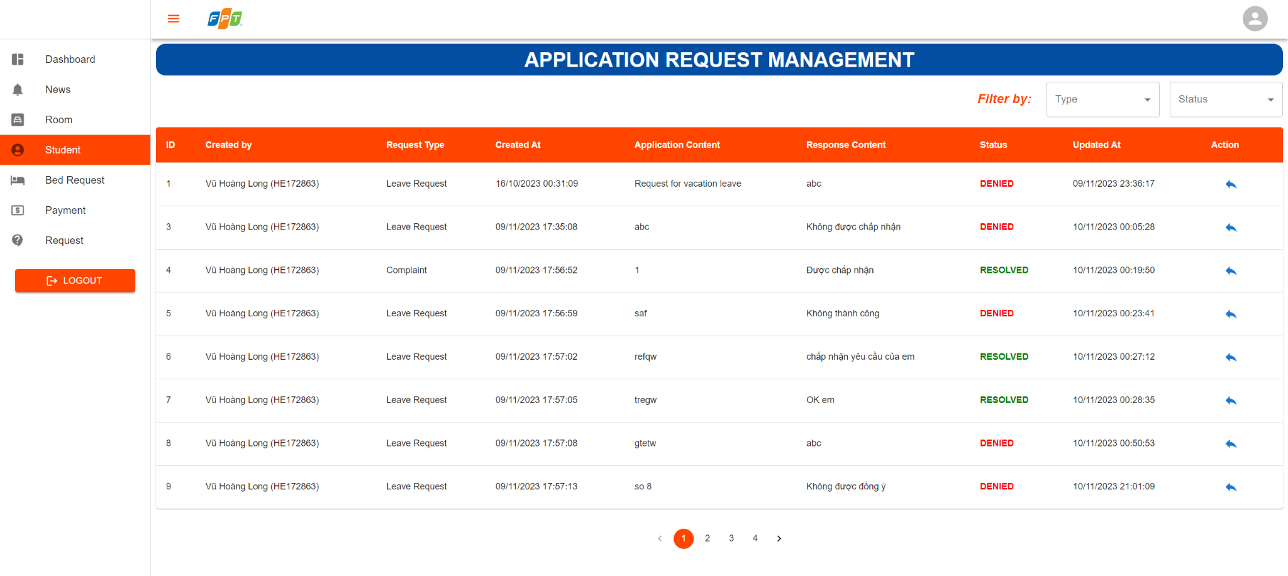

| **Field Name** | **Field Type** | **Description** |
| --- | --- | --- |
| Home | Hyperlink | User click to redirect to home |
| News | Hyperlink | User click to redirect to news |
| Bed Booking | Hyperlink | User click to redirect to bed booking |
| Bed Payment | Hyperlink | User click to redirect to bed payment |
| Booked History | Hyperlink | User click to redirect to booked history |
| Request | Hyperlink | User click to redirect to request |
| Room | Image | User can view information room and display list bed |
| Select Type | Select | User can choose option request type |
| Select Status | Select | User can choose option status of request |
| Icon Reply | Button | User can reply a request |
| Number(1,2..) | Button | User click to redirect to next or previous pages |
| < | Button | User click to redirect previous pages |
| > | Button | User click to redirect next pages |

#### b. Database Access

SELECT * FROM request_application ra

INNER JOIN student s ON ra.student_id = s.student_id

INNER JOIN request_application_type rat ON rat.request_application_type_id = ra.request_application_type

WHERE s.student_id = ?

AND (? is null OR rat.request_application_type_id = ?)

AND (? is null OR status = ?)

### 3.8 View List Room

The feature allow users to view list room in the system

#### a.UI Design

* Related UC: View List Room

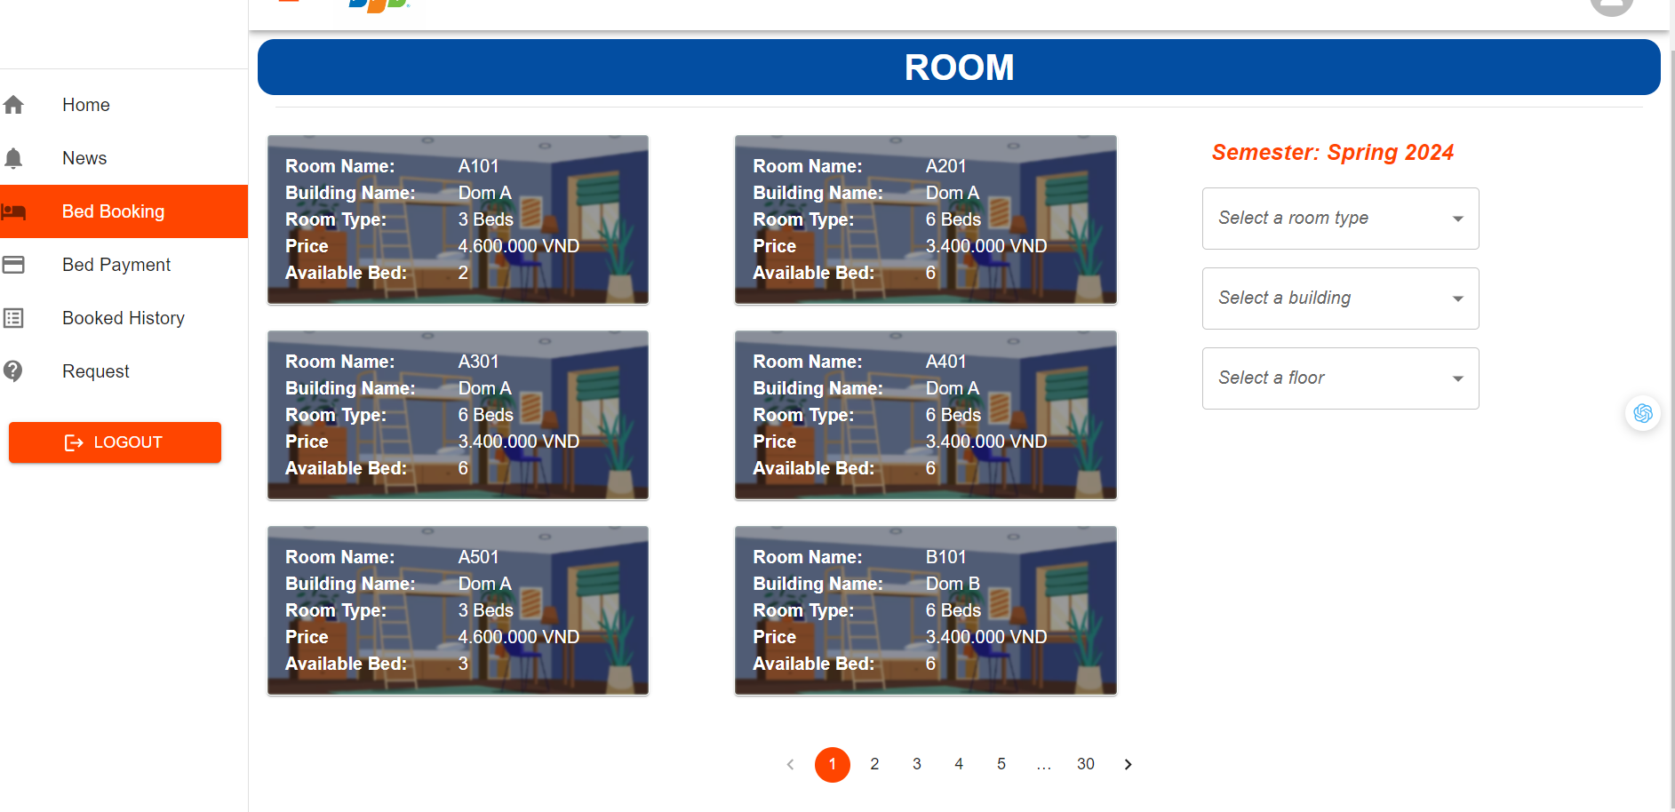

| **Field Name** | **Field Type** | **Description** |
| --- | --- | --- |
| Home | Hyperlink | User click to redirect to home |
| News | Hyperlink | User click to redirect to news |
| Bed Booking | Hyperlink | User click to redirect to bed booking |
| Bed Payment | Hyperlink | User click to redirect to bed payment |
| Booked History | Hyperlink | User click to redirect to booked history |
| Request | Hyperlink | User click to redirect to request |
| LOGOUT | Button | User clicks to redirect to homepage |
| Room | Image | User can view information room and display list bed |
| Select a room type | Select | User can choose option room type |
| Select a building | Select | User can choose option building |
| Select a floor | Select | User can choose option floor |
| Number(1,2..) | Button | User click to redirect to next or previous pages |
| < | Button | User click to redirect previous pages |
| > | Button | User click to redirect next pages |

#### b.Database Access

SELECT r.* FROM room r

JOIN building b ON b.building_id = r.building_id

JOIN room_type rt ON rt.room_type_id = r.room_type_id

JOIN bed be ON r.room_id = be.room_id

WHERE (:buildingId is NULL OR b.building_id = :buildingId)

AND (:roomTypeId is NULL OR rt.room_type_id = :roomTypeId)

AND (:floor is NULL OR r.floor = :floor)

AND (:status is NULL OR :status LIKE '' or be.status = :status)

GROUP BY r.room_id;

#### 

### 3.9 View List Beds

The feature allow users to view list beds in the system

#### a.UI Design

* Related UC: View List Beds

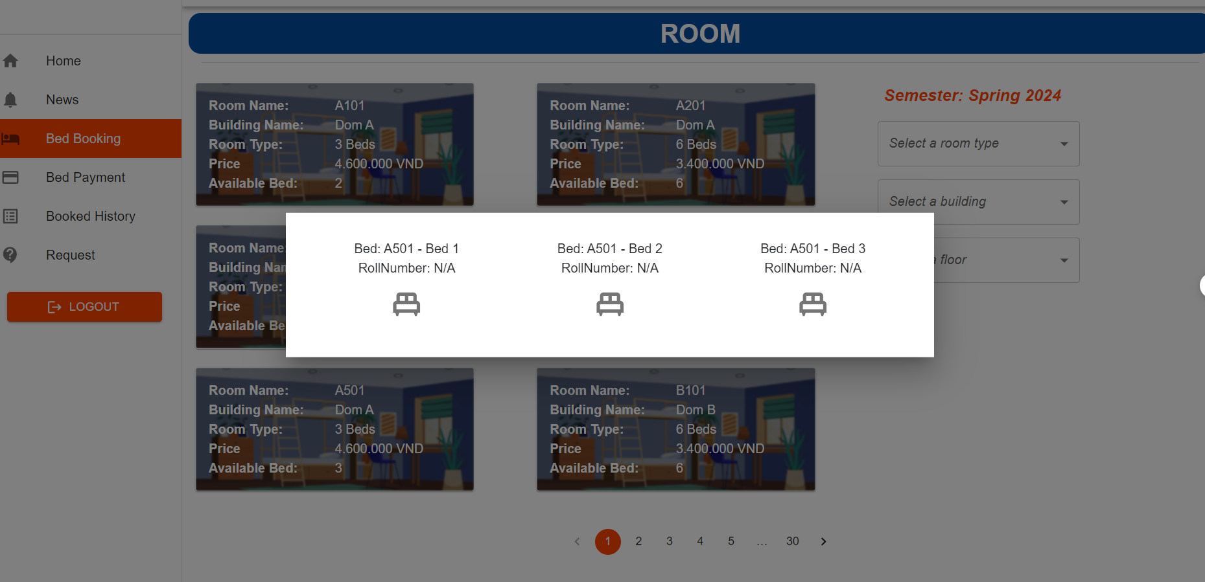

| **Field Name** | **Field Type** | **Description** |
| --- | --- | --- |
| Home | Hyperlink | User click to redirect to home |
| News | Hyperlink | User click to redirect to news |
| Bed Booking | Hyperlink | User click to redirect to bed booking |
| Bed Payment | Hyperlink | User click to redirect to bed payment |
| Booked History | Hyperlink | User click to redirect to booked history |
| Request | Hyperlink | User click to redirect to request |
| Room | Image | User can view information room and display list bed |
| LOGOUT | Button | User clicks to redirect to homepage |
| Select a room type | Select | User can choose option room type |
| Select a building | Select | User can choose option building |
| Select a floor | Select | User can choose option floor |
| Number(1,2..) | Button | User click to redirect to next or previous pages |
| Bed | Icon | User click bed they want to book |
| < | Button | User click to redirect previous pages |
| > | Button | User click to redirect next pages |

#### b. Database Access

SELECT * FROM bed b

LEFT JOIN student s ON b.student_id = s.student_id

WHERE b.room_id = ?

### 3.10 View Information of Bed

The feature allow users to view bed information in the system

#### a.UI Design

* Related UC: View Information of Bed

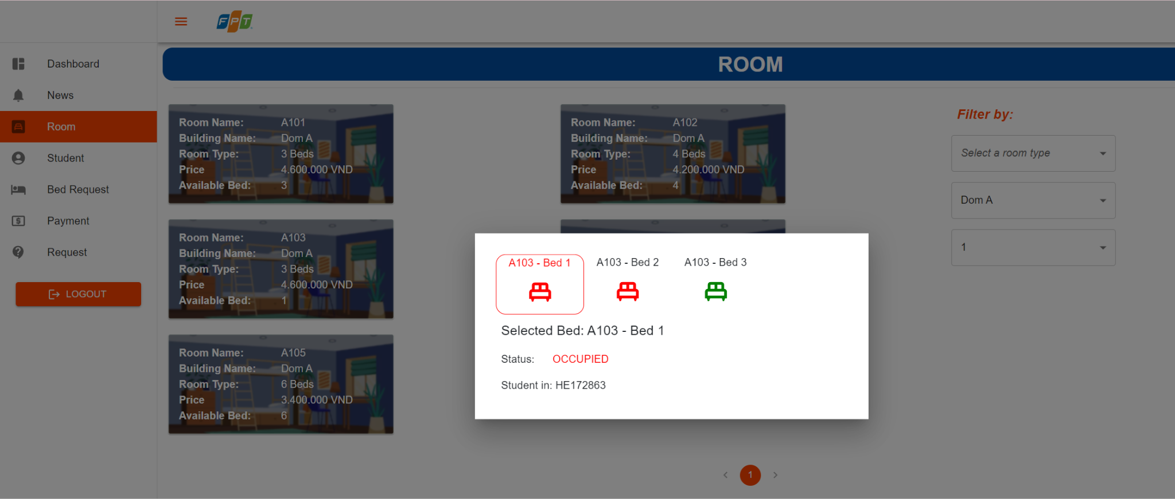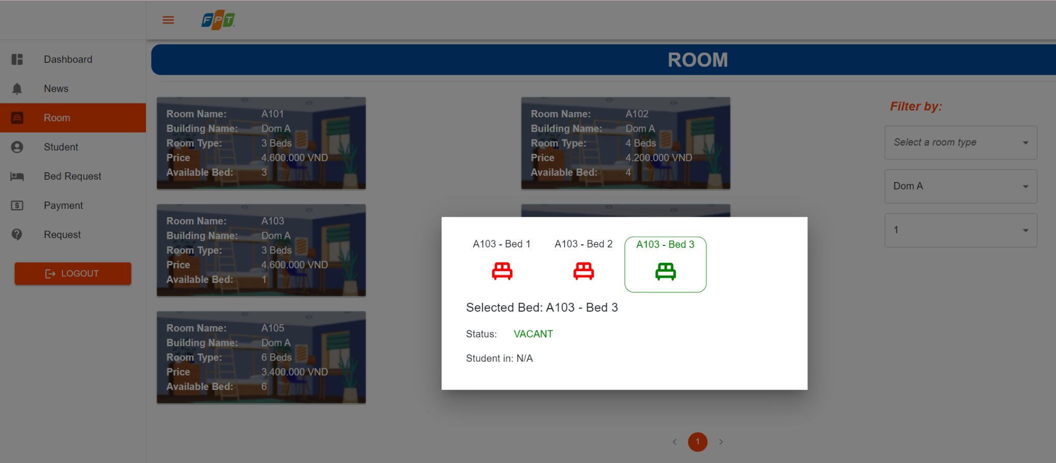

| **Field Name** | **Field Type** | **Description** |
| --- | --- | --- |
| Home | Hyperlink | User click to redirect to home |
| News | Hyperlink | User click to redirect to news |
| Bed Booking | Hyperlink | User click to redirect to bed booking |
| Bed Payment | Hyperlink | User click to redirect to bed payment |
| Booked History | Hyperlink | User click to redirect to booked history |
| Request | Hyperlink | User click to redirect to request |
| Room | Image | User can view information room and display list bed |
| LOGOUT | Button | User clicks to redirect to homepage |
| Select a room type | Select | User can choose option room type |
| Select a building | Select | User can choose option building |
| Select a floor | Select | User can choose option floor |
| Number(1,2..) | Button | User click to redirect to next or previous pages |
| Bed | Icon | User click bed they want to book |
| < | Button | User click to redirect previous pages |
| > | Button | User click to redirect next pages |

#### b. Database Access

SELECT * FROM bed b

WHERE b.room_id = ?

### 3.11 View Bed Request

The feature allow users to view bed booked history in the system

#### a.UI Design

* Related UC: View Bed Request

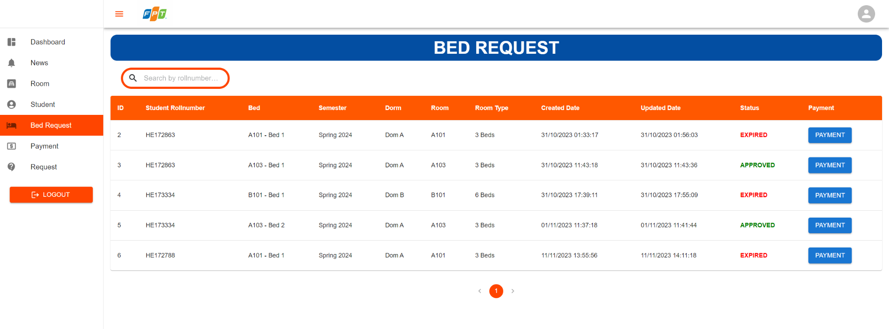

| **Field Name** | **Field Type** | **Description** |
| --- | --- | --- |
| Home | Hyperlink | User clicks to redirect to home |
| News | Hyperlink | User clicks to redirect to news |
| Bed Booking | Hyperlink | User clicks to redirect to bed booking |
| Bed Payment | Hyperlink | User clicks to redirect to bed payment |
| Booked History | Hyperlink | User clicks to redirect to booked history |
| Request | Hyperlink | User clicks to redirect to request |
| Room | Image | User can view information room and display list bed |
| LOGOUT | Button | User clicks to redirect to homepage |
| Eyes | Icon | User clicks on it to reveal bed details |
| Payment | Button | User clicks on it to view payment |
| Number(1,2..) | Button | User click to redirect to next or previous pages |
| Bed | Icon | User click bed they want to book |
| < | Button | User click to redirect previous pages |
| > | Button | User click to redirect next pages |

#### b. Database Access

SELECT br.* FROM bed_request br

JOIN student s on s.student_id = br.student_id

JOIN semester se on se.semester_id = br.semester_id

WHERE (:status IS NULL OR `status` = :status)

AND (:studentRollNumber IS NULL OR :studentRollNumber = '' OR s.roll_number LIKE :studentRollNumber)

AND (:semesterId IS NULL OR se.semester_id = :semesterId)

### 3.12 Update Bed Reservation

The feature allow users to update bed reservation in the system

#### a.UI Design

* Related UC: Update Bed Reservation

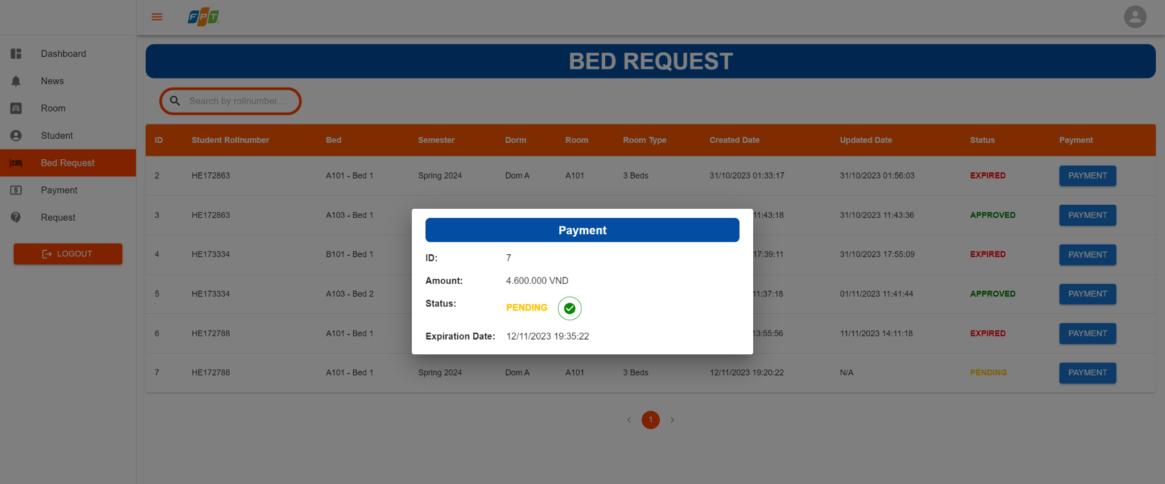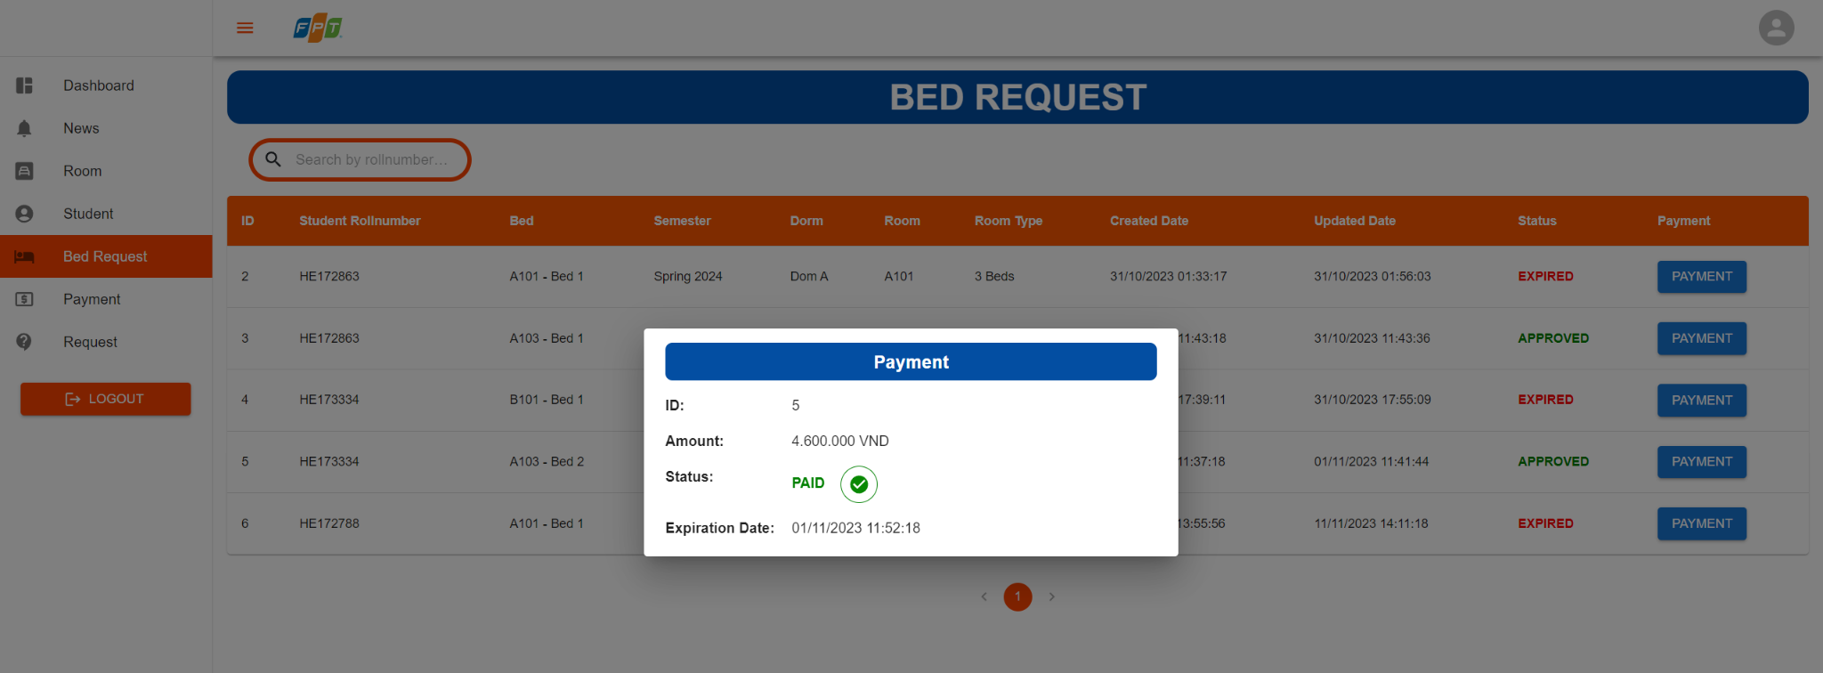

| **Field Name** | **Field Type** | **Description** |
| --- | --- | --- |
| Home | Hyperlink | User clicks to redirect to home |
| News | Hyperlink | User clicks to redirect to news |
| Bed Booking | Hyperlink | User clicks to redirect to bed booking |
| Bed Payment | Hyperlink | User clicks to redirect to bed payment |
| Booked History | Hyperlink | User clicks to redirect to booked history |
| Request | Hyperlink | User clicks to redirect to request |
| Room | Image | User can view information room and display list bed |
| LOGOUT | Button | User clicks to redirect to homepage |
| Icon Tick | Icon Button | User clicks on it to confirm that user has paid the payment of bed request |
| Payment | Button | User clicks on it to view payment |
| Number(1,2..) | Button | User click to redirect to next or previous pages |
| Bed | Icon | User click bed they want to book |
| < | Button | User click to redirect previous pages |
| > | Button | User click to redirect next pages |

#### b. Database Access

UPDATE payment

SET status = ?

WHERE payment_id = ?

### 3.13 Create News

The feature allow users to create news in the system

#### a.UI Design

* Related UC: Create News

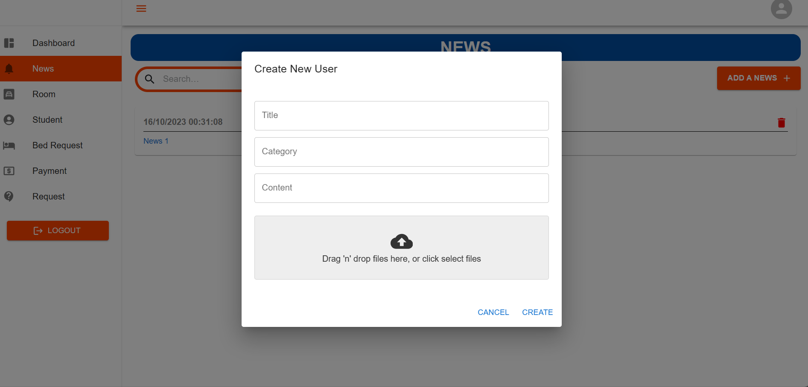

| **Field Name** | **Field Type** | **Description** |
| --- | --- | --- |
| Title | Text | User enter the title |
| Category | Text | User enter the category |
| Content | Text | User enter the content |
| Icon cloud | File receive | User can upload file |
| CREATE | Button | User can create news successfully |
| CANCEL | Button | User cancel create news |

#### b. Database Access

INSERT INTO news (file_data, title, content, category, created_at, updated_at, manager_id)

Value (?,?,?,?,?,?,?)

### 3.14 Delete News

The feature allow users to delete news in the system

#### a.UI Design

* Related UC: Delete News

#### 

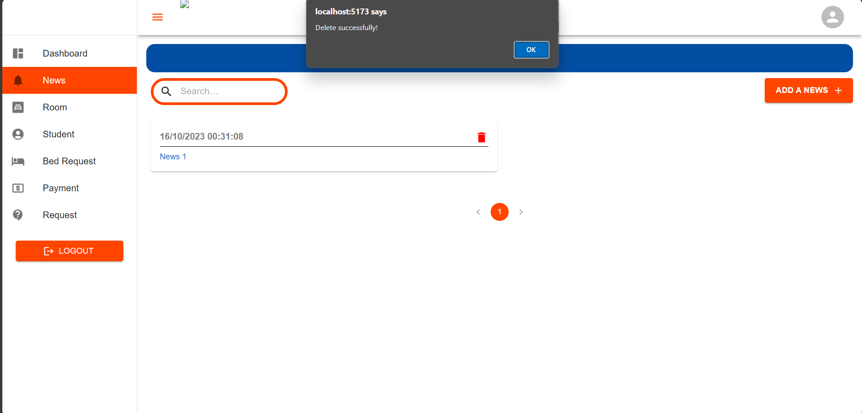

| **Field Name** | **Field Type** | **Description** |
| --- | --- | --- |
| Home | Hyperlink | User clicks to redirect to home |
| News | Hyperlink | User clicks to redirect to news |
| Bed Booking | Hyperlink | User clicks to redirect to bed booking |
| Bed Payment | Hyperlink | User clicks to redirect to bed payment |
| Booked History | Hyperlink | User clicks to redirect to booked history |
| Request | Hyperlink | User clicks to redirect to request |
| Room | Image | User can view information room and display list bed |
| LOGOUT | Button | User clicks to redirect to homepage |
| YES | Button | User clicks on approved delete news |
| NO | Button | User clicks on unapproved delete news |
| OK | Button | User click confirm delete news |
| Payment | Button | User clicks on it to view payment |
| Number(1,2..) | Button | User click to redirect to next or previous pages |
| Bed | Icon | User click bed they want to book |
| < | Button | User click to redirect previous pages |
| > | Button | User click to redirect next pages |

#### b. Database Access

DELETE FROM news

WHERE news_id = ?

### 3.15 Search payment by roll number

The feature allow users to search payment by roll number in the system

#### a.UI Design

* Related UC: Search payment by roll number



| **Field Name** | **Field Type** | **Description** |
| --- | --- | --- |
| Home | Hyperlink | User click to redirect to home |
| News | Hyperlink | User click to redirect to news |
| Bed Booking | Hyperlink | User click to redirect to bed booking |
| Bed Payment | Hyperlink | User click to redirect to bed payment |
| Booked History | Hyperlink | User click to redirect to booked history |
| Request | Hyperlink | User click to redirect to request |
| Room | Image | User can view information room and display list bed |
| Number(1,2..) | Button | User click to redirect to next or previous pages |
| < | Button | User click to redirect previous pages |
| > | Button | User click to redirect next pages |
| Search by rollnumber | Input field | User enter rollnumber to search payment |

#### b. Database Access

SELECT * FROM payment p

INNER JOIN student s ON p.student_id = s.student_id

WHERE (? = ‘’ OR s.roll_number = ?)

### 3.16 Search student by roll number

The feature allow users to search student by roll number in the system

#### a.UI Design

* Related UC: Search student by roll number



| **Field Name** | **Field Type** | **Description** |
| --- | --- | --- |
| Home | Hyperlink | User click to redirect to home |
| News | Hyperlink | User click to redirect to news |
| Bed Booking | Hyperlink | User click to redirect to bed booking |
| Bed Payment | Hyperlink | User click to redirect to bed payment |
| Booked History | Hyperlink | User click to redirect to booked history |
| Request | Hyperlink | User click to redirect to request |
| Room | Image | User can view information room and display list bed |
| Number(1,2..) | Button | User click to redirect to next or previous pages |
| < | Button | User click to redirect previous pages |
| > | Button | User click to redirect next pages |
| Search by rollnumber | Input field | User enter rollnumber to search student |
| Select a building | Select | User can choose option building |
| Select a floor | Select | User can choose option floor |
| Select a room | Select | User can choose option room |
| Icon eye | Button | User can click to view student details |

#### b. Database Access

SELECT * FROM student s

INNER JOIN user u ON s.user_id = u.user_id

LEFT JOIN bed b ON b.student_id = s.student_id

INNER JOIN room r ON r.room_id = b.room_id

INNER JOIN room_type rt ON r.room_type_id = rt.room_type_id

INNER JOIN building bu ON bu.building_id = r.building_id

WHERE (? = ‘’ OR ? = s.roll_number)

## 4. Student

### 4.1 Book bed

The feature allow users to booking bed in the system

#### a.UI Design

* Related UC:Book Bed

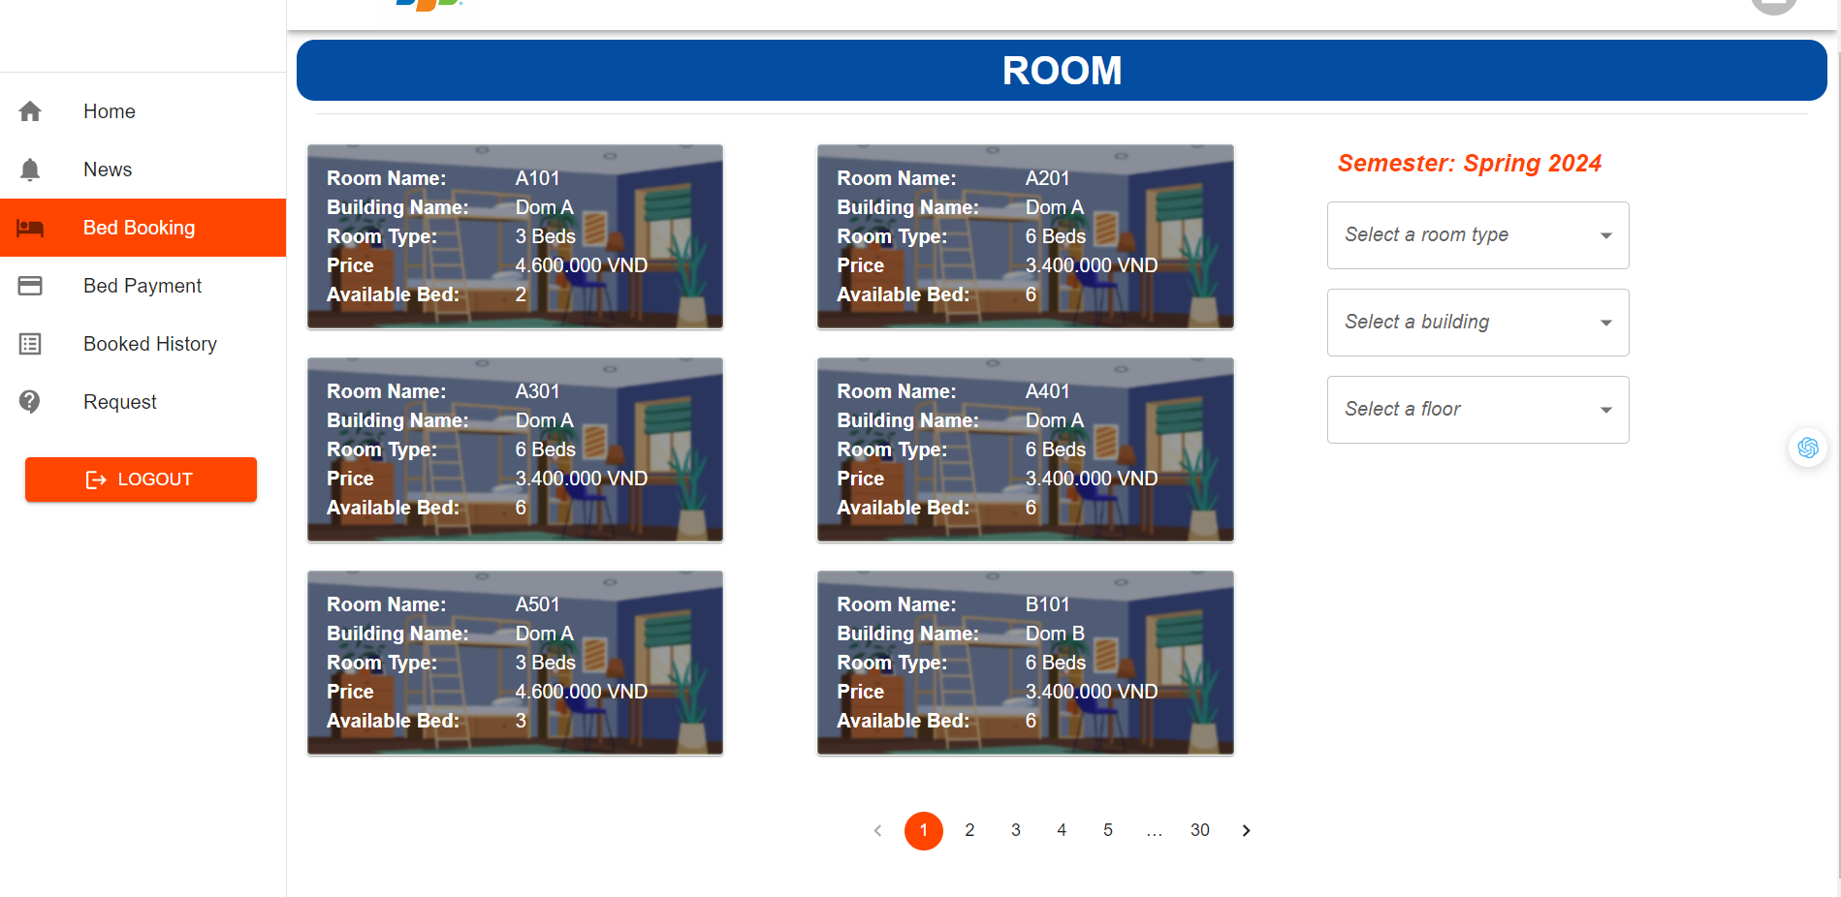

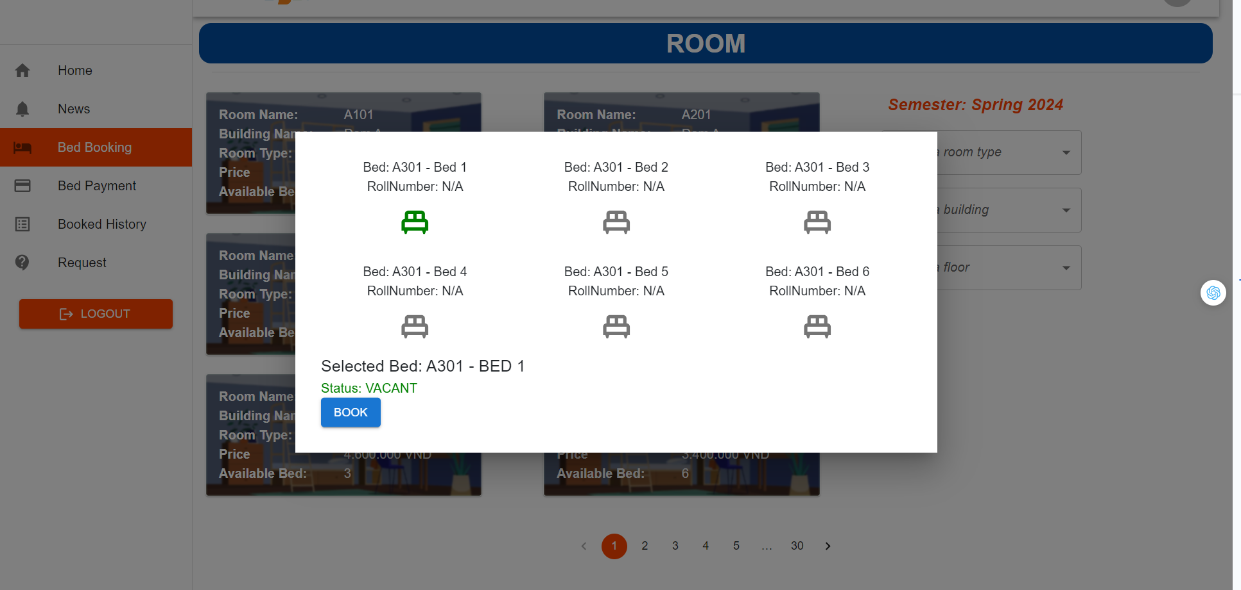

| **Field Name** | **Field Type** | **Description** |
| --- | --- | --- |
| Home | Hyperlink | User click to redirect to home |
| News | Hyperlink | User click to redirect to news |
| Bed Booking | Hyperlink | User click to redirect to bed booking |
| Bed Payment | Hyperlink | User click to redirect to bed payment |
| Booked History | Hyperlink | User click to redirect to booked history |
| Request | Hyperlink | User click to redirect to request |
| Room | Image | User can view information room and display list bed |
| Select a room type | Select | User can choose option room type |
| Select a building | Select | User can choose option building |
| Select a floor | Select | User can choose option floor |
| Bed | Icon | User click bed they want to book |
| Book | Button | User click book bed successful |
| Number(1,2..) | Button | User click to redirect to next or previous pages |
| < | Button | User click to redirect previous pages |
| > | Button | User click to redirect next pages |

#### b.Database Access

**1/ List room based on Room Type, Building and Floor**

SELECT * FROM room r

WHERE r.room_type_id = ?

AND r.building_id = ?

AND r.floor = ?;

**2/ List beds based on Room**

SELECT b.* FROM bed b

INNER JOIN room r on b.room_id = r.room_id

**3/ Check if bed chosen is booked or not**

SELECT * FROM bed b

WHERE b.student_id is null;

**4/ Create bed request**

INSERT INTO bed_request br(created_at, status, updated_at, bed_id, semester_id, student_id) value(?, ‘pending’, ?, ?, ?, ?);

### 4.2 View List Room

The feature allow users to view list room in the system

#### a.UI Design

* Related UC:View List Room



| **Field Name** | **Field Type** | **Description** |
| --- | --- | --- |
| Home | Hyperlink | User click to redirect to home |
| News | Hyperlink | User click to redirect to news |
| Bed Booking | Hyperlink | User click to redirect to bed booking |
| Bed Payment | Hyperlink | User click to redirect to bed payment |
| Booked History | Hyperlink | User click to redirect to booked history |
| Request | Hyperlink | User click to redirect to request |
| LOGOUT | Button | User clicks to redirect to homepage |
| Room | Image | User can view information room and display list bed |
| Select a room type | Select | User can choose option room type |
| Select a building | Select | User can choose option building |
| Select a floor | Select | User can choose option floor |
| Number(1,2..) | Button | User click to redirect to next or previous pages |
| < | Button | User click to redirect previous pages |
| > | Button | User click to redirect next pages |

#### b.Database Access

SELECT r.* FROM room r

JOIN building b ON b.building_id = r.building_id

JOIN room_type rt ON rt.room_type_id = r.room_type_id

JOIN bed be ON r.room_id = be.room_id

WHERE (:buildingId is NULL OR b.building_id = :buildingId)

AND (:roomTypeId is NULL OR rt.room_type_id = :roomTypeId)

AND (:floor is NULL OR r.floor = :floor)

AND (:status is NULL OR :status LIKE '' or be.status = :status)

GROUP BY r.room_id;

## 

### 4.3 View List Beds

The feature allow users to view list beds in the system

#### a.UI Design

* Related UC:View List Beds



| **Field Name** | **Field Type** | **Description** |
| --- | --- | --- |
| Home | Hyperlink | User click to redirect to home |
| News | Hyperlink | User click to redirect to news |
| Bed Booking | Hyperlink | User click to redirect to bed booking |
| Bed Payment | Hyperlink | User click to redirect to bed payment |
| Booked History | Hyperlink | User click to redirect to booked history |
| Request | Hyperlink | User click to redirect to request |
| Room | Image | User can view information room and display list bed |
| LOGOUT | Button | User clicks to redirect to homepage |
| Select a room type | Select | User can choose option room type |
| Select a building | Select | User can choose option building |
| Select a floor | Select | User can choose option floor |
| Number(1,2..) | Button | User click to redirect to next or previous pages |
| Bed | Icon | User click bed they want to book |
| < | Button | User click to redirect previous pages |
| > | Button | User click to redirect next pages |

#### b. Database Access

SELECT * FROM bed b

WHERE b.room_id = ?

### 4.4 View Bed Booked History

The feature allow users to view bed booked history in the system

#### a.UI Design

* Related UC:View Bed Booked History

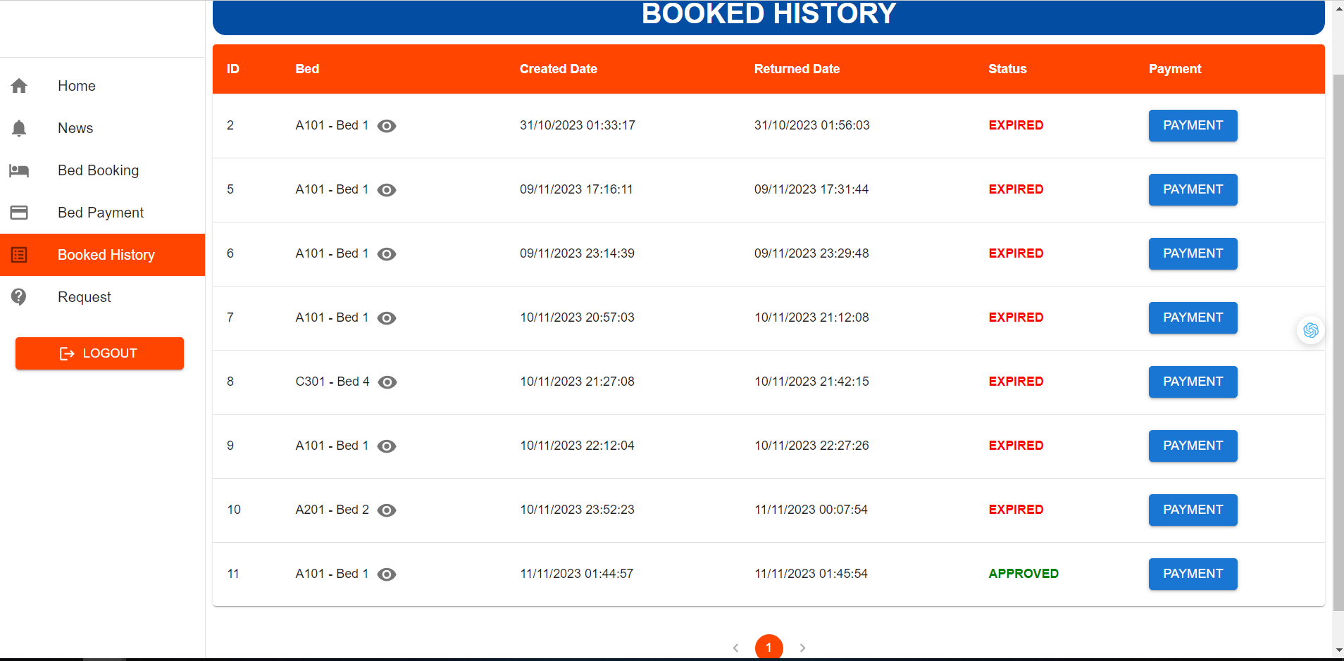

| **Field Name** | **Field Type** | **Description** |
| --- | --- | --- |
| Home | Hyperlink | User clicks to redirect to home |
| News | Hyperlink | User clicks to redirect to news |
| Bed Booking | Hyperlink | User clicks to redirect to bed booking |
| Bed Payment | Hyperlink | User clicks to redirect to bed payment |
| Booked History | Hyperlink | User clicks to redirect to booked history |
| Request | Hyperlink | User clicks to redirect to request |
| Room | Image | User can view information room and display list bed |
| LOGOUT | Button | User clicks to redirect to homepage |
| Eyes | Icon | User clicks on it to reveal bed details |
| Payment | Button | User clicks on it to view payment |
| Number(1,2..) | Button | User click to redirect to next or previous pages |
| Bed | Icon | User click bed they want to book |
| < | Button | User click to redirect previous pages |
| > | Button | User click to redirect next pages |

#### b. Database Access

SELECT br.* FROM bed_request br

JOIN student s on s.student_id = br.student_id

JOIN semester se on se.semester_id = br.semester_id

WHERE (:status IS NULL OR `status` = :status)

AND (:studentRollNumber IS NULL OR :studentRollNumber = '' OR s.roll_number LIKE :studentRollNumber)

AND (:semesterId IS NULL OR se.semester_id = :semesterId)

### 4.5 View Bed Details

The feature allow users to view bed details in the system

#### a.UI Design

* Related UC:View Bed Details

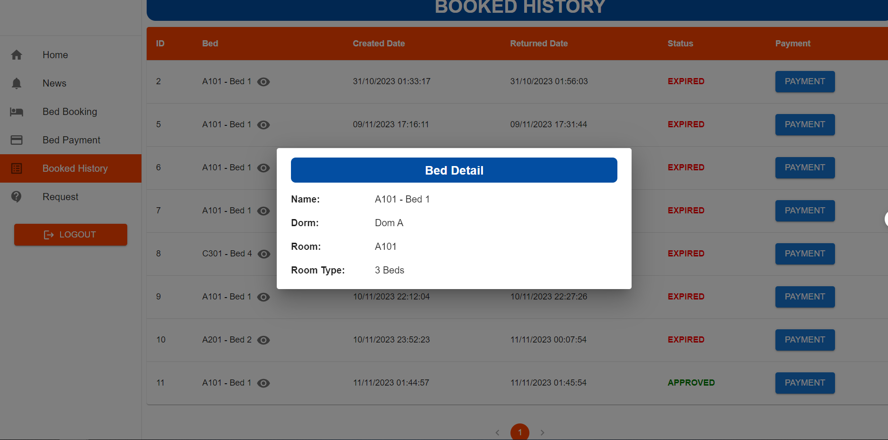

| **Field Name** | **Field Type** | **Description** |
| --- | --- | --- |
| Home | Hyperlink | User clicks to redirect to home |
| News | Hyperlink | User clicks to redirect to news |
| Bed Booking | Hyperlink | User clicks to redirect to bed booking |
| Bed Payment | Hyperlink | User clicks to redirect to bed payment |
| Booked History | Hyperlink | User clicks to redirect to booked history |
| Request | Hyperlink | User clicks to redirect to request |
| Room | Image | User can view information room and display list bed |
| LOGOUT | Button | User clicks to redirect to homepage |
| Eyes | Icon | User clicks on it to reveal bed details |
| Payment | Button | User clicks on it to view payment |
| Number(1,2..) | Button | User click to redirect to next or previous pages |
| Bed | Icon | User click bed they want to book |
| < | Button | User click to redirect previous pages |
| > | Button | User click to redirect next pages |

#### 

#### b. Database Access

SELECT * FROM bed_request br

WHERE br.bed_request_id = ?

### 4.6 View Payment

The feature allow users to view payment in the system

#### a.UI Design

* Related UC:View Payment

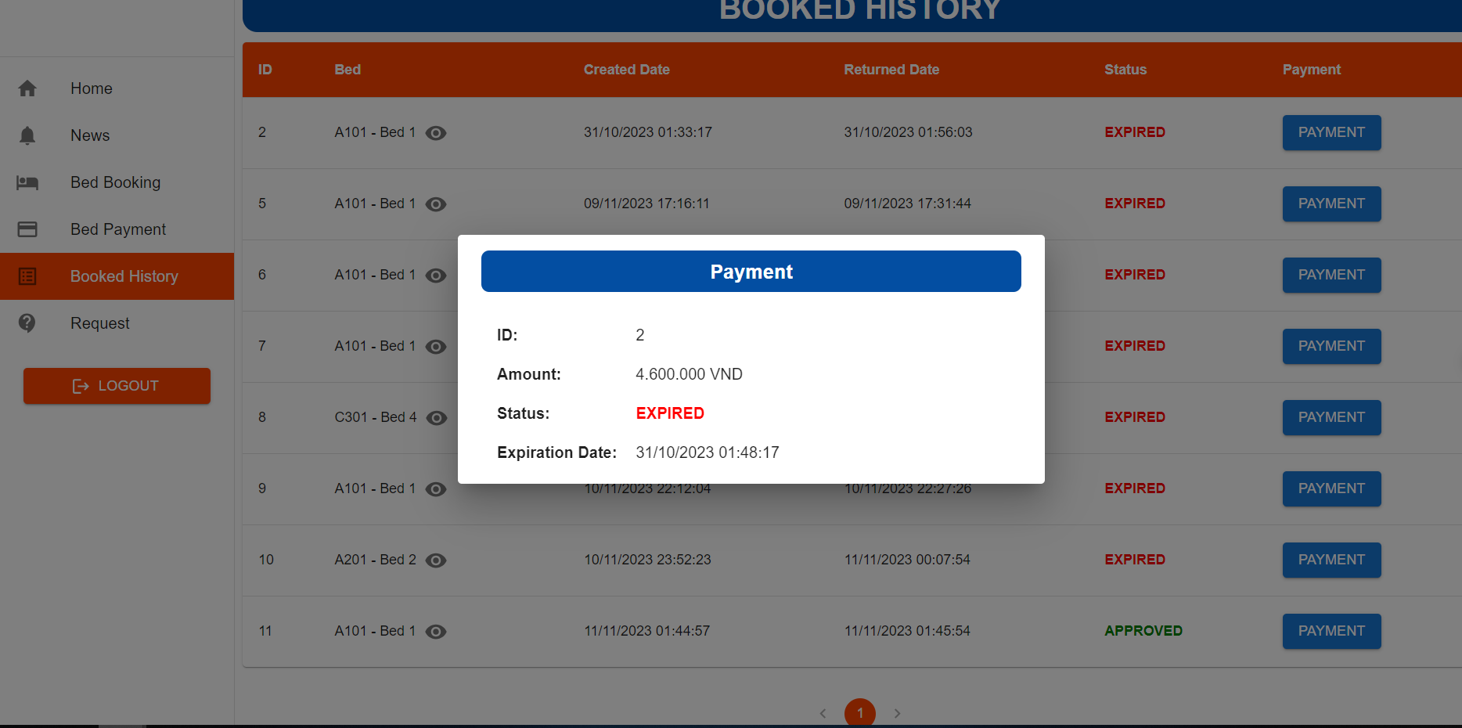

| **Field Name** | **Field Type** | **Description** |
| --- | --- | --- |
| Home | Hyperlink | User clicks to redirect to home |
| News | Hyperlink | User clicks to redirect to news |
| Bed Booking | Hyperlink | User clicks to redirect to bed booking |
| Bed Payment | Hyperlink | User clicks to redirect to bed payment |
| Booked History | Hyperlink | User clicks to redirect to booked history |
| Request | Hyperlink | User clicks to redirect to request |
| Room | Image | User can view information room and display list bed |
| LOGOUT | Button | User clicks to redirect to homepage |
| Eyes | Icon | User clicks on it to reveal bed details |
| Payment | Button | User clicks on it to view payment |
| Number(1,2..) | Button | User click to redirect to next or previous pages |
| Bed | Icon | User click bed they want to book |
| < | Button | User click to redirect previous pages |
| > | Button | User click to redirect next pages |

#### b. Database Access

SELECT * FROM payment p

WHERE p.payment_id = ?

### 4.7 View Request Application History

The feature allow users to view request application in the system

#### a.UI Design

* Related UC:View Request Application History

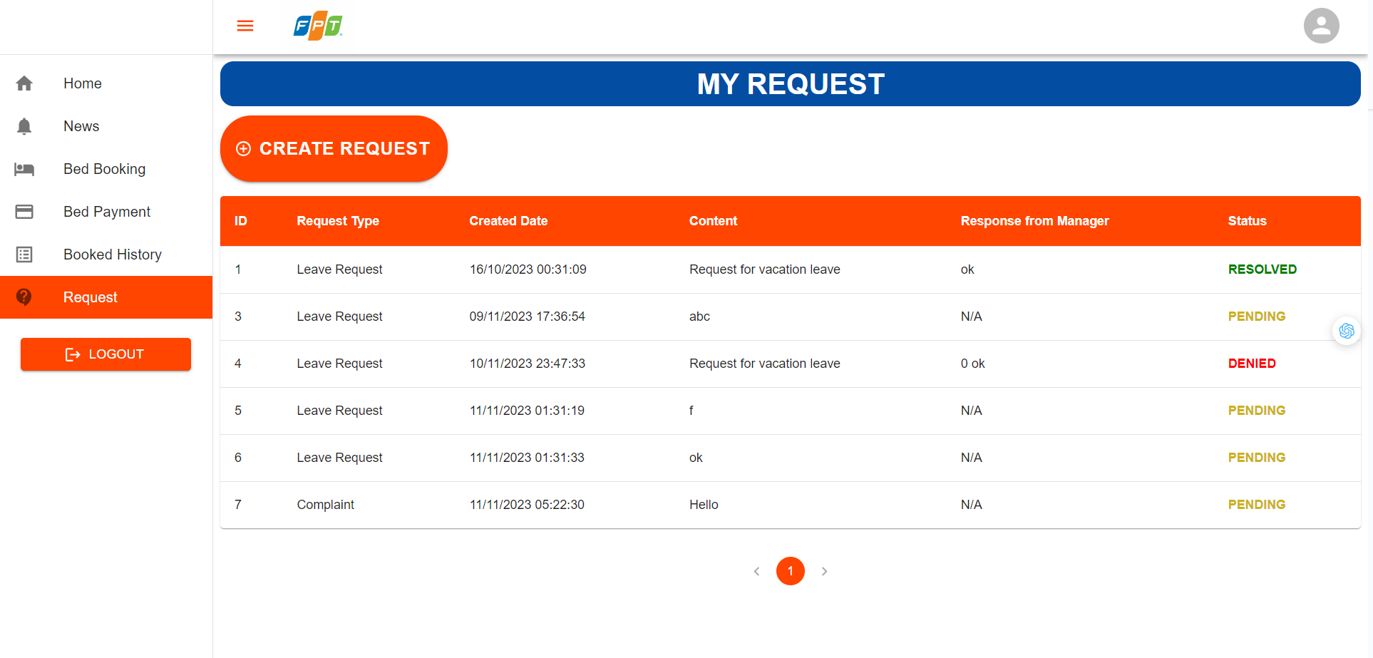

| **Field Name** | **Field Type** | **Description** |
| --- | --- | --- |
| Home | Hyperlink | User clicks to redirect to home |
| News | Hyperlink | User clicks to redirect to news |
| Bed Booking | Hyperlink | User clicks to redirect to bed booking |
| Bed Payment | Hyperlink | User clicks to redirect to bed payment |
| Booked History | Hyperlink | User clicks to redirect to booked history |
| Request | Hyperlink | User clicks to redirect to request |
| LOGOUT | Button | User clicks to redirect to homepage |
| CREATE REQUEST | Button | User clicks to display the pop-up create request form |
| Avatar | Image | User clicks on it, revealing two options |
| Number(1,2..) | Button | User click to redirect to next or previous pages |
| Three parallel orange lines | Icon | User clicks to minimize the screen |
| < | Button | User click to redirect previous pages |
| > | Button | User click to redirect next pages |

#### b. Database Access

SELECT * FROM request_application ra

WHERE ra.student_id = ?

### 4.8 Send Request Application

The feature allow users to send request application in the system

#### a.UI Design

* Related UC:Send Request Application

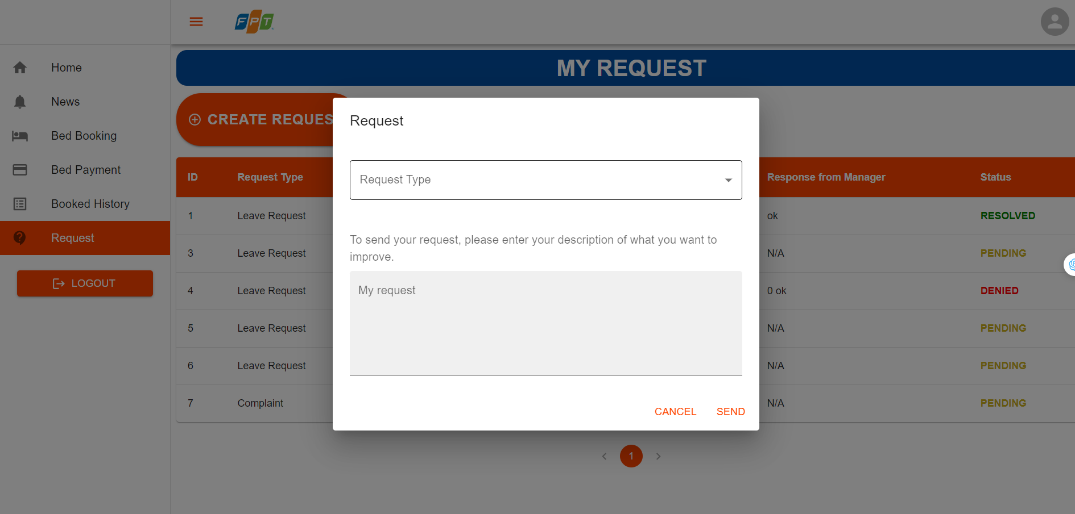

| **Field Name** | **Field Type** | **Description** |
| --- | --- | --- |
| Home | Hyperlink | User clicks to redirect to home |
| News | Hyperlink | User clicks to redirect to news |
| Bed Booking | Hyperlink | User clicks to redirect to bed booking |
| Bed Payment | Hyperlink | User clicks to redirect to bed payment |
| Booked History | Hyperlink | User clicks to redirect to booked history |
| Request | Hyperlink | User clicks to redirect to request |
| LOGOUT | Button | User clicks to redirect to homepage |
| CREATE REQUEST | Button | User clicks to display the pop-up create request form |
| Avatar | Image | User clicks on it, revealing two options |
| Number(1,2..) | Button | User click to redirect to next or previous pages |
| Three parallel orange lines | Icon | User clicks to minimize the screen |
| < | Button | User click to redirect previous pages |
| > | Button | User click to redirect next pages |
| Request Type | Select | Users can choose request type |
| SEND | Button | Users clicks button send request successfully |
| CANCEL | Button | Users clicks button cancel pop-up |

#### b. Database Access

INSERT INTO request_application(student_id, request_application_type_id, request_content, status)

value (?, ?, ?, ?, ‘pending’)

#### 

## 5. Admin

### 5.1 View List User

This feature allow user to view list of user in the system

#### a.UI Design

* Related UC:View List User

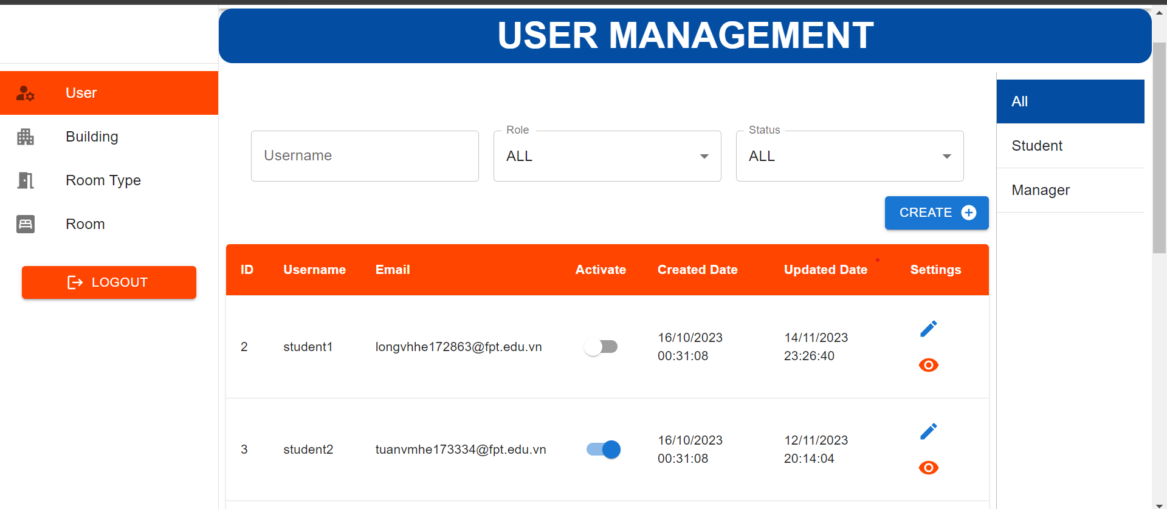

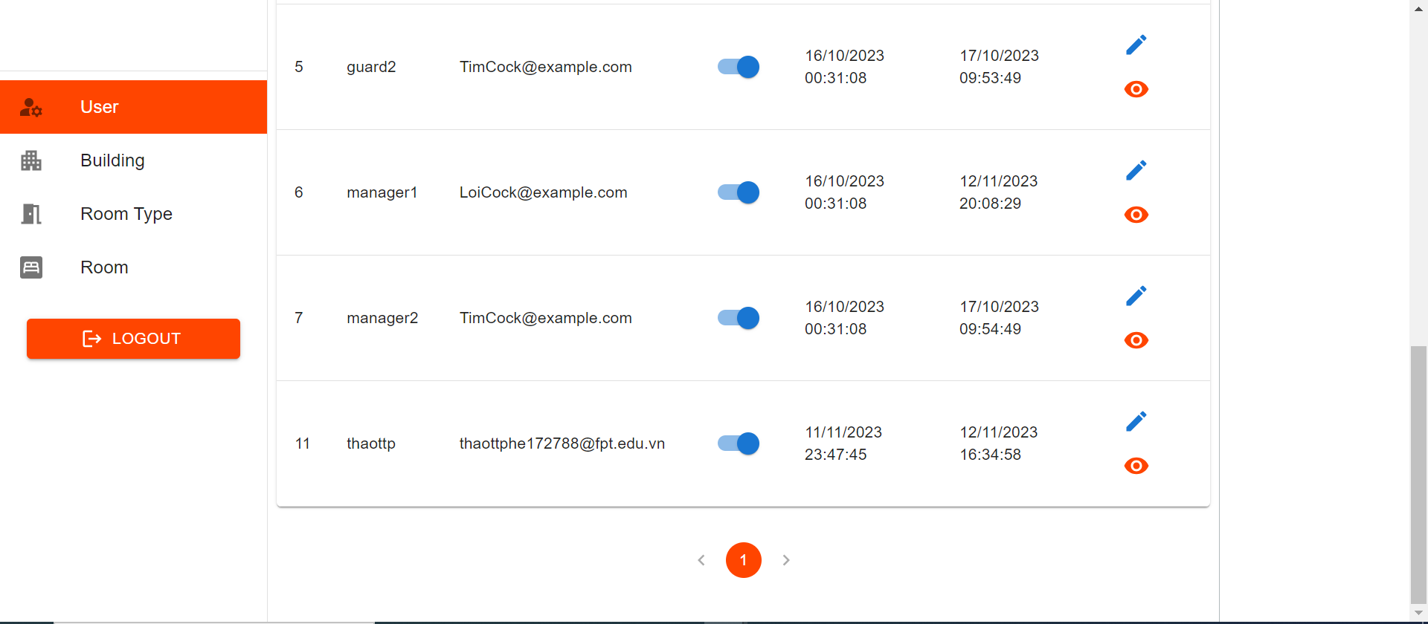

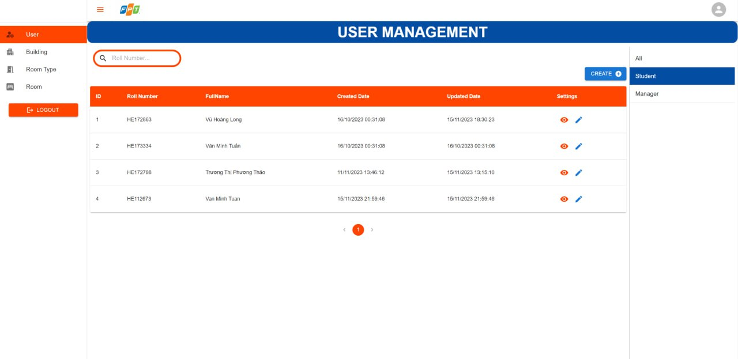

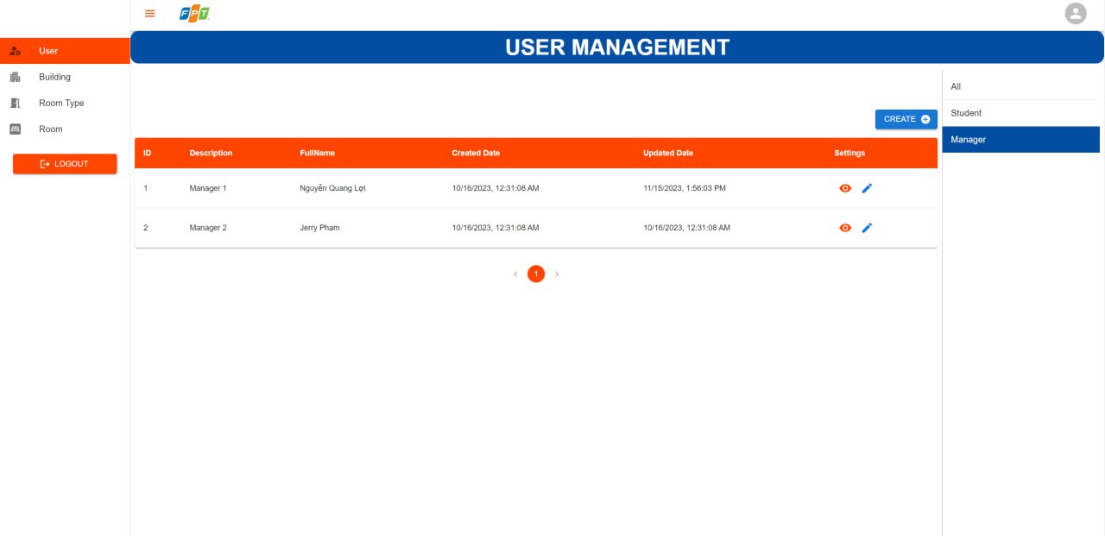

| **Field Name** | **Field Type** | **Description** |
| --- | --- | --- |
| User | Hyperlink | User click to redirect to “User Management” screen |
| Building | Hyperlink | User click to redirect to “Building” screen |
| Room Type | Hyperlink | User click to redirect to “Room Type” screen |
| Room | Hyperlink | User click to redirect to “Room” screen |
| All | Hyperlink | User click to redirect to “User Management” screen |
| Student | Hyperlink | User click to redirect to “Student” screen |
| Manager | Hyperlink | User click to redirect to “Manager” screen |
| Search bar | Input | User enter username to find user by username |
| Filter by role | Dropdown | User select a role name to filter user by role |
| Filter by status | Dropdown | User select a status to filter user by their status |
| Create user | Button | User click on to view a pop up form for create new user |
| Change status | Toggle button | User click on to change user status |
| Pen | Button | User click on to view a pop up form for edit user |
| Eye | Button | User click on to view user details |
| Number(1,2..) | Button | User click to redirect to next or previous pages |
| < | Button | User click to redirect previous pages |
| > | Button | User click to redirect next pages |

#### 

#### b.Database Access

**1/ Select all users**

SELECT * FROM user u

**2/ Select all students**

SELECT * FROM user u

INNER JOIN student s ON u.user_id = s.user_id

**3/ Select all managers**

SELECT * FROM user u

INNER JOIN manager m ON u.user_id = m.user_id

### 5.2 Create User

This feature allow user to create new user in the system

#### a. UI Design

* Related UC:Create User

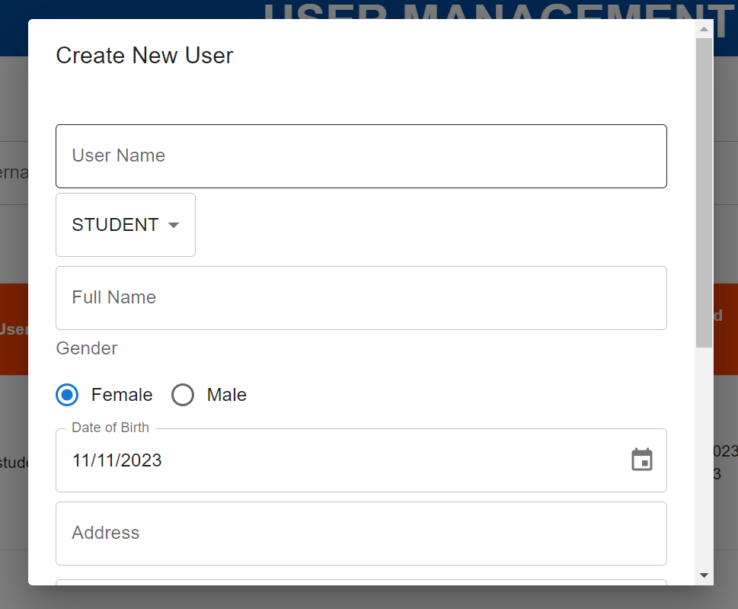

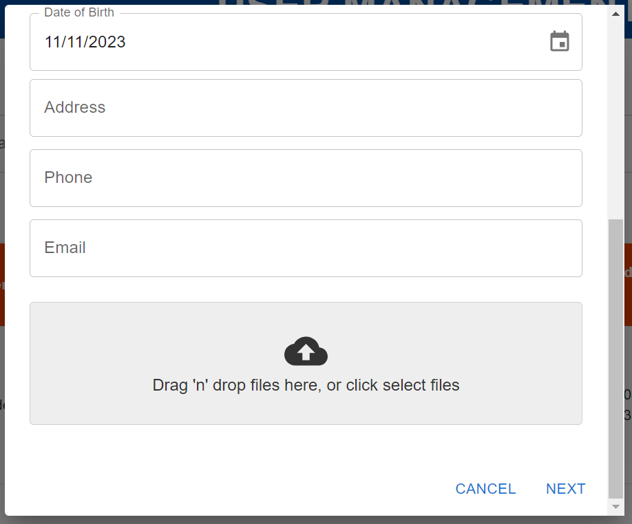

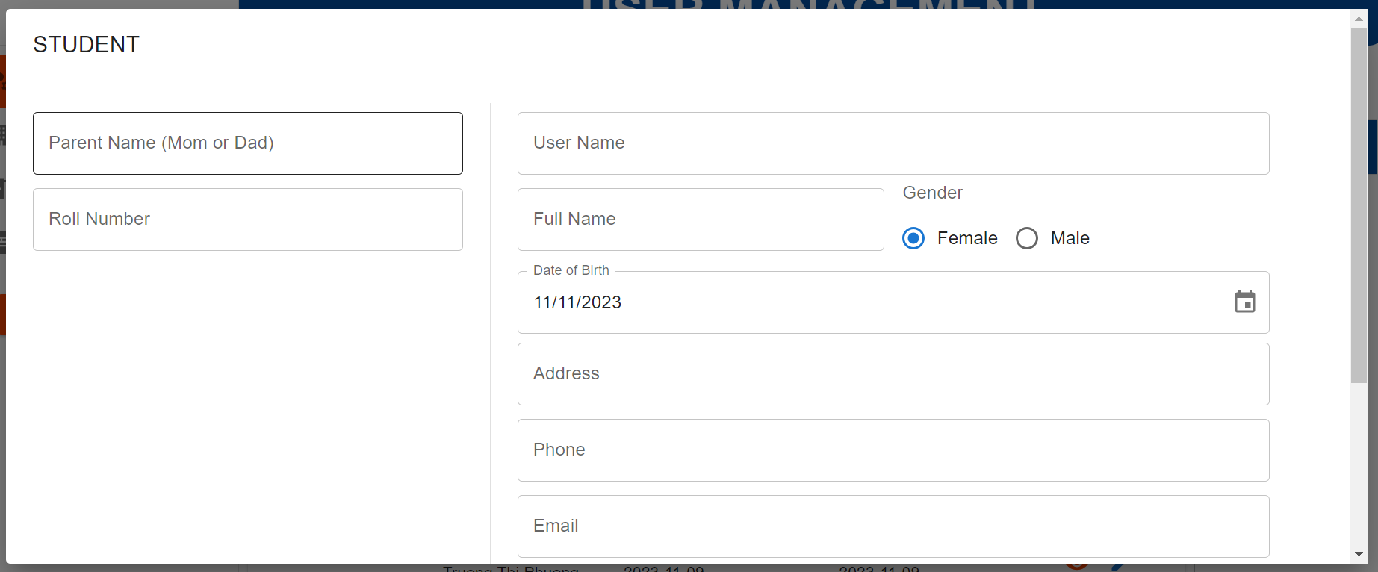

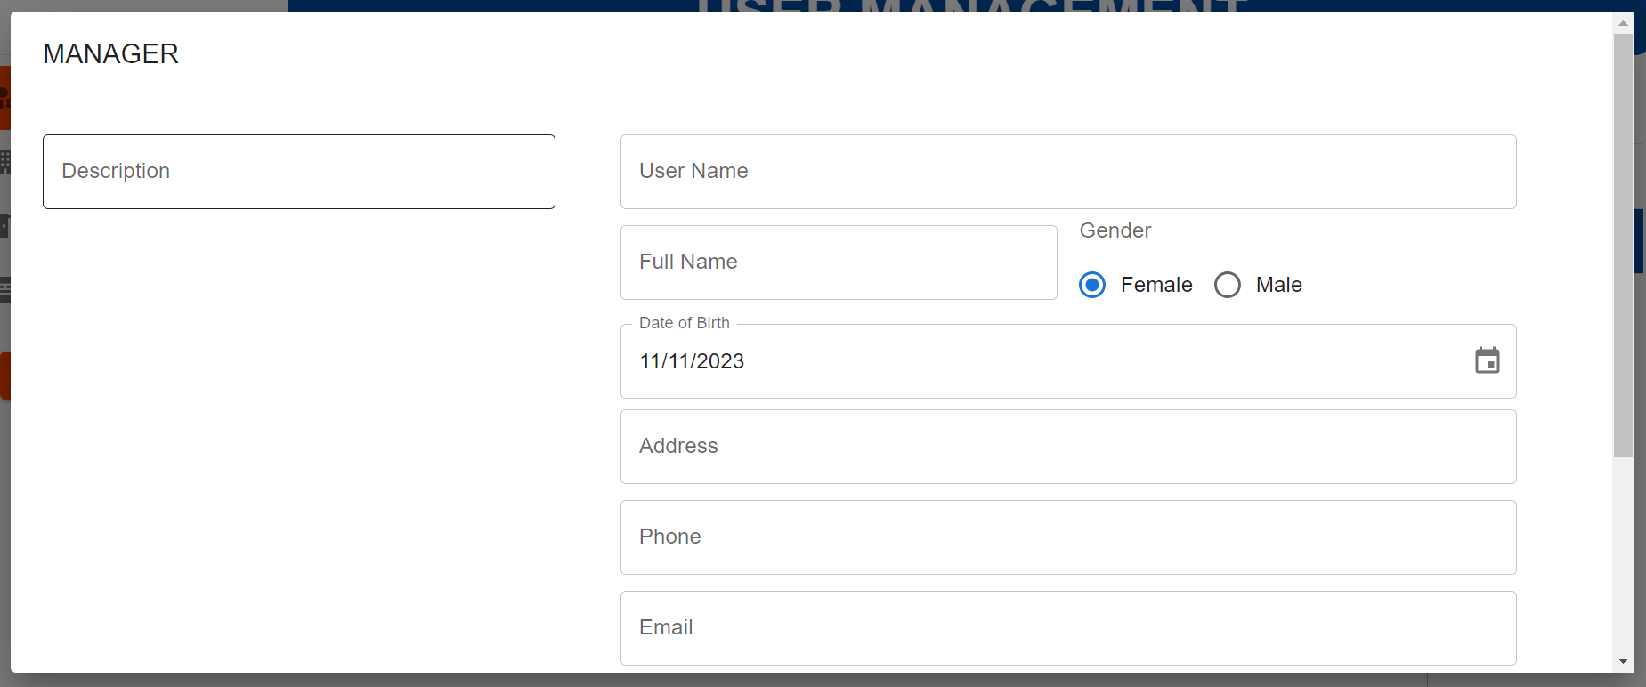

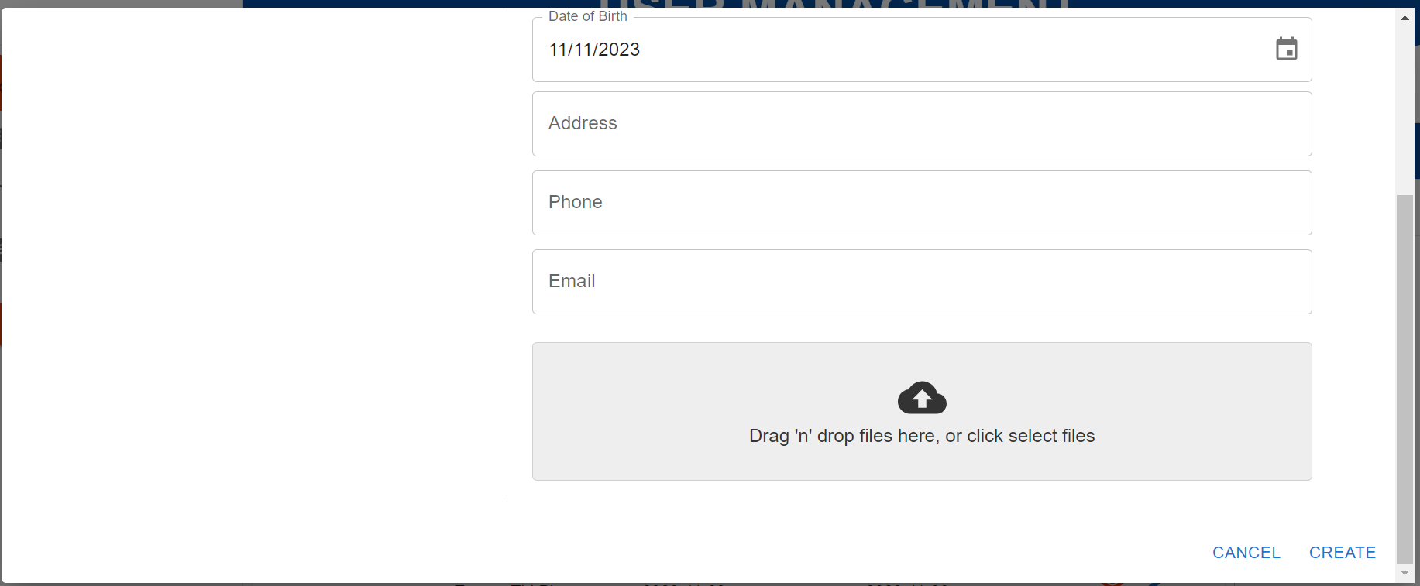

| **Field Name** | **Field Type** | **Description** |
| --- | --- | --- |
| User Name | Input | User enter username of new user |
| Role Select | Dropdown | User selects a role from the dropdown list |
| Full Name | Input | User enter full name of new user |
| Gender | Radio Input | User tick in to input gender of new user |
| Date of Birth | Input | User choose date of birth of new user |
| Address | Input | User enter address of new user |
| Phone | Input | User enter phone number of new user |
| Email | Input | User enter email of new user |
| File | Input | User drag and drop or choose avatar image of new user |
| Parent Name | Input | User enter parent name of new manager user |
| Roll Number | Input | User enter roll number of new student user |
| Description | Input | User enter email of new manager user |
| Cancel | Button | User click on to close the pop up form |
| Next | Button | User click on to move to the next form depend on chosen role |
| Create | Button | User click on to send all input information and create new user |

#### 

#### b.Database Access

**1/ Create new user**

INSERT INTO user u

(address, avatar_image, created_at, date_of_birth, email, full_name, gender, password, phone, status, updated_at, username, role_id, file_data, file_name, file_type)

value (?, ?, ?, ?, ?, ?, ?, ?, ?, ‘active’, ?, ?, ? ,?, ?, ?);

**2/ Create new student**

INSERT INTO student s

(created_at, description, parent_name, roll_number, updated_at, user_id);

Value (?, ?, ?, ?, ?, ?)

**3/ Create new manager**

INSERT INTO student s

(created_at, description, updated_at, user_id);

Value (?, ?, ?, ?);

### 5.3 Update User

This feature allow user to edit user information

#### a.UI Design

* Related UC:Update User

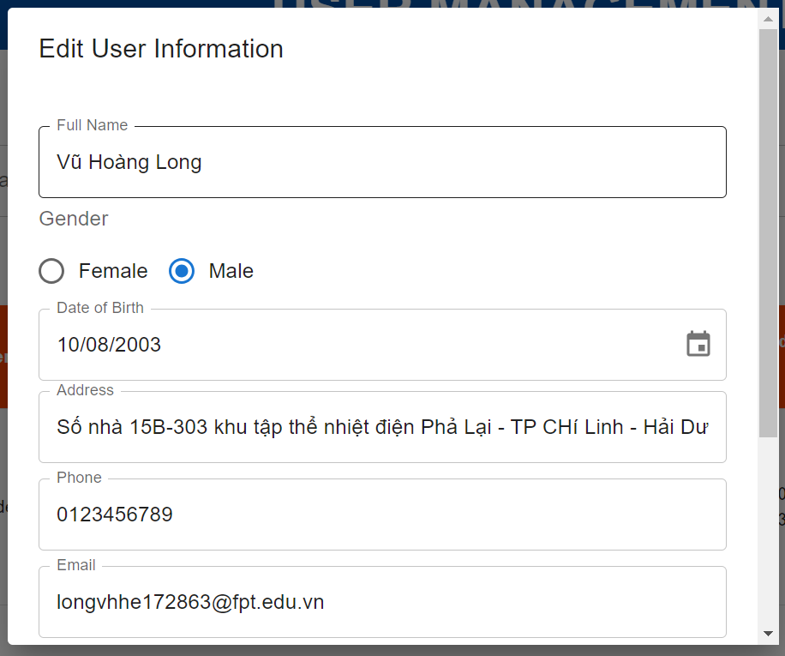

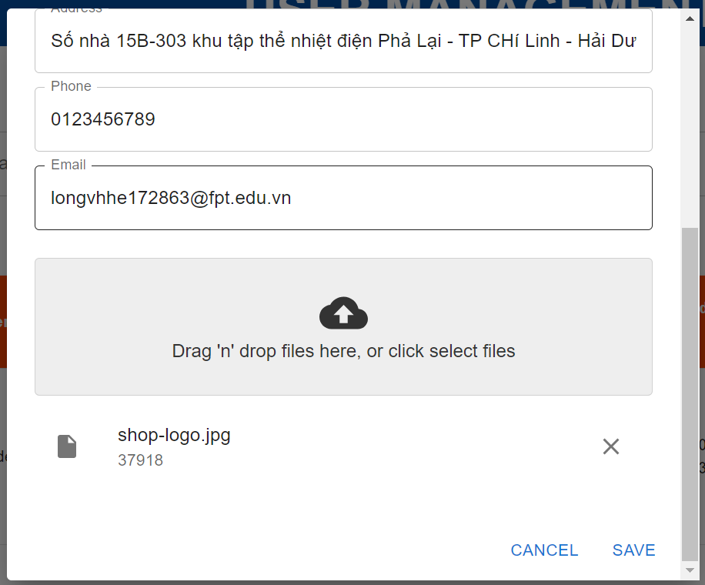

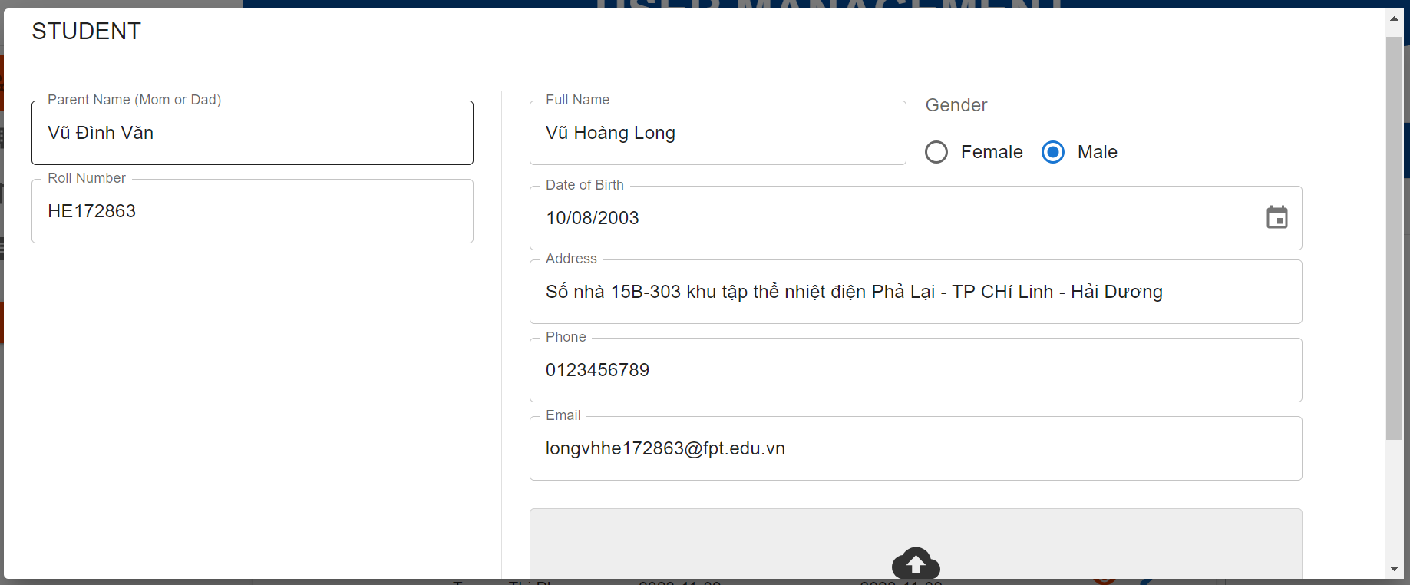

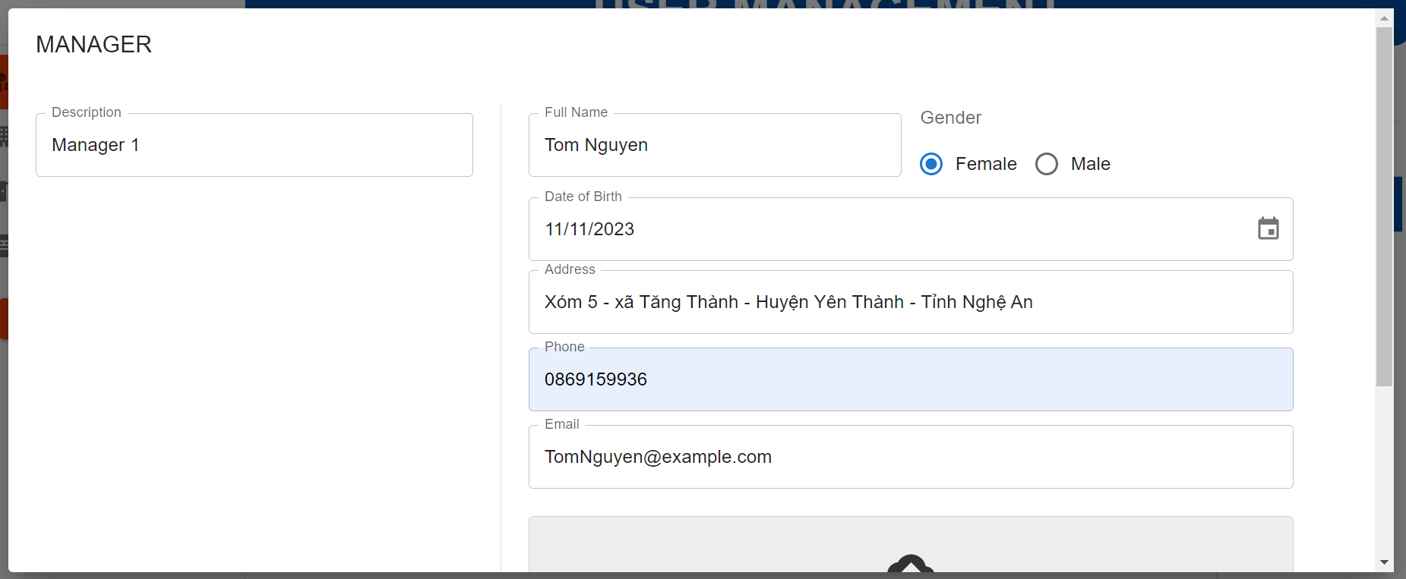

| **Field Name** | **Field Type** | **Description** |
| --- | --- | --- |
| Full Name | Input | User enter new full name of user |
| Gender | Radio Input | User tick in new gender of user |
| Date of Birth | Input | User choose new date of birth to user |
| Address | Input | User enter new address of user |
| Phone | Input | User enter new phone number of user |
| Email | Input | User enter new email of user |
| File | Input | User drag and drop or choose new avatar image of user |
| Parent Name | Input | User enter new parent name of manager user |
| Roll Number | Input | User enter new roll number of student user |
| Description | Input | User enter new email of manager user |
| Cancel | Button | User click on to close the pop up form |
| Save | Button | User click on to send all input information and save new user information |

#### 

#### b.Database Access

**1/ Create new user**

UPDATE user u

SET address = ?,

avatar_image = ?,

date_of_birth = ?,

email = ?,

full_name = ?,

gender = ?,

phone = ?,

updated_at =?,

username = ?,

role_id = ?,

file_data = ?,

file_name = ?,

file_type = ?

WHERE user_id = ?;

**2/ Create new student**

UPDATE student

SET description = ?,

parent_name = ?,

roll_number = ?,

updated_at = ?

WHERE student_id= ?;

**3/ Create new manager**

UPDATE manager

SET description = ?,

updated_at = ?

WHERE manager_id= ?;

### 5.4 Update User Status

This feature allow user to delete user from the system

#### a.UI Design

* Related UC:Update User Status

#### 

| **Field Name** | **Field Type** | **Description** |
| --- | --- | --- |
| Yes | Button | User click to update user status |
| Update status | Toggle button | User click to change deactivate/activate user account |
| No | Button | User click to stop stop update action |

#### b.Database Access

**1/ Delete all things belonged to this user if he is student**

UPDATE bed

SET student_id = null

WHERE student_id = ?

DELETE FROM bed_request br

WHERE br.student_id = ?

DELETE FROM payment p

WHERE p.student_id = ?

DELETE FROM request_application ra

WHERE ra.student_id = ?

DELETE FROM student s

WHERE p.student_id = ?

**2/ Delete all things belonged to this user if he is a manager**

UPDATE payment

SET checked_by_manager_id = null

WHERE checked_by_manager_id = ?

UPDATE request_application

SET manager_id = null

WHERE manager_id = ?

UPDATE news

SET take_by_manager_id = null

WHERE take_by_manager_id = ?

DELETE FROM manager m

WHERE m.manger_id = ?

**3/ Delete all things belonged to this user**

DELETE FROM token t where t.user_id = ?

DELETE FROM bed_request br WHERE br.user_id = ?

DELETE FROM student s WHERE s.user_id = ?

DELETE FROM manager m WHERE m.user_id = ?

### 5.5 View User Details

This feature allow user to view user details

#### a.UI Design

* Related UC:View User Details

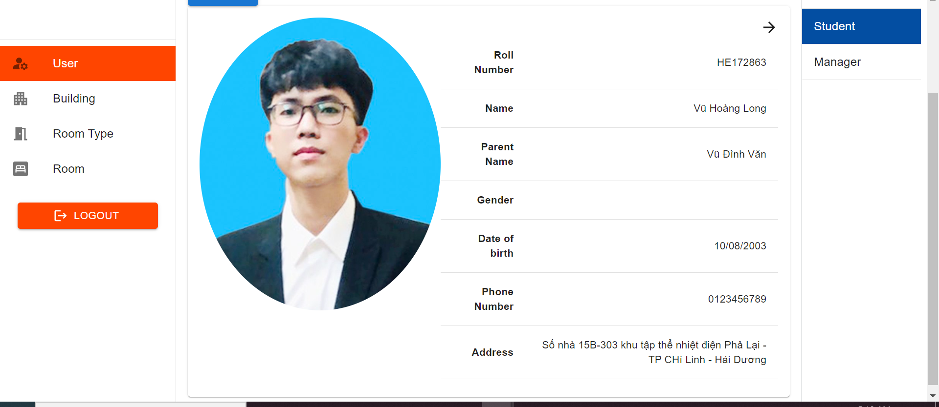

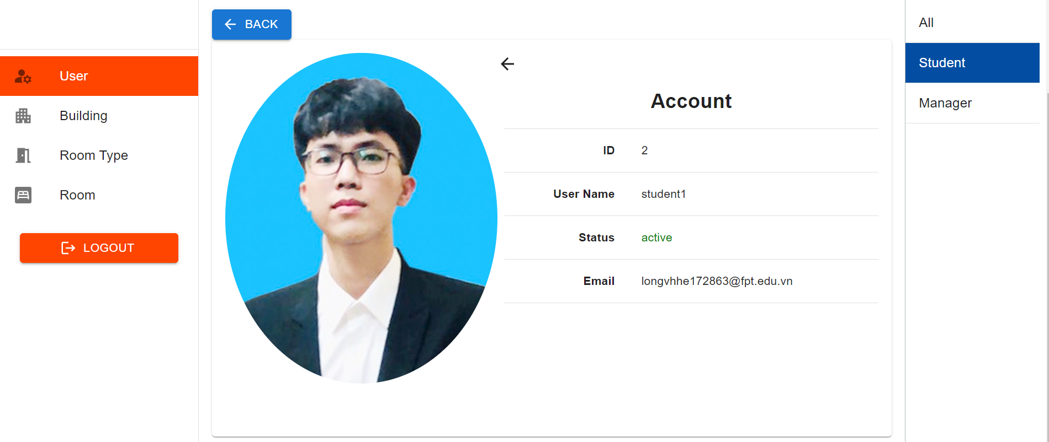

#### 

| **Field Name** | **Field Type** | **Description** |
| --- | --- | --- |
| User | Hyperlink | User click to redirect to “User Management” screen |
| Building | Hyperlink | User click to redirect to “Building” screen |
| Room Type | Hyperlink | User click to redirect to “Room Type” screen |
| Room | Hyperlink | User click to redirect to “Room” screen |
| All | Hyperlink | User click to redirect to “User Management” screen |
| Student | Hyperlink | User click to redirect to “Student” screen |
| Manager | Hyperlink | User click to redirect to “Manager” screen |
| Search bar | Input | User enter username to find user by username |
| Filter by role | Dropdown | User select a role name to filter user by role |
| Filter by status | Dropdown | User select a status to filter user by their status |
| Create user | Button | User click on to view a pop up form for create new user |
| Change status | Toggle button | User click on to change user status |
| Pen | Button | User click on to view a pop up form for edit user |
| Bin | Button | User click on to delete user |
| Eye | Button | User click on to view user details |
| Back | Button | User click to return to the previous screen |
| ← | Button | User click to view the first page of user details |
| → | Button | User click to view the second page of user details |

#### b.Database Access

**1/ View student**

SELECT * FROM user u

INNER JOIN student s ON u.user_id = s.user_id

WHERE u. user_id = ?

**2/ View manager**

SELECT * FROM user u

INNER JOIN manager m ON u.user_id = s.user_id

WHERE u.user_id = ?

### 5.6 View List Building

This feature allow user to view list of buildings

#### a.UI Design

* Related UC:View List Building

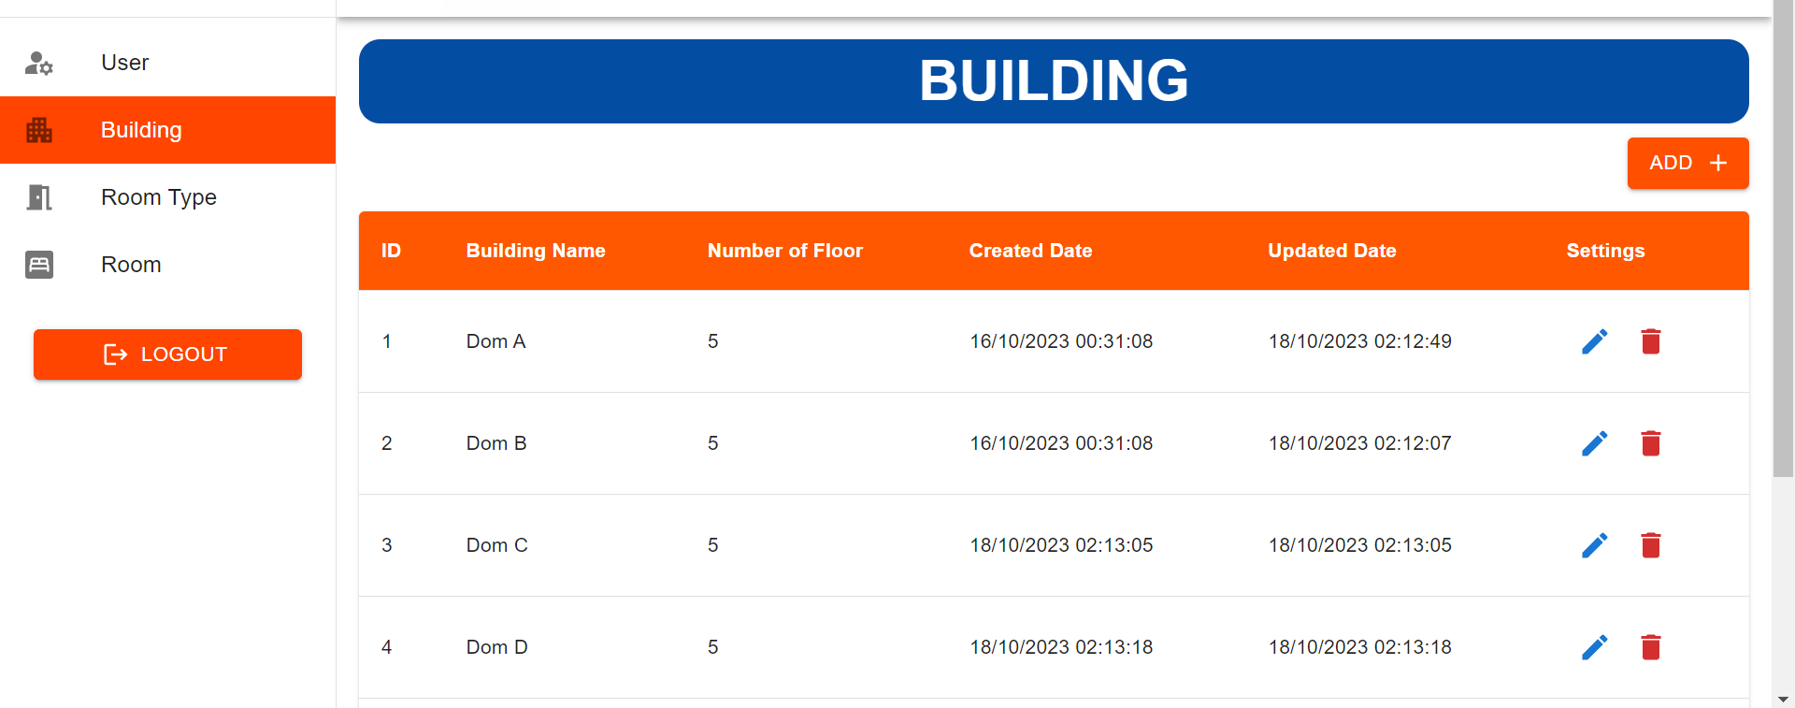

| **Field Name** | **Field Type** | **Description** |
| --- | --- | --- |
| User | Hyperlink | User click to redirect to “User Management” screen |
| Building | Hyperlink | User click to redirect to “Building” screen |
| Room Type | Hyperlink | User click to redirect to “Room Type” screen |
| Room | Hyperlink | User click to redirect to “Room” screen |
| ADD + | Button | User click on to view a pop up form for create new building |
| Pen | Button | User click on to view a pop up form for edit building |
| Bin | Button | User click on to delete building |

#### 

#### b.Database Access

SELECT * FROM building

### 5.7 Create Building

This feature allow you to create new building

#### a.UI Design

* Related UC:Create Building

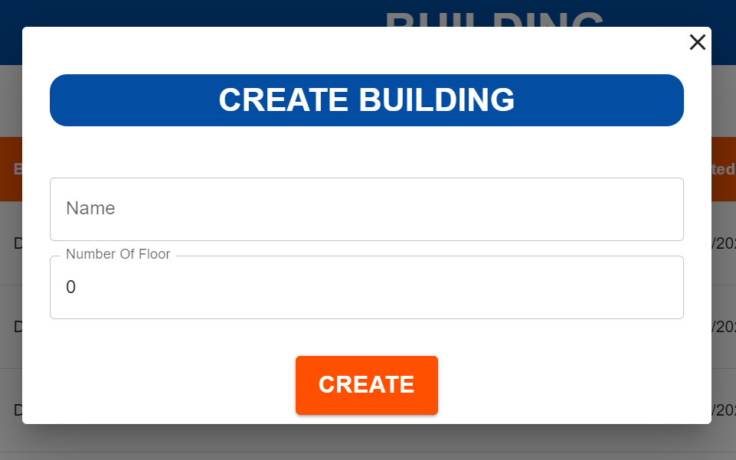

| **Field Name** | **Field Type** | **Description** |
| --- | --- | --- |
| Name | Input | User enter building name of new building |
| Number of Floor | Input | User enter number of floor of new building |
| X | Button | User click on to close the pop up form |
| Create | Button | User click on to send all input information and create new user |

#### 

#### b.Database Access

INSERT INTO building(building_name, number_of_floor) value (?, ?)

### 5.8 Update Building

This feature allow user to update building information

#### a.UI Design

* Related UC:Update Building

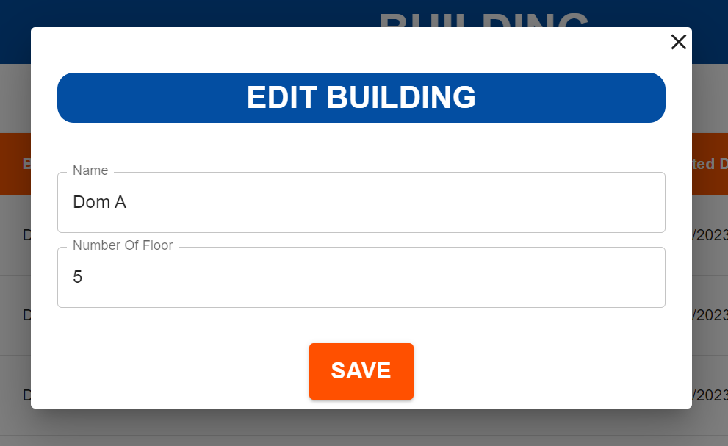

| **Field Name** | **Field Type** | **Description** |
| --- | --- | --- |
| Name | Input | User enter new building name |
| Number of Floor | Input | User enter new number of floor |
| X | Button | User click on to close the pop up form |
| Save | Button | User click on to send all input information and save new building information |

#### 

#### b.Database Access

**1/ Update room name if the name of building change**

UPDATE room

SET room_name = CONCAT(?, RIGHT(room_name, 3))

WHERE building_id = ?

**2/ Update building**

UPDATE building(building_name, number_of_floor) value (?, ?)

### 5.9 Delete Building

This feature allow user to delete building

#### a.UI Design

* Related UC:Delete Building

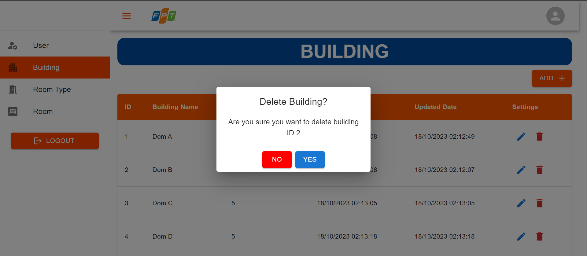

| **Field Name** | **Field Type** | **Description** |
| --- | --- | --- |
| Yes | Button | User click to delete building |
| No | Button | User click to stop delete action |

#### 

#### b.Database Access

**1/ Delete all payments**

SELECT bed_request_id FROM bed_request br

INNER JOIN bed b ON b.bed_id = br.bed_id

INNER JOIN room r ON b.room_id = r.room_id

INNER JOIN building bu ON bu.building_id = r.building_id

WHERE r.building_id = ?

DELETE FROM payment

WHERE bed_request_id in (?,?, … , ?)

**2/ Delete all bed requests**

SELECT bed_id FROM bed b

INNER JOIN room r ON b.room_id = r.room_id

INNER JOIN building bu ON bu.building_id = r.building_id

WHERE r.building_id = ?

DELETE FROM bed_request

WHERE bed_id in (?,?, … , ?)

**3/ Delete all beds**

SELECT room_id FROM room r

INNER JOIN building bu ON bu.building_id = r.building_id

WHERE r.building_id = ?

DELETE FROM beds

WHERE room_id in (?,?, … , ?)

**4/ Delete all rooms**

DELETE FROM room

WHERE building_id = ?

**5/ Delete building**

DELETE FROM building

WHERE building_id = ?

### 5.10 View List Room Type

This feature allow user to view list of room types

#### a.UI Design

* Related UC:View List Room Type

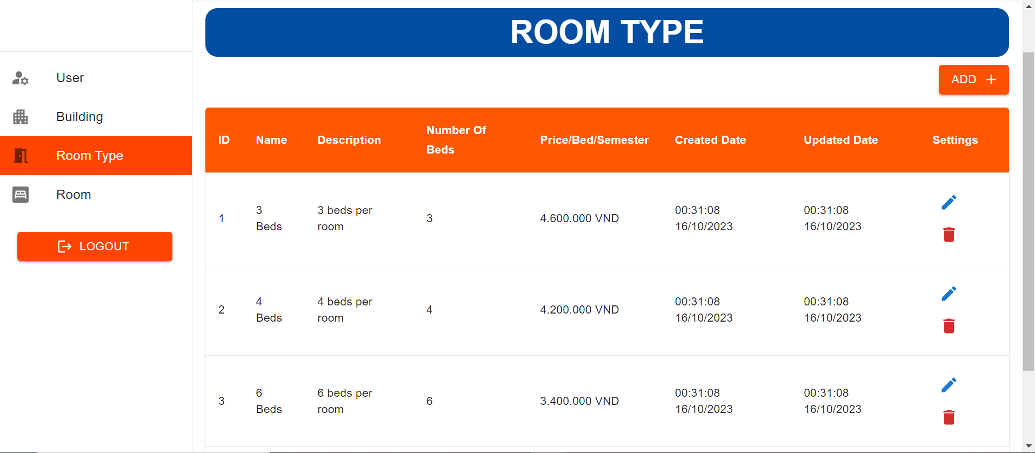

| **Field Name** | **Field Type** | **Description** |
| --- | --- | --- |
| User | Hyperlink | User click to redirect to “Room Type” screen |
| Building | Hyperlink | User click to redirect to “Building” screen |
| Room Type | Hyperlink | User click to redirect to “Room Type” screen |
| Room | Hyperlink | User click to redirect to “Room” screen |
| ADD + | Button | User click on to view a pop up form for create new room type |
| Pen | Button | User click on to view a pop up form for edit room type |
| Bin | Button | User click on to delete room type |

#### 

#### b.Database Access

SELECT * FROM room_type

WHERE room_type_id = ?

### 5.11 Create Room Type

This feature allow user to create new room type

#### a.UI Design

* Related UC:Create Room Type

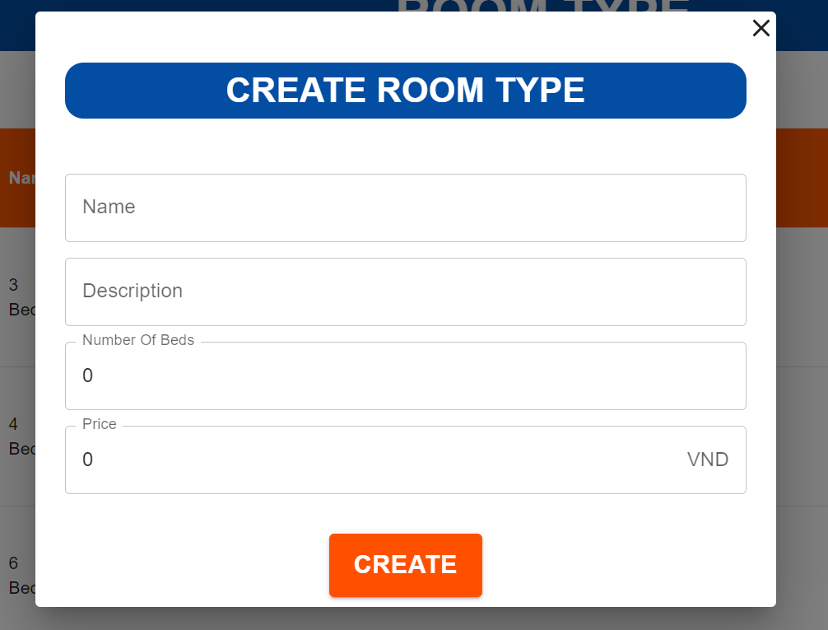

#### 

| **Field Name** | **Field Type** | **Description** |
| --- | --- | --- |
| Name | Input | User enter name of new room type |
| Description | Input | User enter room type description |
| Number of Beds | Input | User enter number of beds of new room type |
| Price | Input | User enter room type price |
| X | Button | User click on to close the pop up form |
| Create | Button | User click on to send all input information and create new room type |

#### b.Database Access

INSERT INTO room_type (room_type_name, description, number_of_beds) VALUE (?, ?, ?)

### 5.12 Update Room Type

This feature allow user to update room type information

#### a.UI Design

* Related UC:Update Room Type

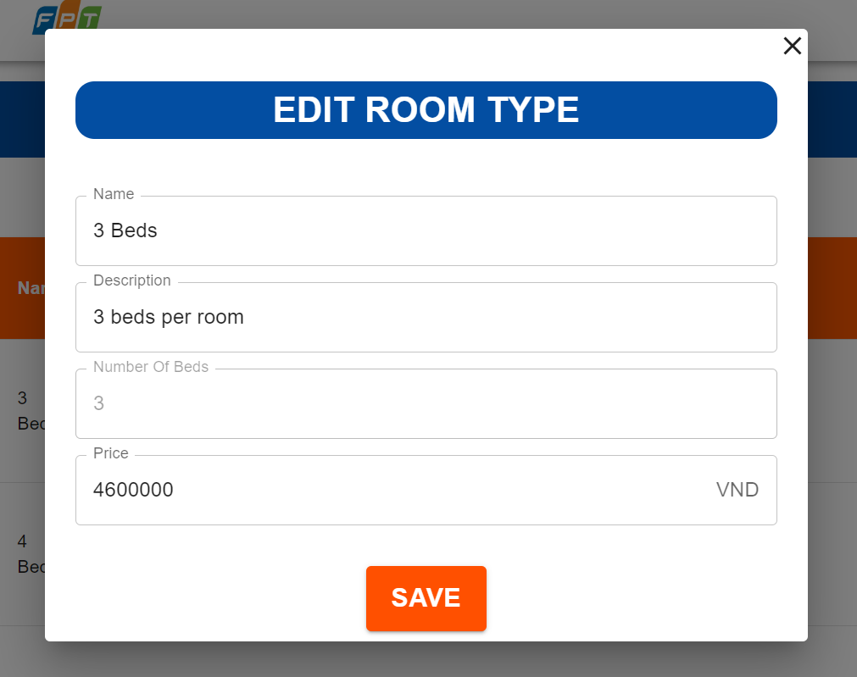

| **Field Name** | **Field Type** | **Description** |
| --- | --- | --- |
| Name | Input | User enter new name of room type |
| Description | Input | User enter room type description |
| Price | Input | User enter room type price |
| X | Button | User click on to close the pop up form |
| Save | Button | User click on to send all input information and save new room type |

#### 

#### b.Database Access

UPDATE room_type

SET room_type_name = ?,

desciption = ?,

number_of_beds = ?,

price = ?

WHERE room_type_id = ?

### 5.13 Delete Room Type

This feature allow user to delete room type

#### a.UI Design

* Related UC:Delete Room Type

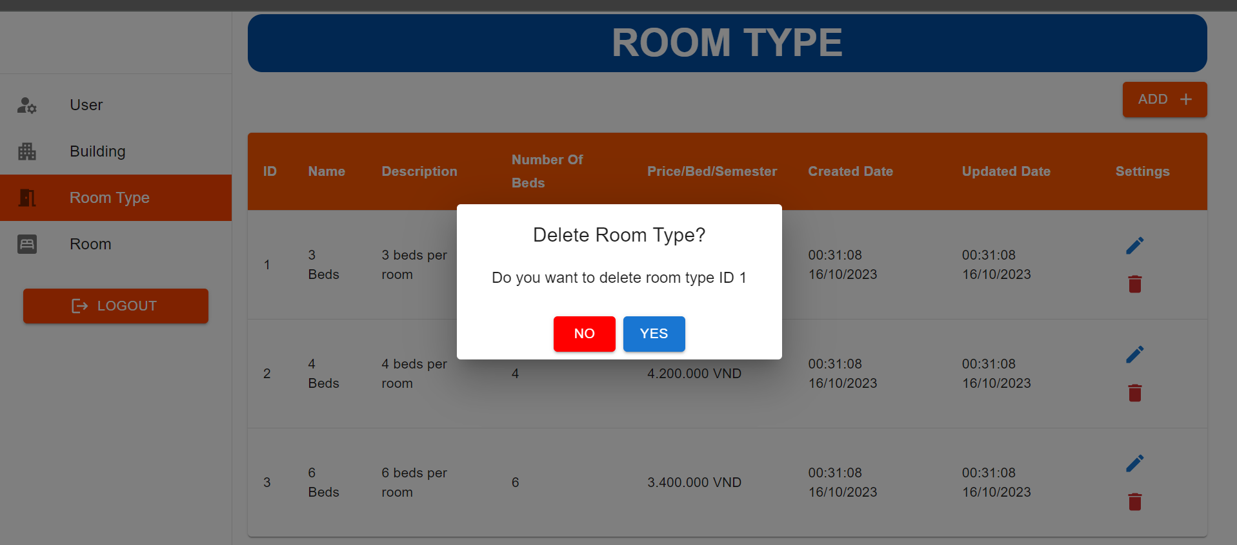

| **Field Name** | **Field Type** | **Description** |
| --- | --- | --- |
| Yes | Button | User click to delete room type |
| No | Button | User click to stop delete action |

#### 

#### b.Database Access

**1/ Delete all payments**

SELECT bed_request_id FROM bed_request br

INNER JOIN bed b ON b.bed_id = br.bed_id

INNER JOIN room r ON b.room_id = r.room_id

INNER JOIN room_type rt ON rt.room_type_id = r.room_type_id

WHERE r.room_type_id = ?

DELETE FROM payment

WHERE bed_request_id in (?,?, … , ?)

**2/ Delete all bed requests**

SELECT bed_id FROM bed b

INNER JOIN room r ON b.room_id = r.room_id

INNER JOIN room_type rt ON rt.room_type_id = r.room_type_id

WHERE r.room_type_id = ?

DELETE FROM bed_request

WHERE bed_id in (?,?, … , ?)

**3/ Delete all beds**

SELECT room_id FROM room r

INNER JOIN room_type rt ON rt.room_type_id = r.room_type_id

WHERE r.room_type_id = ?

DELETE FROM beds

WHERE room_id in (?,?, … , ?)

**4/ Delete all rooms**

DELETE FROM room

WHERE room_type_id = ?

**5/ Delete building**

DELETE FROM room_type

WHERE room_type_id = ?

### 5.14 View List Room

This feature allow user to view list of rooms

#### a.UI Design

* Related UC:View List Room

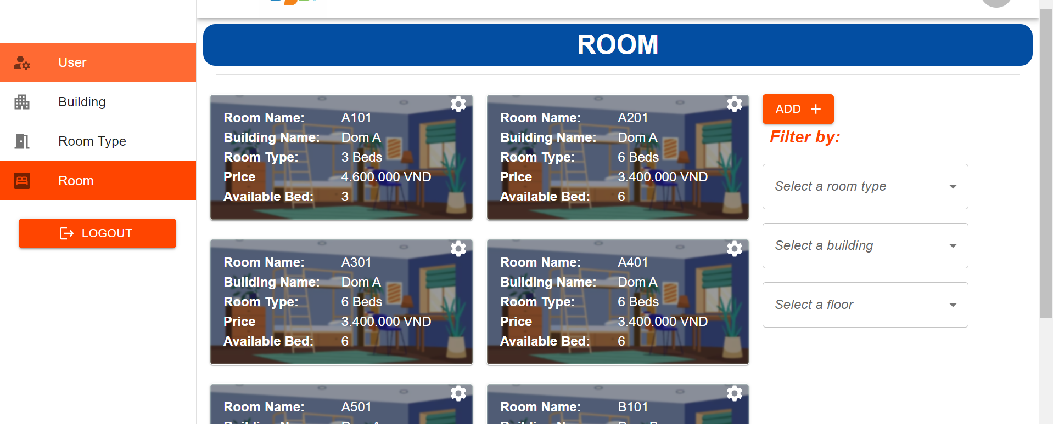

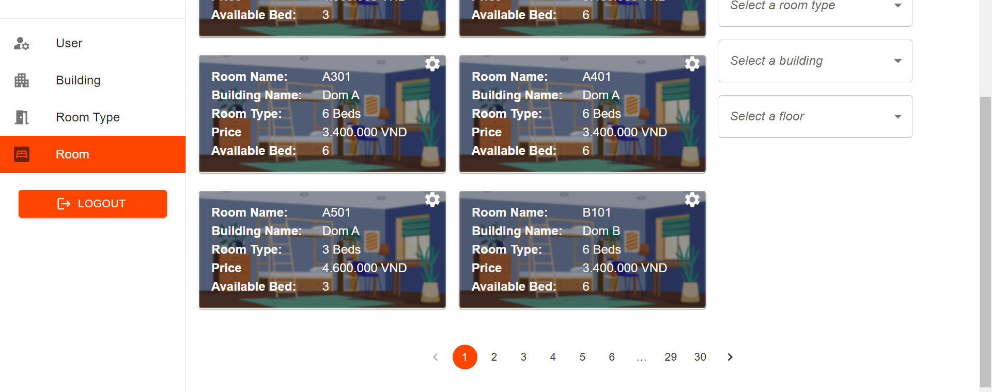

#### 

| **Field Name** | **Field Type** | **Description** |
| --- | --- | --- |
| User | Hyperlink | User click to redirect to “User Management” screen |
| Building | Hyperlink | User click to redirect to “Building” screen |
| Room Type | Hyperlink | User click to redirect to “Room Type” screen |
| Room | Hyperlink | User click to redirect to “Room” screen |
| Select a room type | Select | User can choose option room type |
| Select a building | Select | User can choose option building |
| Select a floor | Select | User can choose option floor |
| Select a room type | Select | User can choose option room type |
| Number(1,2..) | Button | User click to redirect to next or previous pages |
| < | Button | User click to redirect previous pages |
| > | Button | User click to redirect next pages |
| Room | Image | User can view information room and display list bed |
| Setting | Icon | User can hover for option edit or delete |
| Pen | Button | User click to open pop up form for edit room |
| Bin | Button | User click to delete room |

#### 

#### b.Database Access

SELECT r.* FROM room r

INNER JOIN room_type rt ON r.room_type_id = rt.room_type_id

### 5.15 Create Room

This feature allow user to create new room in the system

#### a.UI Design

* Related UC:Create Room

#### 

| **Field Name** | **Field Type** | **Description** |
| --- | --- | --- |
| Name | Input | User enter name of new room type |
| Room Type | Select | User choose room type |
| Dom | Select | User choose dorm |
| Floor | Select | User choose floor |
| X | Button | User click on to close the pop up form |
| Create | Button | User click on to send all input information and create new room |

#### 

#### b.Database Access

INSERT INTO room (room_name, room_type_id, building_id, floor)

VALUE (?, ?, ?, ?, ?)

### 5.16 Delete Room

This feature allow user to delete room from the system

#### a.UI Design

* Related UC:Delete Room

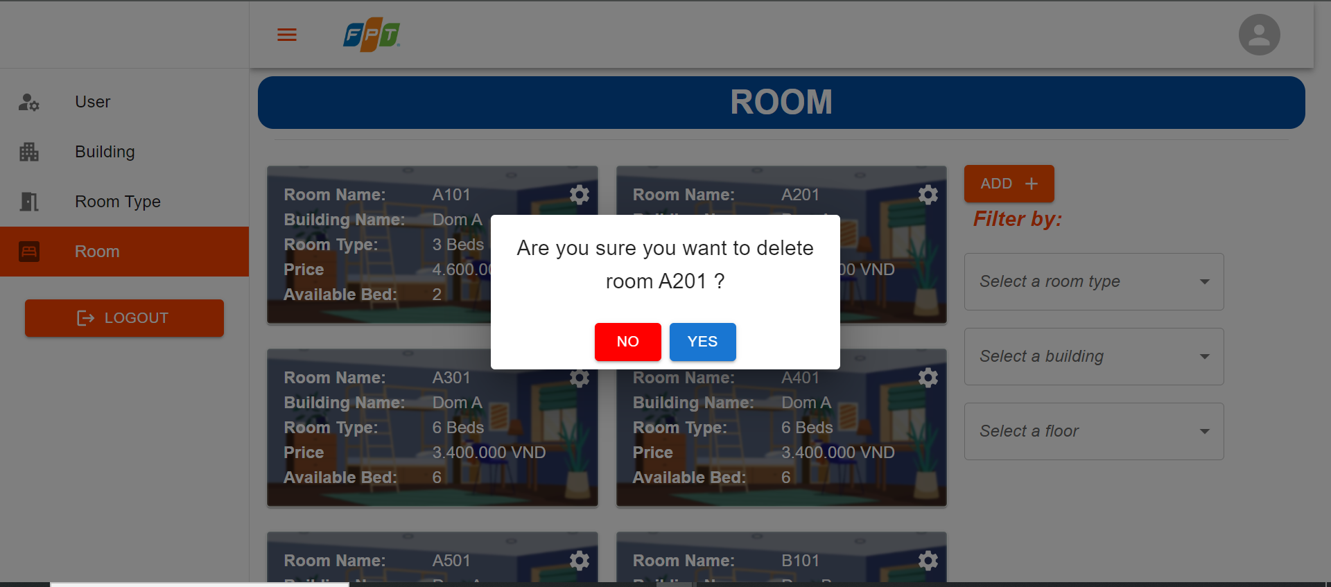

| **Field Name** | **Field Type** | **Description** |
| --- | --- | --- |
| Yes | Button | User click to delete room |
| No | Button | User click to stop delete action |

#### 

#### b.Database Access

**1/ Delete all beds belonged to room**

DELETE FROM bed b

WHERE b.room_id = ?

**2/ Delete room**

DELETE FROM room r

WHERE r.room_id = ?

### 5.17 View List Bed

This feature allow user to view list of bed in a room

#### a.UI Design

* Related UC:View List Bed

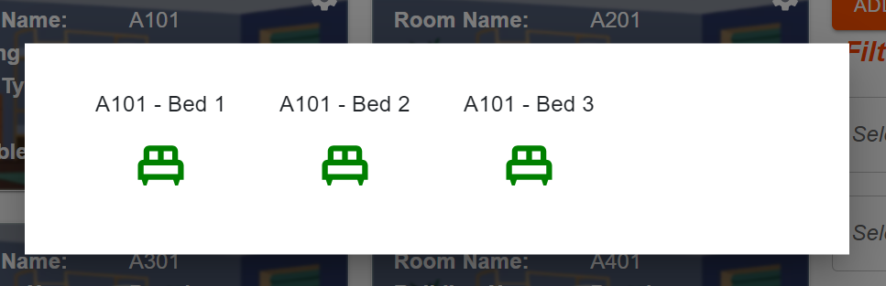

| **Field Name** | **Field Type** | **Description** |
| --- | --- | --- |
| Bed | Icon | Click to view more details of bed |

#### 

#### b.Database Access

SELECT * FROM bed b

WHERE b.room_id = ?

| # | Message code | Message Type | Context | Content |
| --- | --- | --- | --- | --- |
| 1 | MSG-01 | In red | Inputted username has already existed. | Your provided username has already existed! |
| 2 | MSG-02 | Pop-up | Input-required fields are empty | Please fill out this field. |
| 3 | MSG-03 | In red | Inputted email has already existed. | Your provided email has already existed! |
| 4 | MSG-04 | In red | Inputted phone numbers already existed. | Your provided phone number has already existed! |
| 5 | MSG-05 | In red | Username or password is not correct when clicking sign-in | Incorrect username or password |
| 6 | MSG-06 | In red | Old password is not correct when changing password | Incorrect old password |
| 7 | MSG-07 | In red | New password and the confirm new password do not match | New password and confirm new password do not match |
| 8 | MSG-08 | In red | Provided email or username does not correspond to any existing account in the system | Can not find the corresponding account |
| 9 | MSG-09 | In-red | Password reset token expired | Your request is expired, please try again |
| 10 | MSG-10 | In red | The entered membership card number does not match the required format | Membership card number does not match the required format |
| 11 | MSG-11 | In red | The entered membership card number has already been registered by another user | This membership card number has already been registered |
| 12 | MSG-12 | In red | Another user books the same seat(s) before the current user completes the booking process | The selected seat(s) are no longer available |
| 13 | MSG-13 | In red | User takes longer than 5 minutes to complete the payment process | The payment session has expired. Please try again. |
| 14 | MSG-14 | In red | The user fails to update movie details, such as encountering database errors or violating constraints | Update failed! |
| 15 | MSG-15 | In red | The user fails to provide valid and complete details during the addition process, the system displays an error message | Add failed! |
| 16 | MSG-16 | In red | The delete process encounters bad result, such as the delete object is no longer available in the database | Delete failed! |

# **IV. Appendix**

### **1. Assumptions & Dependencies**

#### **Assumptions**

* AS-1: Consistent access to the internet is crucial for the dormitory management system to function effectively.
* AS-2: Dormitory staff will be adequately trained to use the system and will have the necessary hardware (computers, tablets, etc.) to access the system.
* AS-3: The student database will be current and regularly updated, ensuring that the system has accurate information for room assignments and management.

#### **Dependencies**

* DE-1: The dormitory management system relies on the financial settlement to ensure accurate financial records.

### **2. Limitations & Exclusions**

#### **Limitations**

* LI-1: The effectiveness of the dormitory management system may be limited by the availability of reliable internet connectivity and the level of training and technology access among dormitory staff and students.

#### **Exclusions**

* EX-1: The application does not provide a platform for student feedback

### 

### **3. Business Rules**

| ID | Rule Definition | Type of Rule | Static or Dynamic | Source |
| --- | --- | --- | --- | --- |
| BR-1 | All students who wish to reserve a place in the dormitory must be FPT University students | Facts | Static | Manager |
| BR-2 | Each room is only allowed to accommodate the specified number of members | Facts | Dynamic | Manager |
| BR-3 | All students must make payment before moving into the dormitory, failure to make payment will result in not being allowed to stay in subsequent semester | Constraint | Static | Manager |
| BR-4 | All students must make payment within the timeframe specified by the university and the dormitory management, if payment is delayed, a valid reason must be provided | Facts | Dynamic | Manager |
| BR-5 | A room cannot have both male and female students, a room can only have either male students or female students | Constraint | Static | Manager |
| BR-6 | The dormitory fee is calculated based on the price of each type of room, and if students have previously stayed in the dormitory, an additional fee may be added if applicable | Computation | Dynamic | Manager |
| BR-7 | Dormitory residents are not allowed to bring pets into the dormitory building | Facts | Static | Manager |
| BR-8 | Each person is only allowed to reserve one bed in one term | Facts | Static | Manager |
| BR-9 | Employees must complete a safety training course before they can operate heavy machinery | Action Enablers | Static | Manager |
| BR-10 | Before updating anything in the system, careful consideration and evaluation are necessary to ensure that it does not have any adverse impact on the quality of the user experience | Action Enablers | Static | Manager |